**Research Report**

**“Supported Living and Assisted Living in Ukraine in the Context of the Deinstitutionalization Reform”**

**Authors:**

Olena Prashko

Vita Sydorenko

Olena Bordiukova

Research assistance: Yana Bykova

**Expert evaluation of the study:**

Andrii Chernousov

**Proofread by:**

**Layout and design:**

**Project implementing organization:** All-Ukrainian Association of Organizations for People with Disabilities “The League of the Strong”

**Partner Organizations:**

NGO “Kharkiv Institute of Social Research”

NGO “Human Rights Lab”

**The publication has been prepared within the project**

**The publication reflects the position of the authors and does not necessarily coincide with the position**

**Please send your comments and suggestions to**

**Kyiv 2024**

**RESEARCH REPORT**

**SUPPORTED LIVING AND ASSISTED LIVING IN UKRAINE IN THE CONTEXT OF THE DEINSTITUTIONALIZATION REFORM**

**CONTENTS**

**INTRODUCTION** 3

**ACKNOWLEDGEMENTS** 4

**ABBREVIATIONS** 5

**ISSUE RELEVANCE**

Overcoming issues during implementation of projects aimed at reforming the inpatient care system 6

**RESEARCH METHODOLOGY**

Research tools 7

**STATE POLICY ON THE SUPPORTED LIVING DEVELOPMENT**

Priority area of activity of the Ministry of Social Policy of Ukraine

Regulatory and legal framework for the provision of social services in Ukraine. Overview of key documents 11

Determination of the population needs in social services in an administrative-territorial unit/territorial community 15

**INFORMING THE POPULATION ABOUT SOCIAL SERVICES OF SUPPORTED LIVING** 16

**STATISTICAL DATA** 19

Provision of social services in territorial communities 19

**INTERNATIONAL PRACTICES OF INDEPENDENT LIVING** 37

**NATIONAL PRACTICES OF SOCIAL SERVICES**

**OF SUPPORTED LIVING ORGANIZATION** 53

**CONCLUSIONS AND RECOMMENDATIONS** 92

ANNEXES 98

INTRODUCTION

The previous model of social support for people with disabilities and the elderly in Ukraine was based on institutional care, according to which people lived in specialized institutions. However, this system does not meet the requirements of the UN Convention on the Rights of Persons with Disabilities and the principles of the Living in Dignity Model (LDM), which aims to integrate people with disabilities into communities. Institutional care restricts the right to independent living and social participation, which has been criticised by international organizations and the UN Committee on the Rights of Persons with Disabilities.

European Disability Forum Position Paper on deinstitutionalisation emphasizes the importance of moving from institutional care to community-based services for people with disabilities.

Current trends regarding the implementation of supported living models in Ukraine are based on enabling people with disabilities or mental disorders to live independently in the community with support, instead of staying in institutions. It provides access to individual services and assistance, including social workers, medical support and rehabilitation programs. The main goal is to promote independent living and social integration. An important part of this model is the adaptation of world experience and integration into Ukrainian realities through social service reforms. The practical task is to realize people’s right to independent living in compliance with human rights standards.

This study considers the approach to organizing supported living and assisted living (day care, home care) in accordance with the current Ukrainian legislation and reality, but they shall be assessed separately, taking into account the collected data.

All-Ukrainian Association of Organizations for People with Disabilities “The League of the Strong” does not assess the compliance of existing practices and does not promote group homes.

**Andrii Chernousov**

**ACKNOWLEDGEMENTS**

For assistance in preparing the report and information provided:

**Nikulin Vitalii**, representative of the Ukrainian Parliament Commissioner for Human Rights;

**Tokarieva Uliana**, Deputy Minister of Social Policy of

Ukraine.

For interviews:

**Lomakina Tetiana**, Presidential Commissioner for Barrier-Free Environment;

**Suvalo Orest**, Ukrainian-Swiss Project “MH4YOU”

**Olena Temchenko**, Ukrainian-Swiss Project “MH4YOU”

**Serhienko Iryna**, NGO “League of Social Workers”

**Oryshchyn Nataliia**, Center for Supported Living in Lviv

**Shtohryn Halyna**, NGO “Dream Workshop”

**Holovanova Raisa**, Center for Social Services and Social Integration, Pereiaslav

**Hordii Ivan**, resident of NGO “Dream Workshop”

**Oksana Ilkiv**, House of supported living “Caritas-Stryi”

**Lesia Samoilenko**, NGO “'Kolping Family in Vinnytsia”

**Kovalchuk Yuliia**, Gorohiv PNI

**Stanislav Turyna**, person with experience of living with a mental disorder

**Nadiia Maiorova**, NGO “Family for Persons with Disability”

**Marian Tsudnyi**, Lviv Regional Clinical Pshychiatric Hospital

ABBREVIATIONS

**CO** – charitable fund/organization

**PO** – public organization

**HC** – social home care service

**DC** – social day care service

**Derzhstandart** – State standard of social service of the supported living of elderly people and persons with disabilities

**Media** – mass media

**CMU** – Cabinet of Ministers of Ukraine

**MSP** – the Ministry of Social Policy of Ukraine

**MoH** – the Ministry of Health of Ukraine

**MH4U** – Mental Health for Ukraine project

**NPM** – national preventive mechanism

**NGO** – non-governmental organization

**RMA** – regional military administration

**LSG** – local self-government bodies

**UN** – United Nations

**PNI** – psycho-neurological institution

**SL** – social service of supported living

**TC** – territorial community

ISSUE RELEVANCE

The social service of supported living is becoming increasingly relevant in the context of the deinstitutionalization reform in Ukraine, which is aimed at ensuring human rights, improving the quality of life and integrating persons with disabilities and elderly people into the community.

The institutional care system no longer corresponds to the modern philosophy providing for equal rights for all citizens, creating a barrier-free environment, non-discrimination and personal integrity. Residential social care facilities cannot provide decent living conditions and do not support the social integration of their residents, who often are isolated from society, are unable to meet their individual needs, which leads to social isolation and acquired helplessness.

The Convention on the Rights of Persons with Disabilities, ratified by Ukraine on 16.12.20091, recognizes the rights of persons with disabilities to personal autonomy and independence, including the freedom to make their own decisions. Article 3 of the Convention recognizes respect for inherent dignity, individual autonomy including the freedom to make one's own choices, and independence of persons as one of its general principles.

Article 9 of the Convention outlines the conditions for ensuring that persons with disabilities exercise the right to independent living, which consists in the opportunity to fully participate in all aspects of life, to have equal access to the physical environment, to transportation, to information and communications, including information and communication technologies and systems, as well as to other facilities and services available or provided to the population, both in urban and rural areas.

In Ukraine, the institutional care system is recognized as ineffective, which consists in placing a person with a disability in social care facility, which provides care, but deprives the right to independent existence, where a person is limited in rights and becomes helpless.

The social service of supported living for elderly people and people with disabilities (hereinafter referred to as the “social service”) is an alternative to the residential system and provides a set of measures, in particular, living, training, developing and supporting independent living skills, in particular protecting the rights and interests of people with disabilities and elderly people, involving them in the life of the territorial community, etc. 2.

Creating conditions for independent living is especially relevant due to the growing number of people with disabilities and elderly

1. <https://zakon.rada.gov.ua/laws/show/1767-17>
2. [https://zakon.rada.gov.ua/laws/show/966-15#Text](https://zakon.rada.gov.ua/laws/show/966-15%23Text)

people as a result of internal displacement from the combat area. Supported living can become a more flexible and effective alternative in war conditions.

Transition to a system of social service of supported living can provide a higher quality of life for persons with disabilities and elderly people, their integration into the community and access to other various services that promote an independent lifestyle. Studying the international experience of countries implementing such services is important for adapting best practices to Ukrainian realities and needs.

The national legislation of Ukraine is gradually adapting to European standards, but still needs improvement in the field of social protection and care. The adoption of relevant regulatory legal acts and their implementation is crucial for the successful introduction of the deinstitutionalization reform and the development of the supported living system.

RESEARCH METHODOLOGY

Within the scope of the research, 4 online meetings were held for methodology development. During these meetings were held internal discussions on updating and adapting the methodology to the research objectives.

To verify the information, written requests were sent to stakeholders and requests for conducting:

* 13 expert interviews (with Government representatives – 1; with civil society – 4; with heads of residential social care facilities – 2; with persons with disabilities – 2; with SL social service providers, parents of children with disabilities – 5);
* 10 focus groups, which involved 55 people (social services experts – 2; representatives of communities in Sumy, Vinnytsia, Odesa, Lviv regions – 4);
* parents of children with disabilities receiving SL services – 1; adults receiving SL services – 1;
* heads of residential social care facilities – 2).

During the research, a methodological framework was agreed upon, which included:

Research tools:

Questionnaires for interviews (Appendix 1) with:

* representatives of state authorities;
* social care facilities specialists;
* heads of state and non-state-owned institutions with social service of supported living and assisted living;
* social service provision experts;
* recipients of social service of supported living.

Guidelines for focus groups (Appendix 2):

* community representatives;
* social service provision experts;
* residents of supported living facilities;
* heads of social care facilities.

Requests for information:

Requests were sent to obtain official information on the number of facilities and the number of recipients of in-patient care social services in institutions; recipients of social day care services, supported living in communities. Letters were sent to:

* Ministry of Social Policy;
* MoH;
* RMA.

Geography of the study:

Requests for information on the development of the supported living system concerned all regions of Ukraine, except for communities on territories which are temporarily not controlled by Ukraine.

Research limitations:

Possible statistical error due to the provision of incomplete information by the RMA.

Lack of data on the implementation of the service in temporarily occupied territories.

Strategy for overcoming obstacles:

Mixed research methods (quantitative and qualitative).

Data verification by addressing stakeholders and conducting additional interviews.

Flexible planning and adjustment of the research in accordance with changes in external conditions.

Purpose of the research

Study the actual situation of the implementation of the social service of supported living in Ukraine in the context of the war, taking into account the growth in the number of people with disabilities, single elderly people and the realization of their right to live in communities on an equal basis with others.

**Research objectives**

1. Analyse statistical data on the number of residential social care facilities in Ukraine and the number of people receiving their social services of inpatient care.
2. Assess the current number of social services (supported living, day care, home care) providers and recipients.
3. Determine society’s needs in the development of the supported living system.
4. Assess the readiness of state authorities and heads of residential social care facility for the implementation of social services alternative to inpatient care.
5. Assess the readiness of residents for the implementation of social services of supported living in their communities.
6. Study international experience and principles of care for people with disabilities and elderly people.
7. Develop recommendations for the transition from institutional care to community care.

**Research methods**

Collection and analysis of statistical data as of 01.06.2024 by the following categories:

* number of residential social care facilities in Ukraine;
* number of persons receiving inpatient social care services in residential social care facilities;
* number of home care, day care, supported living social services recipients in communities;
* number of persons undergoing treatment in healthcare institutions providing psychiatric care;
* number of persons undergoing treatment in healthcare institutions providing psychiatric care and having lost social ties;
* number of patients in healthcare institutions providing psychiatric care who can live in communities independently with support, study and work, upon provision of appropriate conditions.

**Surveys and interviews:**

* Survey of heads of residential social care facilities of state and non-state ownership using Google forms.
* Interviews with heads of institutions, specialists and recipients of social services of supported living.

Monitoring of institutions:

Visits to 2 institutions that provide supported living services to assess living conditions and the level of access to social services, in particular, the Lviv Center for Psychosocial Rehabilitation, and SL facility in Pereiaslav.

Research of sources:

* analysis of national regulatory and legal acts;
* search for materials on the topic in the media and social networks;
* analysis of official websites of state authorities and social service providers;
* analysis of interviews with stakeholders;
* communication with stakeholders during visits to institutions.

Comparative analysis:

Comparison of international and national practices in providing social services of supported living.

System analysis:

Analysis of the existing system of social services provision in communities.

Analysis of needs and opportunities for the development of supported living.

Expected results

1. Identification of key issues and shortcomings in the current system of social services of supported living provision.
2. Study of the communities’ need for the development of social services of supported living in Ukraine.
3. Preparation of conclusions based on the results of the study.

Data were provided by representatives of institutions, social service specialists, as well as directly from social services recipients which ensured details and relevancy.

This methodology provides a comprehensive approach to studying the state of social services of supported living in Ukraine, which allows identifying key issues and developing effective recommendations for the development of the social protection system.

**STATE POLICY ON THE SUPPORTED LIVING DEVELOPMENT**

**Priority area of activity of the Ministry of Social Policy of Ukraine. Regulatory and legal framework for the provision of social services in Ukraine. Overview of key documents**

Provision of social services of supported living has been identified as a priority area of activity of the Ministry of Social Policy of Ukraine since 2023. In order to study the position of central government bodies on the development of supported living in Ukraine, a request was submitted to the Ministry of Social Policy of Ukraine (hereinafter referred to as the “Ministry of Social Policy”) at the beginning of the research.

The Ministry of Social Policy has identified key priority tasks, one of which is the creation of an environment of equal opportunities for every person, including persons with disabilities and children with disabilities.

In accordance with the Guiding Principles on Deinstitutionalization, Including in Emergencies, adopted by the UN Committee on the Rights of Persons with Disabilities on 10.10.20223, the Ministry of Social Policy of Ukraine is working on a mechanism for a gradual transition from 24-hour inpatient care for the elderly and persons with disabilities to the provision of social services of supported living, day care in the community. This will allow such persons to socialize, become active members of society and live independently with support.

*“We, as a country, must take responsibility, we must take on and carry out this reform. This is a huge reform and its implementation must begin with finding the resources. Now we are only taking the first steps and are grateful to our international partners who are piloting supported living houses across the country. We will write regulatory legal acts (and some of them have already been written), but in order to transfer a country of thirty million people from one system to another, we need three important resources – time, money and people” (from an interview with Tetiana Lomakina, Presidential Commissioner for Barrier-Free Environment).*

To create an optimal support model for people with psychic disorders, the Ministry of Social Policy of Ukraine in 2023 began implementing a number

1. chrome-extension://efaidnbmnnnibpcajpcglclefindmkaj/https://www.unicef.org/ukraine/media/8776/fileof pilot projects, in particular, development of a system for providing social services to people with psychic disorders.

*Ukraine, as a democratic country, is moving towards the European space. Understanding human rights, human needs, people’s demand for support, we must develop modern forms of support for people who need attention and care, therefore supported living and the first pilot projects that are currently underway are the first steps towards the transition to a new modern model (from an interview with Tetiana Lomakina, Advisor – Presidential Commissioner for Barrier-Free Environment).*

The order of the Ministry of Social Policy of Ukraine No. 489-N dated 18.12.2023 established a working group to improve legislation on the development of the social service of supported living, its regulations and composition were approved.

The working group held 2 meetings, at which a number of regulatory and legal acts were worked out (the draft Roadmap for the development of social services of supported living, the draft State Standard for social services of supported living ).

To discuss the issue of organizing the provision of social services of supported living in territorial communities, a number of round tables were held during 2023 with the participation of the international organization SOFT Tulip (Kingdom of the Netherlands)4, the Swiss project “Mental Health for Ukraine”5, and the United Nations Development Programme in Ukraine6.

Regulatory and legal framework for the provision of social services in Ukraine

Overview of key documents

The main organizational and legal principles for the provision of social services aimed at preventing difficult life circumstances, overcoming or minimizing their negative consequences, to individuals/families in difficult life circumstances are defined by the Law of Ukraine “On Social Services” No. 2671-VIII dated 17.01.20197 (hereinafter referred to as the “Law”).

According to the Law, social service providers may belong to the state, municipal or non-state sectors.

The State Standard of Social Services for supported living for the Elderly and Persons with Disabilities was approved by the Order of the Ministry of Social Policy of Ukraine No. 9568 dated 07.06.2017.

1. <https://www.facebook.com/SOFTtulip2016/>
2. <http://surl.li/kvxvvp>
3. <https://www.undp.org/uk/ukraine>
4. [https://zakon.rada.gov.ua/laws/show/2671-19#Text](https://zakon.rada.gov.ua/laws/show/2671-19%23Text)
5. [https://zakon.rada.gov.Ua/laws/show/z0806-17#Text](https://zakon.rada.gov.ua/laws/show/z0806-17%23Text)

The State Standard defines the social service for supported living for the elderly and persons with disabilities as a set of measures providing living, training, development and support of independent living skills, assistance in organizing the daily routine, organization of medical patronage, assistance in housekeeping (purchase and delivery of food, medicines and other goods, cooking, cosmetic cleaning), representation of interests, assistance in organizing interaction with other specialists and services, information on social protection issues, assistance in obtaining free legal aid, aimed at creating social and living conditions for independent living for social services recipients, protecting their rights and interests and involving them in the life of the territorial community9.

According to the State Standard,supported living service includes:

living;

training, developing and supporting independent living skills;

assistance in organizing the daily routine;

organization of medical patronage;

assistance in running the household – purchasing and delivering food, medicines and other goods, cooking, cleaning;

representation of interests;

assistance in organizing interaction with other specialists and services;

provision of population with information on social protection;

assistance in obtaining free legal aid.

Improvement and development of the social service of supported living is included in the action plans for the implementation of several State Strategies.

The Action Plan for 2021-2023 for the implementation of the State Strategy for Regional Development for 2021-2027, approved by the order of the Cabinet of Ministers of Ukraine No. 497-r10 dated May 12, 2021 provides for the development of a Model Regulation on a house (apartment) of supported living, the draft of which is being developed by the Ministry of Social Policy.

1. [https://zakon.rada.gov.ua/laws/show/z0806-17#Text](https://zakon.rada.gov.ua/laws/show/z0806-17%23Text)
2. [https://zakon.rada.gov.Ua/laws/show/497-2021-%D1%80#Text](https://zakon.rada.gov.Ua/laws/show/497-2021-%D1%80%23Text)

The Resolution of the Cabinet of Ministers of Ukraine № 572-r “On Approval of the Action Plan for 2024-2026 to Implement the Concept for the Development of Mental Health Care in Ukraine until 203011” dated June 21, 2024 approved an action plan aimed at the development of supported living in Ukraine.

Task 5 of the Action Plan on Ensuring Access and Sustainability of Mental Health Services provides for measures ensuring access for individuals to receive psychiatric care at their place of residence without the need for referral to residential social care facilities or healthcare institutions providing psychiatric care:

1. integration of mental health support services into the primary level of medical care;
2. integration of mental health support services into the emergency medical care system;
3. development of a network of mental health centers based on cluster hospitals and outpatient clinics;
4. development of a network of mobile multidisciplinary teams responding to the needs of the population in medical services by integrating them into mental health centers based on cluster hospitals;
5. increasing the number of social day care services providers for persons with disabilities and the elderly;
6. resolving the issue of implementing a social service of supported living for persons with psychic disorders and intellectual disabilities;
7. developing a state standard for the social service of transit supported living;
8. increasing the number of providers of social services of temporary rest for persons caring for children/persons with disabilities;
9. monitoring the provision of psychological assistance as a component of social services to families/individuals in difficult life circumstances12.

The Action Plan for the Implementation of the Human Development Strategy for 2021-2023,

1. [http: //surl.li/ddbdek](http://surl.li/ddbdek)
2. [https://zakon.rada.gov.Ua/laws/show/572-2024-%D1%80#Text](https://zakon.rada.gov.Ua/laws/show/572-2024-%D1%80%23Text)

approved by the Order of the Cabinet of Ministers of Ukraine No. 1617-r13 dated December 9, 2021 provides for amendments to the State Standard for Supported Living.

In order to implement the Action Plan for 2023-2024 for the Implementation of the National Strategy for creating a barrier-free space in Ukraine for the period up to 2030, approved by the order of the Cabinet of Ministers (No. 372-r dated April 25, 2023), the resolution of the Cabinet of Ministers (No. 1124 dated October 27, 2023) “Some issues of the provision of social services”14 amended 3 resolutions of the Cabinet of Ministers of Ukraine regulating the provision of social services, in particular supported living .

Determination of the population needs in social services in an administrative-territorial unit/territorial community

According to Article 6 of the Law, the social service of supported living is a basic social service.

Determination of individual needs in social services to the population is an important component of the service provision system, in particular in the organization of the service of supported living . In communities such determination is not carried out properly or is carried out formally, without taking into account the needs of the population in such services, without conducting extensive information campaign for community residents.

Determination of the needs of the administrative-territorial unit/territorial community population in social services including those involving social services providers from the non-state sector, publication of the relevant results; based on the results of the needs of an individual/family ensuring the provision of basic social services to individuals/families in accordance with their needs, **falls within the powers** of district state administrations in Kyiv and Sevastopol, executive bodies of village, settlement, city councils. The Ministry of Social Policy adopted the relevant regulatory legal acts.

Thus, the order No. 130-N dated 19.04.2023, registered with the Ministry of Justice of Ukraine on 11.07.2023 under No. 1169/40225 approved the Procedure for determining the needs of the population of an administrative-territorial unit / territorial community in social services15 (hereinafter referred to as the “Procedure”).

1. [https://zakon.rada.gov.ua/laws/show/1617-2021-%D1%80#Text](https://zakon.rada.gov.ua/laws/show/1617-2021-%D1%80%23Text)
2. [https://zakon.rada.gov.Ua/laws/show/1124-2023-%D0%BF#Text](https://zakon.rada.gov.Ua/laws/show/1124-2023-%D0%BF%23Text)
3. [https://zakon.rada.gov.Ua/laws/show/z1169-23#Text](https://zakon.rada.gov.Ua/laws/show/z1169-23%23Text)

In accordance with the Procedure, data collection and generalization to determine the needs of the population in social services are carried out by the local social protection body with the involvement of social managers, social work specialists, representatives of associations of workers in the social service system, associations of providers and recipients of social services, educational entities, healthcare institutions, public associations, charitable organizations, scientific institutions and other entities and specialists whose participation is required for the collection and generalization of data.

During a state of emergency or martial law in the territory of Ukraine or in a separate area thereof, the determination of the population’s needs for social services is carried out in accordance with the procedure specified in Section V of the Procedure. This section provides for a simplified procedure for assessing needs.

INFORMING THE POPULATION ABOUT SOCIAL SERVICES OF SUPPORTED LIVING

One of the sources for informing the population about available social services are the official websites of state authorities and local self-government bodies.

The official websites of the Government and central state authorities contain information about the possibility and conditions for the population to receive the social service of supported living:

* the decision to provide a social service of supported living to the elderly and persons with disabilities with the identifier 01579 and general information about the service itself is posted on the single portal of state services “Diia”16.
* the content of the social service of supported living, contacts of the Departments of Social Policy of regional state administrations, to whose specialists one can turn to arrange the service (National Social Service of Ukraine17).

- possibility to submit an application for a supported living service for the elderly and people with disabilities in the electronic office of social services of the Ministry of Social Policy of Ukraine. According to the information posted on the website, submitting an application takes about 30 minutes, and the term for its consideration does not exceed 14 calendar days from the date of application18.

16 https://guide.diia.gov.ua/view/pryiniattia-rishennia-pro-nadannia-sotsialnoi-posluhy-z-pidtrymanoho-prozhyvannia [-osib-pokhyloho-viku-ta-osib-z-invalidnistiu-73db23dc-9f98-42e8-ba8c-d0c4927e1d4a](https://guide.diia.gov.ua/view/pryiniattia-rishennia-pro-nadannia-sotsialnoi-posluhy-z-pidtrymanoho-prozhyvannia-osib-pokhyloho-viku-ta-osib-z-invalidnistiu-73db23dc-9f98-42e8-ba8c-d0c4927e1d4a)

1. <https://nssu.gov.ua/news/posluha-pidtrymanoho-prozhyvannia>
2. <https://elcab.ioc.gov.ua/services/pidt-prozh>

The websites of regional military administrations contain explanations of the procedure for obtaining a social service, the grounds for its receipt and its duration19.

The website of the Lviv Regional Military Administration posted information on the development of a network of supported living centers and leisure centers in the Lviv region, indicating the addresses of 15 institutions providing relevant social services20. Information materials about the service are posted on the official websites of city councils and communities.

Civil society representatives discuss the negative impact of institutionalization on the development of persons with disabilities in publications on social networks on various Internet resources.

A separate topic for discussion is the issue of children staying in the residential institutions system and the experience of organizing supported living in communities. The position of parents of children with disabilities on the need to change the care system is important, who worry about the future of their children in the absence of an alternative to residential institutions21.

One of the informative resources is the official website of MH4U (Mental Health for Ukraine). The organization is a leading stakeholder introducing supported living and assisted living services in Ukraine. MH4U projects are implemented with the support of the Swiss Agency for Development and Cooperation (SDC) with the aim of reforming the mental health care system and are a driver of change in the development of the supported living system.

The organization’s website contains information about various social services – supported living, transit supported living, assisted living22 23.

It is worth noting a series of animated videos about supported living and mental health24.

A guidebook “International and National Standards for the Organization of Supported living ”25 has also been developed, which contains all the necessary document templates required for social services of supported living providers.

19https://vin.gov.ua/dep-smp/sotsialni-posluhy/688-derzhavni-standarty-sotsialnykh-posluh/29028-sotsialna-posluha- pidtrymanoho-prozhyvannya-osib-pokhyloho-viku-ta-osib-z-invalidnistyufu

20 <https://loda.gov.ua/news/82881>

21

<https://zaxid.net/mist_cherez_prirvu_shho_take_pidtrimane_prozhivannya_dlya_doroslih_z_invalidnistyu_n1564138>

1. [https://www.instagram.Com/mh4ukraine/p/C7RsNKuon4R/](https://www.instagram.com/mh4ukraine/p/C7RsNKuon4R/)
2. <https://www.youtube.com/watch?v=6ljLJBe6ppM>
3. <https://cases.media/case/seriya-video-pro-pidtrimane-prozhivannya-ta-psikhichne-zdorovya>

25chrome-extension://efaidnbmnnnibpcajpcglclefindmkaj/https://www.mh4u.in.ua/wp-content/uploads/2023/10/mh4 u_final3010.pdf

Explanatory and informational materials for social services providers and recipients are available on the websites of public organizations that care for people with disabilities. The materials concern the population’s possibility to receive the service of supported living, and contain answers to frequently asked questions: the content of the service, who can use it, how to assess needs, cost, where to apply, etc. 26

Groups in social networks discuss the issues of organization and life activities in houses of supported living, adaptation centers and employment of people with mental and other forms of disabilities. The issues of reforming psychoneurological residential institutions and the system of care for people deprived of civil capacity are also being discussed.

The idea of supported [living for people with disabilities and reforming](https://www.facebook.com/groups/605365518420310/) psychoneurological institutions and the care system brought together 98 concerned citizens in a community to discuss the possibilities and ways of creating houses of supported living, adaptation centers and employment for people with mental and other forms of disabilities27.

26 https://childrights.org.ua/news/9-pytan-ta-vidpovidej-shhodo-poslugy-pidtrymanogo-prozhyvannya-dlya-kogo-ta-y [ak-otrymaty/](https://childrights.org.ua/news/9-pytan-ta-vidpovidej-shhodo-poslugy-pidtrymanogo-prozhyvannya-dlya-kogo-ta-yak-otrymaty/)

27 https://www.facebook.com/groups/605365518420310/?paipv=0&eav=AfaSy5TMBQgsbnRnzQz_TOO0-S_lC-XU ViYknzcPUcfaxLNHympxEsXOYB8ThpKxhzI&_rdr

**STATISTICAL DATA**

**Provision of social services of supported living, day care, home care in residential social care facilities**

**Information on the number of residential social care facilities in Ukraine**

According to the Ministry of Social Policy of Ukraine, as of 01.01.2024, 259 residential social care facilities operated in the social protection system:

children’s residential institution – 36 (13.9% of the total number of facilities);

residential institutions for elderly citizens and persons with disabilities – 78 (30.1%);

psychoneurological residential institution – 145 (56%).

Residential social care facilities of Ukraine

According to the Ministry of Social Policy of Ukraine, as of 01.01.2024, 259 residential social care facilities operated in the social protection system:

children’s residential institutions

residential institutions for the elderly and persons with disabilities

psycho-neurological institutions

Fig. 1 Distribution of residential institutions by client categories

In addition, inpatient all-day care is provided by 305 inpatient branches of territorial social service centers (provision of social services), centers for the provision of social services.

Information on the number of residential social care facilities and the number of people there as of 01.01.2024 by region is provided in Annex 3.

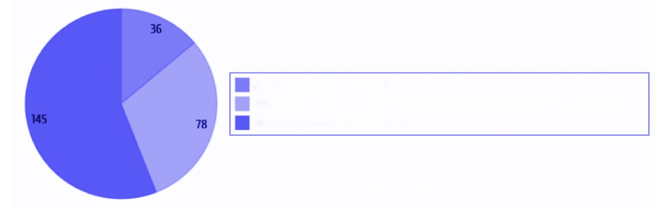

As of 01.01.2024, more than 40.8 thousand people lived in residential social care facilities of Ukraine, namely:

in children’s residential institutions – 4.1 thousand people (10.1% of the total number of people);

in residential institutions for the elderly and people with disabilities – 10.7 thousand people (26.2%);

in psychoneurological residential institutions – 26.0 thousand people (63.7%).

The number of people living in residential social care facilities

As of 01.01.2024, more than 40.8 thousand people

psychoneurological residential institutions 26,000

residential institutions for the elderly and persons with disabilities 10,700

children’s residential institutions 4100

Fig. 2 Allocation of clients by type of institution

About 9.4 thousand people live in the inpatient departments of territorial social service centers (provision of social services), centers for the provision of social services.

Information provided by the RMA on the provision/or non-provision of the social service of supported living in a residential social care facility

As a reply to a request submitted to the RMA regarding the introduction or absence of a social service of supported living in a facility, the number of social services of supported living providers



in the regions, information was provided by 404 facilities from 21 regions of Ukraine.

The following facilities responded:

260 – inpatient departments for permanent residence (single disabled citizens) of territorial social service centers (provision of social services);

37 – residential institution for persons with disabilities and the elderly (including geriatric homes);

84 – psychoneurological residential institution;

19 – children’s residential institution (including other centers providing social services to mothers and children);

4 – charitable organizations (non-state service providers).

Information on the number of clients receiving supported living services in residential social care facilities by region is provided in Annex 4.

**Provision/non-provision of social services of**

**supported living in a residential facility**

The following facilities responded

Residential departments for permanent residence

residential institutions for persons with disabilities and the elderly

psychoneurological residential institution

children’s residential institution

charitable organization

Fig. 3 Types of supported living services providers

Information about institutions of state, non-state, municipal ownership

Information on the introduction or absence of social services of supported living in residential social care facilities was provided by facilities of state, non-state, communal ownership (395 responses), in particular:

facilities of state ownership – 26 (6.6%);

facilities of non-state ownership – 4 (1%);

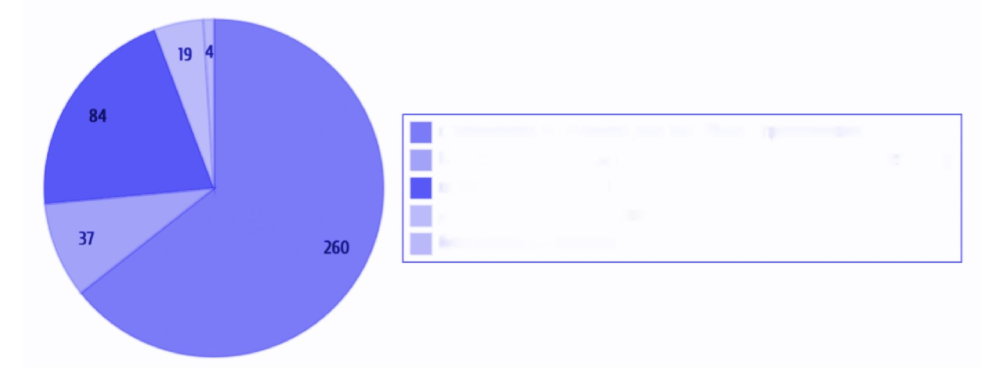

facilities of communal ownership – 365 (92.4%).

Facilities of state, non-state, communal ownership

395 responses were received

facilities of state ownership

facilities of non-state ownership,

facilities of communal ownership

Fig. 4 Distribution of facilities by form of ownership

Information on departments and rooms of supported living in facilities

According to Regulation on PNI clause 5, subclause 2, such type of institutions may provide services of supported living, palliative/hospice and day care, social adaptation, crisis and emergency intervention, and counselling. According to clause 32, the service of supported living is provided to residents with a high level of adaptation and autonomous activity with the possible subsequent establishment of group III disability and employment (with further free supervision regime).

Clause 5 of the Model Regulation on residential institutions for elderly citizens and persons with disabilities, approved by the resolution of the Cabinet of Ministers of Ukraine No. 772 dated September 2, 2020 (Regulation on Residential Institution), residential institutions are given the opportunity to implement social services in the form of supported living, day care, crisis and emergency intervention, temporary rest for persons caring for persons with disabilities, persons with incurable diseases requiring long-term treatment, and social rehabilitation.

Clauses 6 and 7 of the Standard Regulations on the Children’s Residential Institution, approved by the Resolution of the Cabinet of Ministers of Ukraine No. 978 dated December 14, 2016 (Regulation on the Children’s Residential Institution), provide for

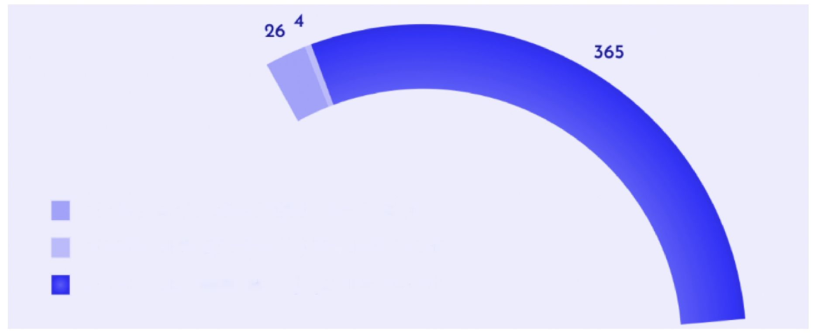

day care, palliative care, supported living, etc. in children’s residential institutions.

Residential social care facility reported (240 responses) that they have 29 departments of supported living (620 care recipients) and 7 rooms (148 care recipients) (excluding non-state service providers). Another 386 people receive the service of supported living under another form of organization of social service provision.

In residential social care facilities there are

* 29 departments of supported living – 620 people
* 7 rooms of supported living – 148 people
* another form of organization of social service provision – 386 people

Another form of organization of social service provision 386

Departments of supported living: 620

Rooms of supported living: 148

Fig. 5 Number of equipped departments/rooms of SL and number of people receiving the service of supported living in facilities

Number of recipients of the social service of supported living who could live independently in communities if provided with support

According to subparagraph 1 of paragraph 5 of the Model Regulations on Psychoneurological Institutions approved by the Resolution of the Cabinet of Ministers of Ukraine No. 957 dated December 14, 2016 (Regulation on PNI), one of the tasks of such type of institutions is to ensure the rights of care recipients to voluntary work. Monitoring visits of the national preventive mechanism indicate that care recipients are involved in performing unpaid work, the performance of which is the duty of the staff. Similar violations are detected by NPM monitors in other residential facilities. There are only



isolated cases of care recipients employment in institutions under civil law contracts. The majority of care recipients are involved in self-service and household work, which has nothing to do with measures aimed at social and labour rehabilitation, which could contribute to the acquisition of skills to live in the community independently or with support. Care recipients lose social and household skills, become helpless, and get used to a paternalism-based system.

Institutions reported that as of the day of the survey, 20,508 people were in these institutions (390 institutions). 1,154 people received supported living services, while, according to the institution staff, 1,490 people can receive such services outside the institution.

**supported living service in facilities**

Total care recipients

Service can be received

Service was received

Fig. 6 Number of people who receive and could receive supported living services

This means that in presence of appropriate conditions, 1,490 people can leave institutions and return to their communities, provided with support.

It is worth noting that not all residential establishments understand the differences between inpatient care and supported living services, which requires educational work by regional military administrations.

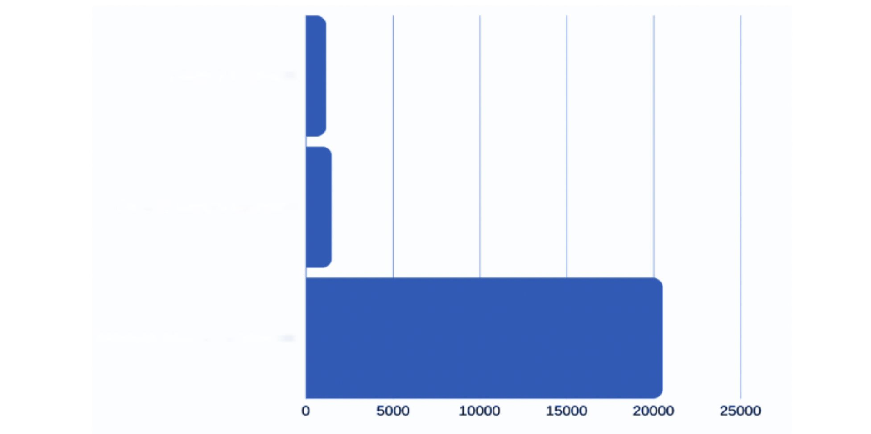

**Information on the number of people employed in institutions and persons whose health allows for work if the necessary conditions were created**

According to information from residential facilities (374 responses), 76 residents of residential social care facilities have been employed. At the same time, under condition of necessary conditions, according to the managers, another 272 people could work.

Information from residential facilities - 374 responses

Employed

Cold be employed

76 persons

272 persons

Fig. 7 Number of employed recipients of supported living services

Number of people in facilities who exercise the right to education

According to the information provided (366 responses), 19 people in 6 residential facilities are receiving education.

Right to education

366 responses were received from residential facilities

Are studying

Could study

19 people from 6 institutions

153 people can study under appropriate conditions



Fig. 8 Number of recipients of supported living services who are studying

The above answers were obtained from:

* Regional municipal institution of the Sumy regional council “Social
* dormitory for orphans and children deprived of parental care” – 6 persons;
* CE “Popasna regional psychoneurological residential institution” – 2 persons;
* Recreation center “Bereh nadii”, Khmelnytskyi region – 9 persons;
* Municipal Institution “Geriatric House of Mercy of St. Panteleimon the Healer” – 1 person;
* Charity Fund “Caritas Stryi Eparchy UGCC” – 1 person.

According to the information provided, 153 care recipients can exercise their right to education under appropriate conditions.

Information on the created conditions in residential social care facility for the development of supported living

The answer on the presence or absence of conditions for the provision of social services of supported living was provided by 339 facilities.

According to the analysis of the answers:

conditions are available: in 53 facilities (15.6%);

conditions are absent: in 286 facilities (84.4%).

Conditions for the development of supported living have been created

339 responses were received from residential facilities

Conditions are available

Conditions are absent

53 institutions

286 institutions

Fig. 9 Availability of conditions for supported living in facilities

**Main factors that are obstacles to the development of supported living**



According to the heads of residential social care facilities, the main factors that are an obstacle to the development of supported living in Ukraine are ranked (264 responses):

1. Lack of free premises, the need for repairs, lack of own premises: 48 (18.2%);
2. Lack of care recipients' need for supported living services, lack of persons in need of supported living: 36 (13.6%);
3. Lack of funding, dependence on the founder or donor: 27 (10.2%);
4. Lack of conditions for the provision of such services in accordance with the state standard of supported living, lack of proper material and technical base: 20 (7.6%);
5. Age and health status of care recipients, which prevents them from receiving the service: 14 (5.3%);
6. Lack of trained personnel, regulatory uncertainty, insufficient number of personnel: 14 (5.3%);
7. Lack of social housing for further residence of persons with disabilities after their training and integration into communities: 2 (0.8%);
8. Military actions, constant shelling, proximity of facility to the combat zone: 2 (0.8%);
9. Lack of support in the community and strategic vision: 1 (0.4%).

Information on social services of supported living providers available in the Register of Providers and Recipients of Social Services

In accordance with Part 11 of Article 15 of the Law, to ensure accounting of social services providers, recipients and the services provided to them, the Ministry of Social Policy of Ukraine has created the Register of Social Services Providers and Recipients (hereinafter referred to as the “Register”).

As of 06.06.2024, Register contains 255 social service providers providing social services of supported living, of which 103 are municipally owned institutions, 152 are non-state social service providers.

In Ukraine, social services for the elderly are provided by social service centers, structural units for the provision of social services of the executive body of the united territorial community and their departments and divisions, territorial social service centers (provision of social services), specialized departments (departments of home palliative care and departments of home social assistance for persons with mental disorders) based on the State Standards of Social Services.

Information on the number of employees providing support to care recipients receiving social services of supported living

In 61 institutions, assistance to clients is provided by social workers, in 11 by psychologists.

Workers who provide support to social services of supported living recipients

61 institutions

11 institutions

social workers

psychologists

Fig. 10 Distribution of specialists providing supported living services in institutions

**Information on the number of patients in healthcare institutions providing psychiatric care who have lost social ties, but can live in communities under special conditions**

The lack of a comprehensive system of social services of supported living in communities affects healthcare institutions providing psychiatric care. According to the Ministry of Health of Ukraine, there are patients in the aforementioned institutions who are receiving treatment for a period, exceeding the period required for treatment.

At the same time, hospitals provide medical care and residential living services to persons who have lost social ties, in particular, internally displaced persons, persons with disabilities and the elderly. Such a service is not funded by the state and does not ensure compliance with the human right to the highest attainable level of health care and the quality of medical services.

As of 01.06.2024, 17,142 patients were in healthcare institutions providing psychiatric care. Of them:

IDPs – 1004;



have lost social ties and require transfer to residential social care facilities of the Ministry of Social Policy of Ukraine (lack of housing, relatives, documents, etc.) – 865;

have lost social ties, but due to their mental and physical health are capable of autonomous life in conditions of supported living in communities – 250.

Information on the number of healthcare institutions providing psychiatric care and the number of their patients having lost social ties is given in Annex 5.

IDPs

Lost social ties and require transfer to residential social care facility of the Ministry of Health of Ukraine

17,142 patients

were in psychiatric care institutions as of 01.06.2024

Capable of autonomous life in conditions of supported living in communities

Fig. 11 Number of patients undergoing treatment in healthcare institutions providing psychiatric care and having lost social ties

Provision of social services in territorial communities

supported living (assisted living – SL), home care (HC), day care (DC) services are provided in territorial communities at the place of residence of citizens. Provision of day care and home care services reduces the risk of people being admitted to residential facilities and provides them opportunity to remain in communities.

. According to information of regional military administrations, as of 24.06.2024, 300,870 residents of territorial communities of 24 regions received the above services:

* social service of supported living – 556 persons (0.2%);
* social day care service – 32,190 persons (10.7%);
* social home care service – 268,124 persons (89.1%).

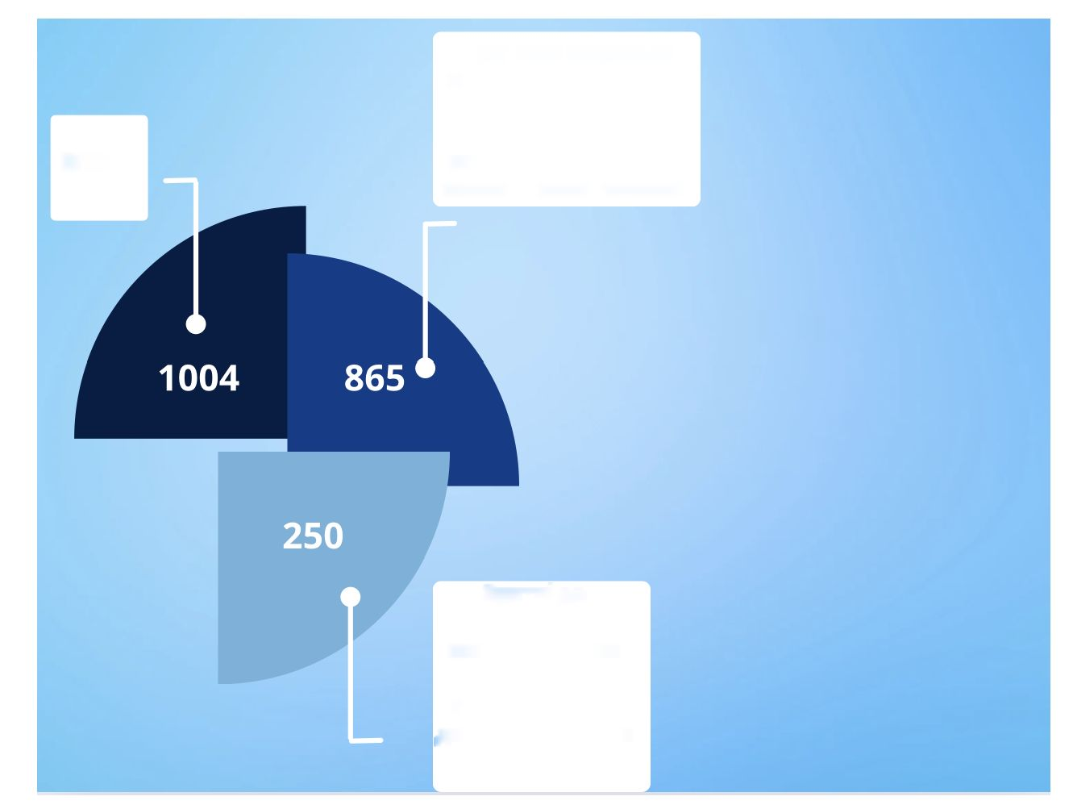

social day care service

300,870

residents of territorial communities of 24 regions

as of 24.06.2024 received services

social service of supported living

social home care service

Fig. 12. Number of residents of territorial communities receiving social services

Generalized information on the number of recipients of social services of home care, supported living, day care and the number of workers providing support is given in Table 2.

|  |  |  |  |  |
| --- | --- | --- | --- | --- |
| **List of social services** | **Number of social services recipients** | **Number of social services employees** | | |
| **Social worker** | **Psychologist** | **Junior healthcare workers** |
| Home care | 268,124 | 17,521.75 | 273.5 | 73.5 |
| Supported living | 556 | 63 | 11 | 27.5 |
| Day care | 32,190 | 190 | 54 | 391 |

*Table 2*

Number of recipients of social services of home care, supported living, day care and the number of workers providing support

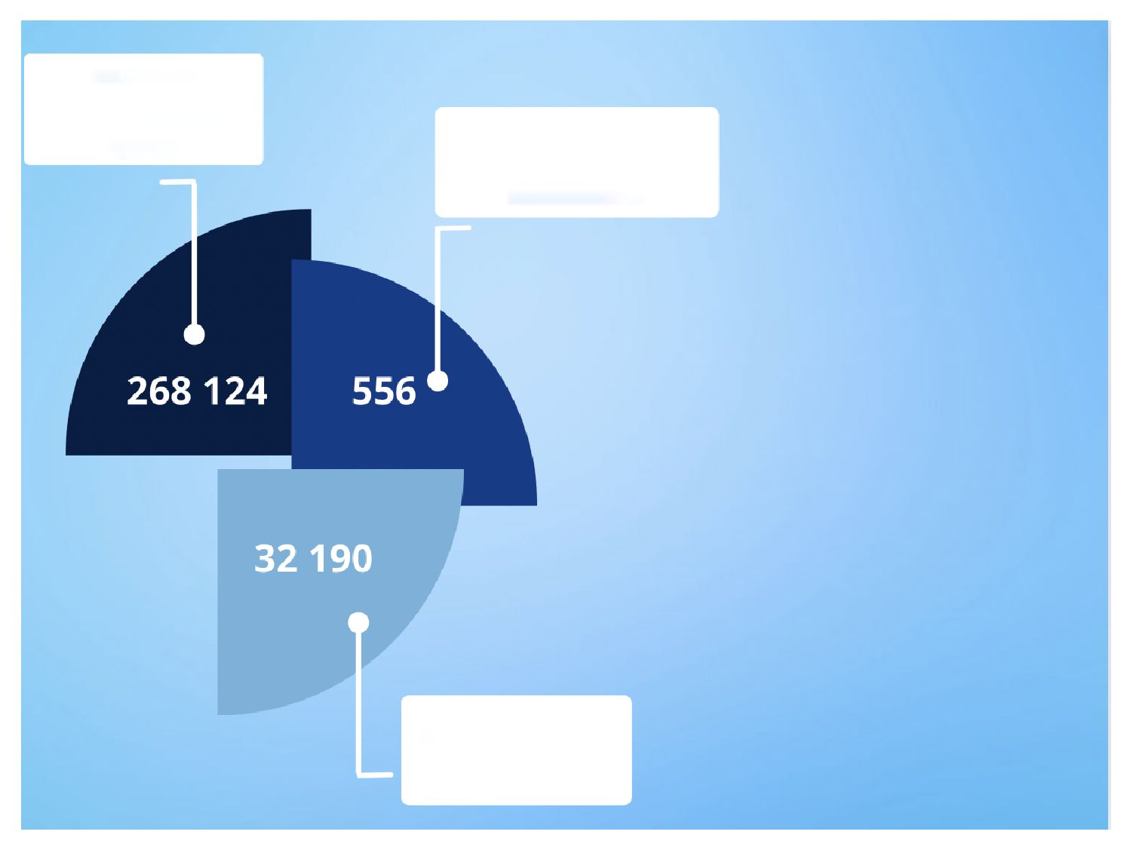

|  |  |  |  |  |
| --- | --- | --- | --- | --- |
| **Total** | **300,870** | **17,774.75** | **338.5** | **492** |
| **18,605.25** | | |

The number of employees providing social services of supported living, home care, day care (SL, HC, DC) is over 18,000 specialists, including social

workers/employees, psychologists, healthcare workers:

social workers/employees – 17,775;

psychologist – 339;

healthcare workers – 492.

On average, one employee works with the following number of service recipients: social worker: 523 social services recipients;

psychologist: 889 social services recipients;

junior healthcare worker: 612 social services recipients.

Number of employees – social services providers per client in communities

Social worker

Junior healthcare worker

Psychologist

Fig. 13 Generalized information on the average number of personnel per client in communities (social worker/employee, junior healthcare worker, psychologist)

**Social service of supported living (SL)**

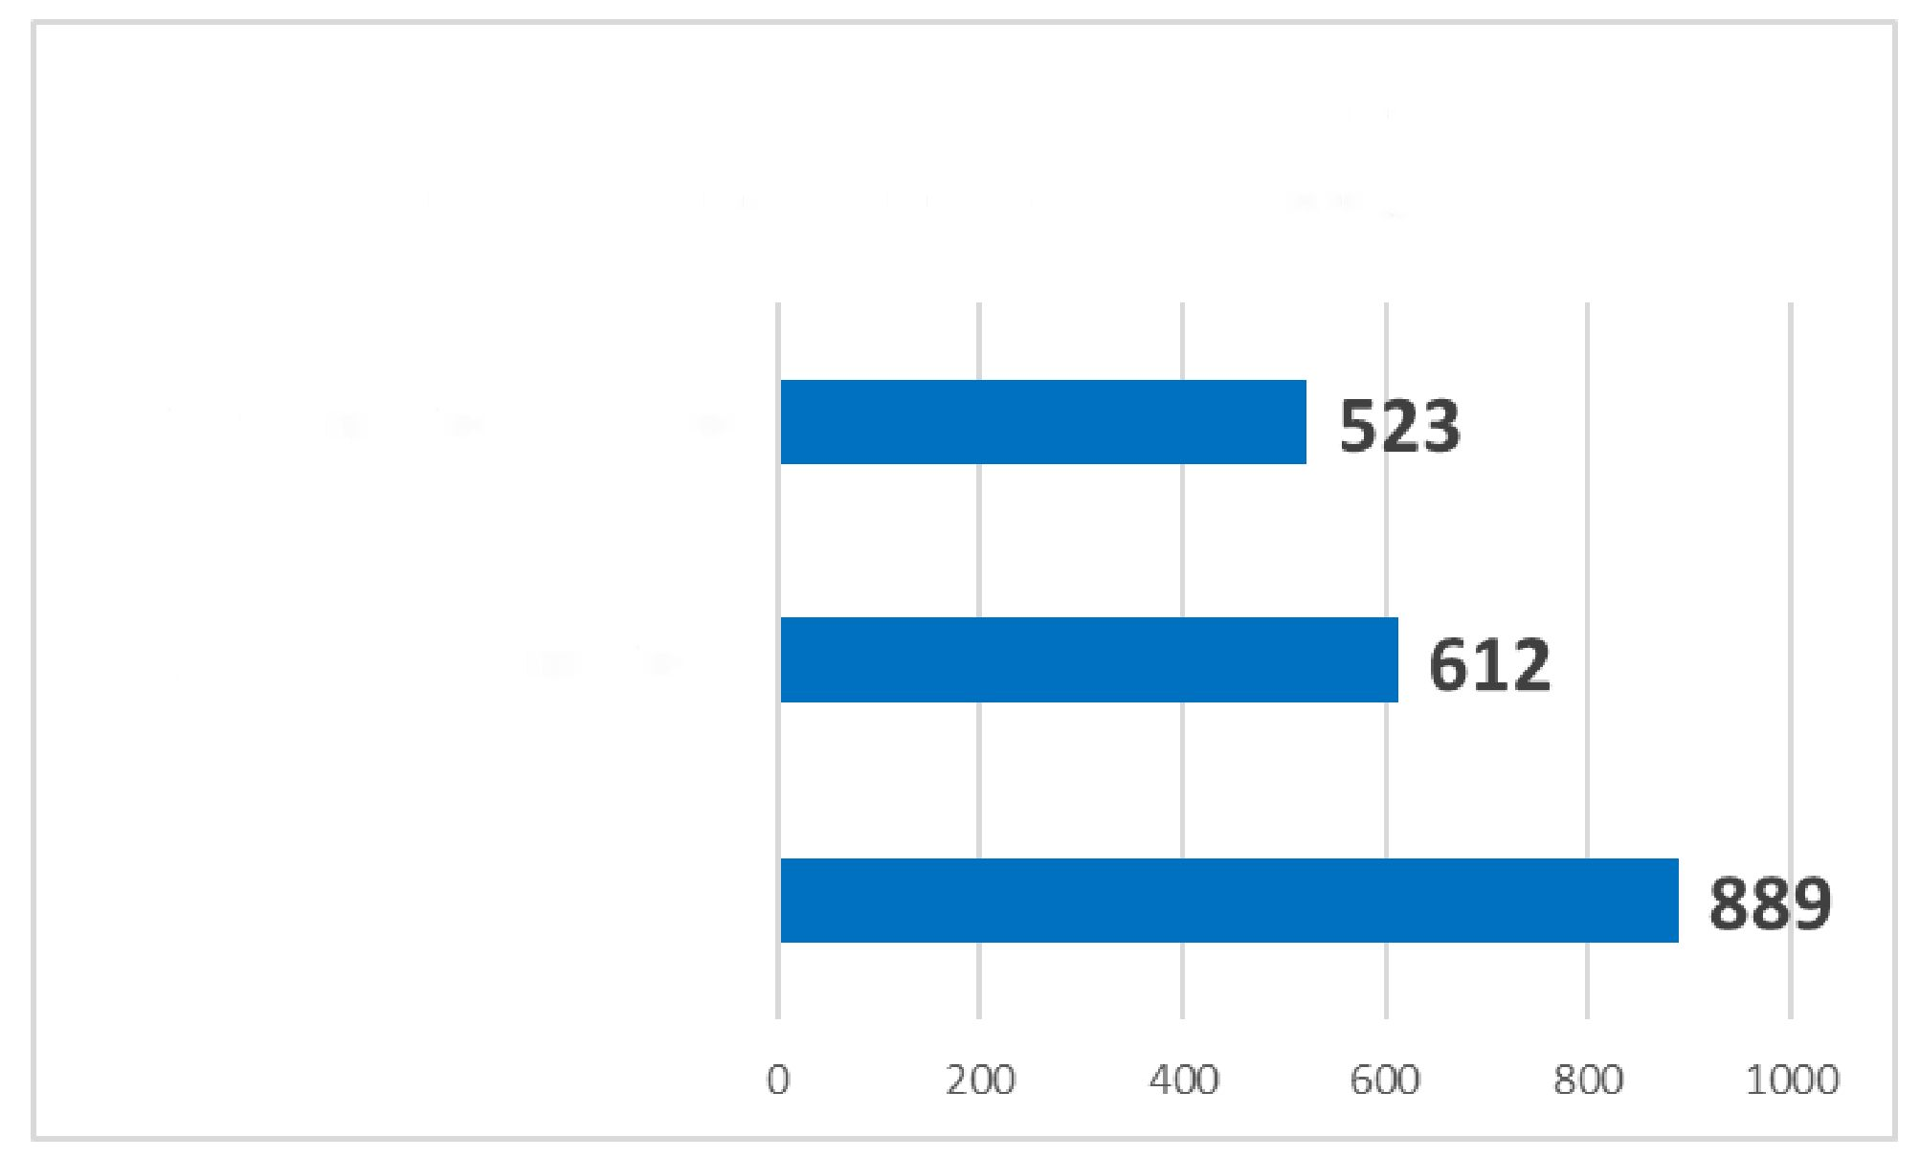

The social service “Supported living” (SL) is provided for 556 people in communities, which is 0.2% of the total number of social services of supported living, home care, day care recipients.

The social service is provided by 63 social workers/employees; 11 psychologists; 27.5 full-time junior healthcare workers.

The largest number of recipients of SL is in Khmelnytskyi (125), Kyiv (88), Kharkiv (71), Odesa (63), Dnipropetrovsk (54), and Zhytomyr (54) regions. Social service is provided in 12 out of 24 regions.

On average, one employee works with the following number of social supported living service recipients:

social worker: one per 8.8 service recipients;

psychologist: one per 50.5 service recipients;

junior healthcare worker: one per 20.2 service recipients.

Number of staff per client in communities providing Supported Living services

Social worker

Junior healthcare worker

Psychologist

Fig. 14 Generalized information on the average number of personnel per client in communities, providing supported living service

There is no information on the provision of the SL service in communities of Volyn, Donetsk, Zakarpattia, Zaporizhzhia, Poltava, Sumy, Luhansk, Rivne, Kherson, Cherkasy, Chernihiv, Chernivtsi regions.

The largest number of social workers involved in the provision of Supported Living services is in Kharkiv (28) and Kyiv regions (10). Of the above categories, healthcare workers are

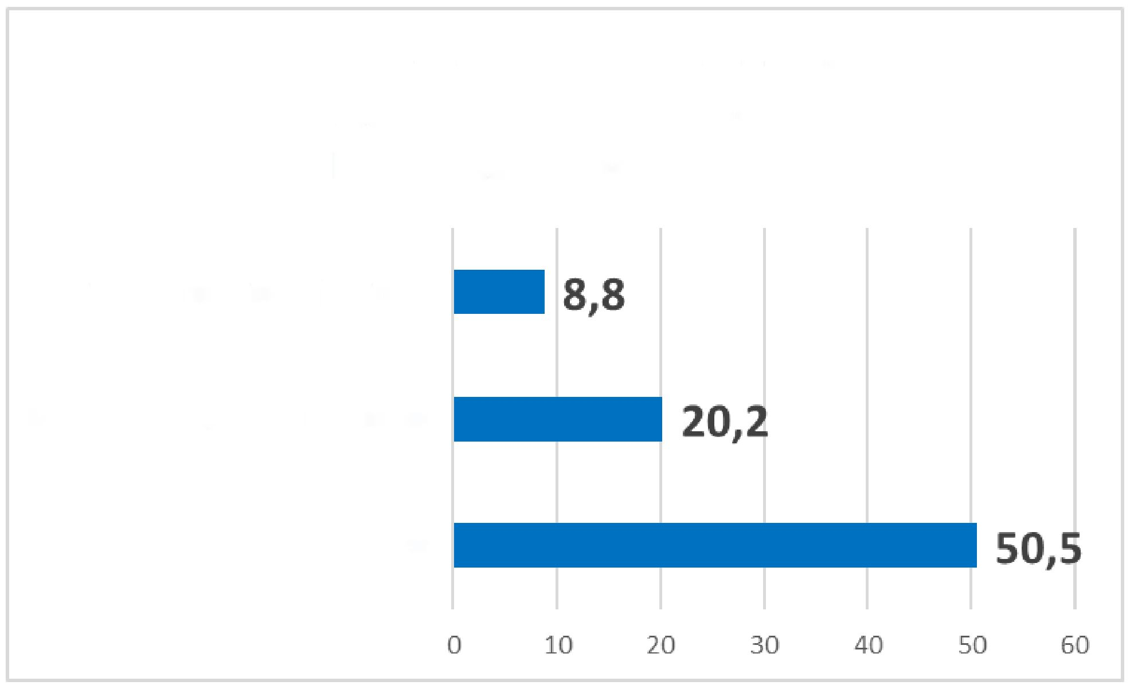

least involved: in only 3 regions out of ten: Odesa (9); Zhytomyr (8); Luhansk (3). Psychologists are involved in 50% of communities.

Information on the number of recipients and employees providing social service of supported living, by regions is provided in Annex 6.

The social service of supported living in communities is focused on people with disabilities, mental disorders or elderly who cannot live independently at home. The number of such people may be smaller compared to those who need home care or day care. The organization of SL services requires significant resources, including:

* arrangement or rental of residential premises;
* ensuring constant medical support;
* providing social support;
* significant costs for staff remuneration;
* maintaining facilities.

The regions lack premises (housing facilities) accessible for the provision of supported living services, which requires time and investment in infrastructure development.

Information of regional military administrations of Ukraine on the number of social services (supported living, home care, day care) recipients and employees by region is summarized in Table 1.

*Table 1*

**Information on the number of recipients social services and employees providing social services, by regions**

|  |  |  |  |  |  |  |  |  |  |  |  |  |
| --- | --- | --- | --- | --- | --- | --- | --- | --- | --- | --- | --- | --- |
| **List of social services** | | | | | | | | | | | | |
| **Region** | **Home care** | | | | **Supported living** | | | | **Day care** | | | |
| number of social services recipients | number of social services employees | | | number of social services recipients | number of social services employees | | | number of social services recipients | number of social services employees | | |
| social worker | psychologist | junior healthcare workers | social worker | psychologist | Junior healthcare workers | social worker | psychologist | junior healthcare workers |
| **Vinnytsia** | 15,329 | 7 | 12.5 | 0 | 10 | 0 | 0 | 0 | 83 | 2 | 1 | 4 |

|  |  |  |  |  |  |  |  |  |  |  |  |  |
| --- | --- | --- | --- | --- | --- | --- | --- | --- | --- | --- | --- | --- |
| **Volyn** | 8555 | 664 | 3 | 0 | 0 | 0 | 0 | 0 | 0 | 0 | 0 | 0 |
| **Dnipropetrovsk** | 32,803 | 2140 | 15 | 8 | 54 | 4 | 2 | 0 | 4450 | 43 | 8 | 11 |
| **Donetsk** | 4857 | 366 | 4 | 0 | 0 | 0 | 0 | 0 | 0 | 0 | 0 | 0 |
| **Zhytomyr** | 16,372 | 1132 | 9 | 7 | 54 | 1 | 0 | 8 | 713 | 0 | 2 | 1 |
| **Zakarpattia** | 3132 | 178 | 4 | 5 | 0 | 0 | 0 | 0 | 294 | 6 | 1 | 1 |
| **Zaporizhzhia** | 1414 | 124 | 0 | 0 | 0 | 0 | 0 | 0 | 132 | 0 | 0 | 2 |
| **Ivano-Frankivsk** | 4822 | 477 | 4 | 2 | 3 | 3 | 0 | 0 | 269 | 19 | 4 | 4 |
| **Kyiv** | 12,038 | 994.5 | 9 | 19 | 88 | 10 | 3 | 0 | 1070 | 17 | 7.5 | 9 |
| **Kirovohrad** | 11,025 | 820 | 5 | 6 | 12 | 1 | 0 | 0 | 397 | 1 | 0 | 1 |
| **Luhansk** | 0 | 0 | 0 | 0 | 4 | 1 | 1 | 3 | 0 | 0 | 0 | 0 |
| **Lviv** | 10,939 | 1092.75 | 5 | 6 | 0 | 0 | 0 | 0 | 288 | 29 | 0 | 0 |
| **Mykolaiv** | 5495 | 645 | 111 | 0 | 38 | 1 | 0 | 0 | 1034 | 5 | 3.5 | 9 |
| **Odesa** | 13,444 | 878 | 10 | 5 | 63 | 4 | 1 | 9 | 37 | 1 | 1 | 5 |
| **Poltava** | 19,481 | 1861.5 | 1 | 0 | 0 | 0 | 0 | 0 | 15,351 | 32 | 8 | 24.5 |
| **Rivne** | 7248 | 709 | 0 | 0 | 34 | 1 | 1 | 0 | 0 | 0 | 0 | 0 |
| **Sumy** | 13,301 | 48 | 16 | 1 | 0 | 0 | 0 | 0 | 754 | 4 | 2 | 3 |
| **Ternopil** | 8899 | 959.5 | 8 | 0 | 0 | 0 | 0 | 0 | 1298 | 3 | 2 | 1 |
| **Kharkiv** | 22,515 | 1664 | 15 | 0 | 71 | 28 | 0 | 0 | 34 | 2 | 1 | 0 |
| **Kherson** | 1483 | 294 | 1 | 0 | 0 | 0 | 0 | 0 | 0 | 0 | 0 | 0 |
| **Khmelnytskyi** | 15,393 | 525 | 10 | 9.5 | 125 | 9 | 3 | 7.5 | 3351 | 10 | 9 | 303.5 |
| **Cherkasy** | 18,251 | 40 | 25 | 0 | 0 | 0 | 0 | 0 | 350 | 4 | 0 | 0 |
| **Chernivtsi** | 3585 | 281.5 | 2 | 4 | 0 | 0 | 0 | 0 | 103 | 4 | 1 | 6 |
| **Chernihiv** | 17,743 | 1621 | 4 | 1 | 0 | 0 | 0 | 0 | 2182 | 8 | 3 | 6 |
| **Total** | **268,124** | **17,521.75** | **273.5** | **73.5** | **556** | **63** | **11** | **27.5** | **32,190** | **190** | **54** | **391** |
| **Total number of social services recipients** | | | | | **300,870** | | | | | | | |
| **Total number of social services providers** | | | | | **18,605.25** | | | | | | | |
| **Total number of social workers/employees** | | | | | **17,774.75** | | | | | | | |
| **Total number of psychologists** | | | | | **338.5** | | | | | | | |
| **Total number of junior healthcare workers** | | | | | **492** | | | | | | | |

The **social “home care” service (HC)** is the most popular social service in communities. Received by 268,124 persons. In communities 17,521.75 social workers, 273.5 psychologists and 73.5 junior healthcare workers are involved.

Generalized information on

On average: social worker: one per 15.3 service recipients; psychologist: one per 980 recipients;

junior healthcare worker: one per 3647.9 recipients.

Social worker

Psychologist

Junior healthcare worker

Number of staff per client for providing the Home Care service

Fig. 15 Generalized information on the average number of staff per client in communities providing home care

Most service recipients live in Dnipropetrovsk (32,803), Poltava (19,481) and Kharkiv (22,515) regions. The least – in Zaporizhzhia (1,414), Kherson (1,483) and Zakarpattia (3,132). In Zaporizhzhia and Kherson regions, it is explained by the evacuation of the population due to proximity to the combat zone and disruption of transport routes, the destruction of medical and social institutions, which complicates the provision of services in these regions.

For example, in Nikopol, employees of the territorial center visit people with disabilities and the elderly, despite the daily shelling of the coastline on bicycles.

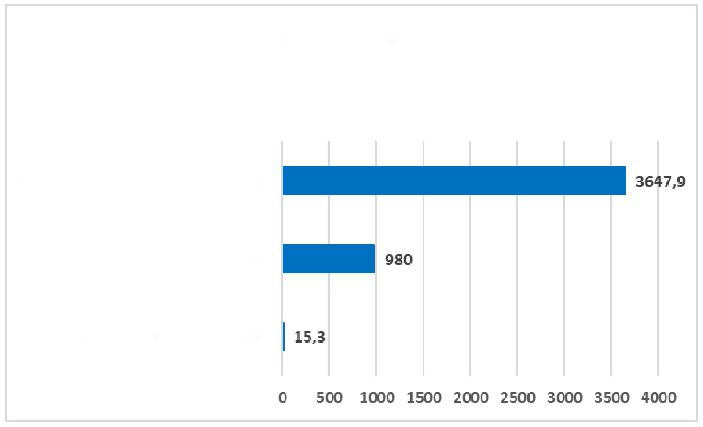

The need for care and psychological support of the population is growing, but in both regions the number of psychologists to provide psychological assistance is insufficient. Social workers who provide assistance at home put their lives and health at risk by performing care.

Information on the number of recipients and employees providing social home care services, by regions is provided in Annex 7.

**Day care (DC).** The social service is provided to 32,190 persons. The Day Care service is provided by 190 social workers/employees, 54 psychologists, and 391 junior healthcare workers.

On average:

social worker: one per 169.4 social service recipients;

psychologist: one per 596.1 social service recipients;

junior healthcare worker: one per 82.1 social service recipients.

Social worker

Psychologist

Junior healthcare worker

Number of staff providing Day care service per client

Fig. 16 Generalized information on the average number of staff per client in communities providing home care

The total number of day care services recipients is 10.9% of the total number of all service recipients.

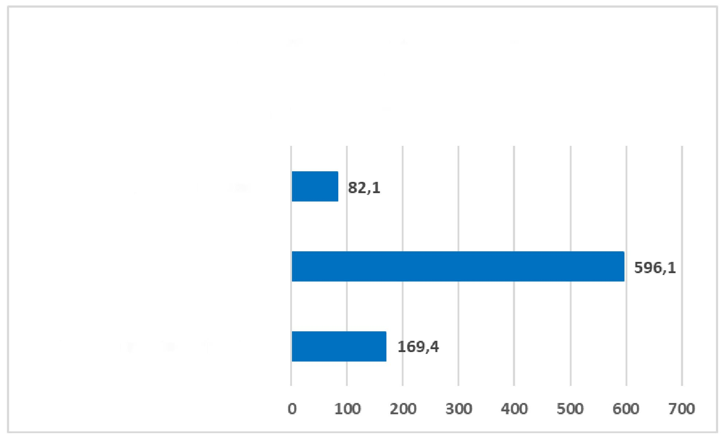

There is no information on the provision of the service in communities of Volyn, Donetsk, Luhansk, Rivne, Kherson regions.

In Dnipropetrovsk region, 43 social workers are involved in providing social services, in Poltava – 32, in Lviv – 29, which is ahead of other regions in terms of the number of personnel.

In Zhytomyr and Zaporizhzhia regions, there are no social workers providing DC service, and there is no data on the support of clients by junior healthcare workers for Lviv and Kharkiv regions.

Poltava region leads in the number of junior healthcare workers (24.5) and psychologists (8). In Khmelnytskyi region, the number of junior healthcare workers is noticeably higher (303.5), which may be the result of the specific organization of services.

Information on the number of recipients and employees providing social day care service, by regions is provided in Annex 8.

INTERNATIONAL PRACTICES OF INDEPENDENT LIVING

supported living programs, which provide different levels of assistance to people with disabilities to live independently, vary considerably across countries.

United States of America

In the United States, assisted living programs often focus on separating housing and support services, providing individualized and flexible support, and encouraging personal choice. Key elements are case management, individualized funding, and person-centered planning. Funding for supported living programs in the United States can come from different levels of government: federal, state, and local. Here are some of the main sources of funding and ways to access these programs:

**Federal funding:** Many programs, such as Section 8 Housing Choice Voucher program or programs for the homeless, receive funding from the U. S. government through the Department of Housing and Urban Development (HUD) or other agencies.

**State funding:** Some states provide additional funds for local supported living programs or coordinate joint programs with the federal government providing housing and services.

**Local funding:** Local governments (city councils, counties) may also allocate funds for housing support programs for local residents.

The U. S. pension system model is based primarily on individual pension insurance. In the U.S.A, there are public and private pension programs that operate on the principle of funded systems. They play a social and investment role. supported living can also be financed by citizens through the funded pension system.

There are special programs for elderly in the U.S.A covering a wide range of services and resources aimed at supporting senior citizens with housing, medical care, social activity, and other needs:

1. **Home Care Assistance:** This service includes support with daily household chores, especially when the elderly needs help with personal hygiene, cooking, cleaning, etc. Programs may also provide palliative or nursing care.
2. **Residential programs for the elderly:** These may include the provision of specialized living arrangements for the elderly, such as retirement homes, senior apartments, or specialized boarding houses, which provide support and security.
3. **Medical care and social services:** These may include access to medical facilities, health promotion programs, counselling, and rehabilitation. Social services may include information support, psychosocial care, and the organization of active activities to support the social life of the elderly.
4. **Social activity programs:** These include senior clubs, organized trips, cultural events, physical and other activities aimed at supporting an active and satisfying social life.

These programs can be funded in a variety of ways:

Federal funding: Programs for the elderly often receive grants or funding from federal agencies, such as the [Administration on Aging](https://acl.gov/about-acl/administration-aging)28 or through the [Medicare](https://acl.gov/programs/connecting-people-services/medicare-improvements-patients-and) and Medicaid medical assistance programs.

Since private health insurance did not solve the issues of affordability of treatment for wealthy groups of the U.S. population, the government increased its participation in financing the health care system.

28

<https://isaacscenter.org/senior-services/?gad_source=1&gclid=CjwKCAjwk8e1BhALEiwAc8MHiP9gGdeA87C-5wBYv> oBqu97pWEfwt39miDARefxDr6FiZBfhe2Fm6xoCmfEQAvD_BwE

Medicare was created to work with citizens of retirement age who want to solve a health issue. The program exists entirely on funds deducted from corporate income taxes, progressive income taxes and payroll taxes. Due to the existence of such a system, hospitals receive part of their income, for example, up to half of the budget of these institutions comes from Medicare.

The Medicare program is used for preventive services, inpatient treatment, calling a health care worker home for therapeutic procedures. The program provides the opportunity to undergo a diagnostic examination or temporarily stay in a nursing home.

**Local funding**: States and local governments may also allocate funds for programs for seniors, especially for local initiatives and housing projects.

Accessing Programs

Accessing programs for seniors often requires contacting local social service organizations directly, such as local offices on aging, senior centers, or non-profit organizations working with seniors. Eligibility often requires meeting certain criteria, which may include age, financial circumstances, or medical needs.

These programs aim to improve the quality of life for elderly by providing the services and resources they need to support independent and comfortable living.

Administration on Aging (AOA)29

The Administration on Aging (AOA) is the lead agency of the U.S. Department of Health and Human Services designated to implement the provisions of the [Older Americans Act](https://acl.gov/node/650) of 1965 (OAA), as amended (42 U.S.C.A.). § 3001 et seq.). OAA promotes the well-being of elderly by providing services and programs designed to help them live independently in their homes and communities. The law also authorizes the federal government to allocate funds to states to provide support services to people over 60.

1. [https:/ /www.ohiolegalhelp.org/uk/resource/terytorialni-ahentstva-z-pytan-starinnya-okruhu-5-ohayo-aaa-5](https://www.ohiolegalhelp.org/uk/resource/terytorialni-ahentstva-z-pytan-starinnya-okruhu-5-ohayo-aaa-5)
2. In-Home Services: include assistance with personal hygiene, meal preparation, shopping, cleaning, transportation, and other daily tasks that help elderly live independently in their own home or apartment.
3. Social Services: provide counselling and support for elderly and their families to ensure social well-being and support in difficult life situations.
4. Health Services: include access to health services, health care, medical care, rehabilitation services, and other medical procedures.
5. Active Aging Programs: may include physical activities, cultural events, art exhibitions, excursions, clubs, and other activities aimed at maintaining the active lives of elderly and supporting their social lives.
6. Housing Services: include supported living programs that provide housing conditions that meet the needs of elderly, including retirement homes, senior apartments, specialized boarding houses, and other options.
7. Legal Assistance: includes legal advice, document preparation, advocacy, and other legal services.

[Medicare](https://acl.gov/programs/connecting-people-services/medicare-improvements-patients-and)

The Medicare Improvement for Patients and Providers Act (MIPPA) program helps Medicare beneficiaries with limited income and assets learn about programs that can save them money on Medicare costs. Through MIPPA, ACL provides grants to states.

ACL administers MIPPA grants to grantees in three ACL programs: [State Health Insurance Assistance Programs (SHIP)](https://acl.gov/programs/connecting-people-services/state-health-insurance-assistance-program-ship),30 [Area](https://acl.gov/programs/aging-and-disability-networks/area-agencies-aging) [Agencies on Aging](https://acl.gov/programs/aging-and-disability-networks/area-agencies-aging) (AAA), and [Aging and Disability Resource Centers](https://acl.gov/programs/aging-and-disability-networks/aging-and-disability-resource-centers)/[No Wrong Door Systems](https://acl.gov/programs/aging-and-disability-networks/aging-and-disability-resource-centers) (ADRC/NWD).31 Grantees inform Medicare beneficiaries about available programs that can help them save money on health care costs.

All of these services are provided through specialized programs, local non-profit organizations, government agencies, and other social services to facilitate supported living arrangements.

Examples of Services:

Florida

1. <https://www.ncoa.org/article/mippa>
2. <https://www.ta-community.com/category/nwd-adrc-grantee-created-resources>

In the state of Florida, supported living programs include a wide range of services designed to support independent living for individuals with disabilities. Key components of such programs include:

Individual planning: each participant has a personal plan designed based on their needs and wishes. This includes a situational assessment and an individual comprehensive assessment [(APD Agency](https://apd.myflorida.com/customers/supported-living/living-guide/index.htm))32.

Funding and coordination: Funding is provided through the Agency for Persons with Disabilities (APD) or through private payment. Key services include financial management assistance, self-advocacy support and access to other services ([The Arc Gateway](https://arc-gateway.org/our-programs/supported-living/))33 ([APD Agency](https://apd.myflorida.com/customers/supported-living/living-guide/index.htm)), such as placement to institution for people with developmental disabilities, supported employment, residential support, individual and family support.

Under this program, coaches provide training and support to adults with developmental disabilities who live in their own homes or apartments. The coaching staff helps with household chores, meal preparation, shopping and personal financial management, as well as teaching social and adaptive skills necessary for independent living. Coaching services are adjusted to each individual’s unique needs.

[Group homes](https://arc-gateway.org/our-programs/group-homes)

Licensed group homes provide supportive relationships, supervision, and encouragement that help people become independent and involved in the community.

[Supported Living](https://arc-gateway.org/our-programs/supported-living)

The coaching staff helps with household chores, meal preparation, shopping, personal financial management and teaching social and adaptive skills necessary for independent living.

1. <https://disabilityrightsflorida.org/disability-topics/disability_topic_info/agency_for_persons_with_disabilities>
2. <https://arc-gateway.org/our-programs/supported-living/>

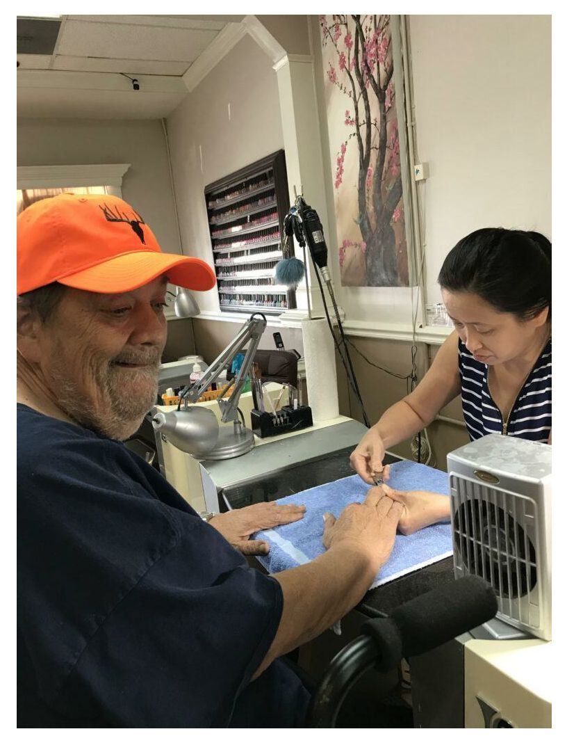

Photo from open sources 34

Oregon

The Oregon Supported Living Program (OSLP) supports adults living independently by providing assistance with various aspects of life. Examples of services include:

Money management: Assistance in budgeting and financial management. Self-Advocacy Support: Training and support in advocating for rights and needs.

Social integration: Assistance in establishing and maintaining social contacts, participation in community activities thanks to the [Oregon Supported Living Program](https://www.oslp.org/supported-living-program.html). The program provides support for 24 adults35.

1. <https://arc-gateway.org/our-programs/supported-living/>
2. <https://www.oslp.org/supported-living-program.html>

[Massachusetts Bay Cove Human Services](https://diversityjobs.com/employer/company/941/Bay-Cove-Human-Services?creative=&keyword=&matchtype=&network=x&device=c&gad_source=1&gclid=Cj0KCQjwvb-zBhCmARIsAAfUI2uX5dnT_VE1cER8uTLfX5ieJ2rJCRlhknnBgUVns9KPnwf9GiP7_GsaAm77EALw_wcB)36 in Massachusetts provides support for people with intellectual/developmental disabilities living independently or with families. Examples of services include assistance with housing and maintenance, budget management, leadership training, advocacy for quality health care, and psychiatric treatment.

Housing Services

Bay Cove operates dozens of community housing programs throughout Greater Boston and Southeastern Massachusetts for people with intellectual/developmental disabilities. Dedicated residential teams provide highly individualized, 24/7 support to those living in Bay Cove homes, with a strong emphasis on community integration and the development of independent living skills.

People living in Bay Cove homes can expect a safe and comfortable environment where all residents participate in creating the culture of each residence through discussions, actions, practices, and procedures. Each person is encouraged to be as involved as they wish in decorating, menu and daily planning. Bay Cove has vast experience of successful support of people with complex disabilities, with significant health care needs, and with behavioural and/or psychiatric, medical, and physical disabilities. There is also a number of requirements for people to be able to receive these services:

* be 22 years of age or older
* meet requirements of the Department of Developmental Services (DDS)
* require rental subsidies (if applicable).

Day Care

Day care programs include educational, health and nutrition classes, cooking groups, and exercise programs ([Bay](https://www.baycovehumanservices.org/developmental-services) [Cove Human Services](https://www.baycovehumanservices.org/developmental-services)) that work with individuals with intellectual and physical developmental disabilities and their families, offering support promoting independence, health maintenance, and full participation of each individual in all aspects of life.

Support includes a wide range of housing, educational, social connections, and employment options. The ultimate goal is to help each person make independent choices that result in houses that are homes, jobs becoming careers, and days and lives full of meaning.

Examples of services include, but are not limited to:

36<http://surl.li/ngwpam>

* case management
* safe and enriching environment
* health and wellness promotion and management
* day services
* home, personal, behavioural, employment, recreational and social skills development and management
* individual planning and goal setting
* budget and medication oversight assistance
* medical case management
* health and psychiatric care coordination with individualized education and planning
* 24-hour consultation with medical staff
* supportive and educational counselling
* 24-hour emergency support
* subsidy management
* day stay
* transportation
* community integration and education
* employment and support
* speech, occupational and physical therapy.

Day Habilitation Program

The Day Habilitation Program (South End) is designed to provide rehabilitation services for people with developmental disabilities and aims to provide nursing support with personal hygiene throughout the day, develop communication skills and support sensory integration.

Support is provided in the following areas: independent living, social development, sensorimotor development, behavioural development, self-management and communication. The program also offers opportunities to participate in physical activities, arts and community involvement.

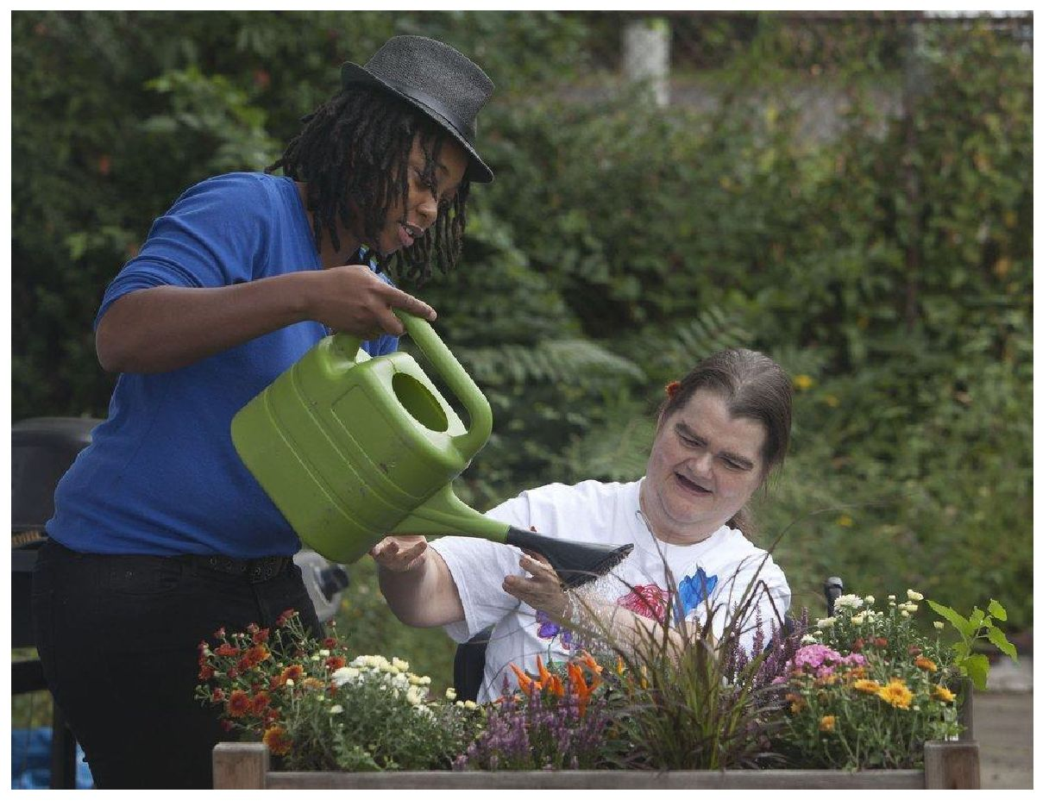

Employment Programs

Employment is a key focus of Bay Cove’s range of day services. Center House Enterprises (South End) and City Square Employment Supports (Charlestown) are employment preparation programs designed to help people with intellectual and mental disorders develop skills for successful community integration and employment.

Programs provide social skills development, job training, practical work experience in community, and employment support. The Supported Employment Program (South End) takes things to the next level by assisting clients with resume development, interview skills training, and after employment of a participant – offering one-on-one on-the-job coaching and employer liaison services.

Community Day Care

Community Day Care offers a range of planned, coordinated activities designed to develop and improve skills of living in the community, life safety, social and work skills, and promoting independence.

Services are adapted to each participant’s highly individualized goals and include educational activities, community outreach, job training, volunteer opportunities, expressive therapy, social and life skills, health and nutrition, cooking classes etc.

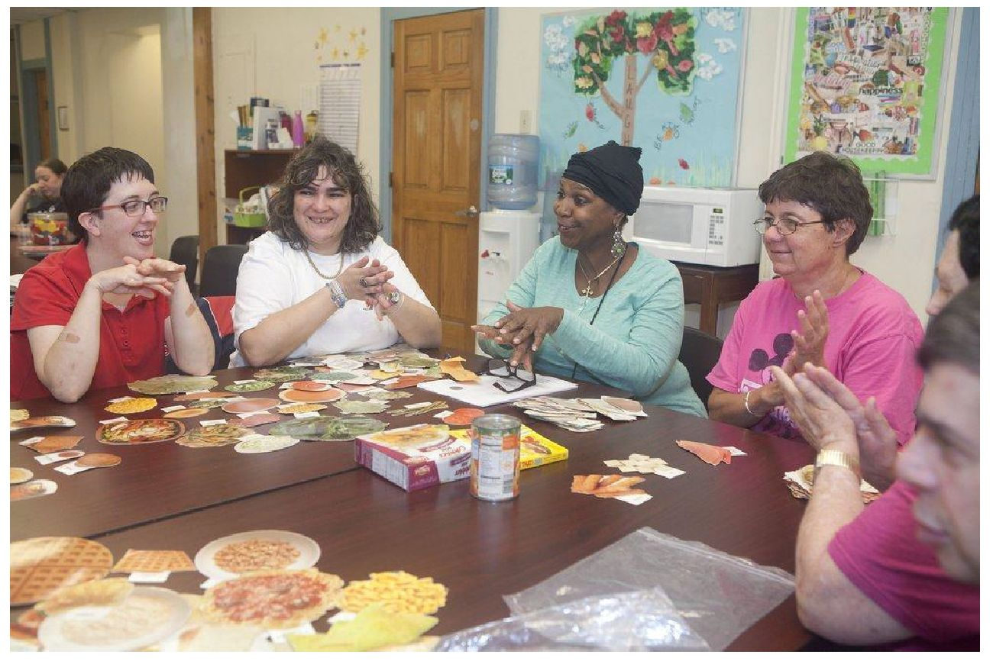

Photo from open sources.

Conclusion

supported living programs vary greatly from state to state. Common elements are:

Individual planning: All services and support are designed based on personal needs and desires.

Financial support: Providing the necessary resources for independent living through various financial mechanisms.

Social integration: Emphasis on the inclusion of persons with disabilities in public life through support and social skills training.

Oversight of the provision of supported living services in the U.S.A. can be implemented through various mechanisms and includes government agencies, accrediting organizations, non-profit organizations, and community. All these mechanisms are aimed at ensuring quality and affordable housing for persons requiring support.

Great Britain

In the UK, extra home care programmes are aimed at helping people with disabilities to remain independent within their communities. Local authorities coordinate services, enabling individuals to live in their own homes, receiving the necessary support from other organizations or employed personal assistants. Support may include:

* personal assistant or other care services
* [direct payments](https://en.wikipedia.org/wiki/Direct_Payments)37, paying for care from private sources
* mobility equipment

37 <http://www.cabinetoffice.gov.uk/upload/assets/www.cabinetoffice.gov.uk/strategy/disability.pdf>

* home adaptation
* security
* emergency call centre
* [Meals on wheels](https://en.wikipedia.org/wiki/Meals_on_wheels)38.

**Key services and components of extra home care:**

1. **Planning and coordination of services.** Local authorities are usually responsible for assessing each person’s needs and developing individual support plans. An important element is incorporating the recipient’s personal preferences and goals into support plans.
2. **Financing.** Funding for extra home care can come from a variety of sources, including local councils, social security funds or personal budgets, which allow people to manage their own support services.
3. **Types of support:**
4. Home-based support: assistance with managing household chores such as cooking, cleaning and other household tasks.
5. Personal assistance: Support with daily activities, including personal care, shopping, doctor visits and social activities.
6. Medical support: Assistance with taking medication and accessing medical services.
7. **Role of personal assistants.** Personal assistants can be hired to provide individualized care directly by people with disabilities or their families. This allows for flexibility and adaptation of support to the specific needs of the recipient.
8. **Social integration.** Extra home care programs encourage social integration by facilitating participation in community activities and building social networks.
9. **Training and skills development.** Programs may include training in basic life skills such as money management, using public transport and developing social skills to improve independence and quality of life.

**Examples of programmes and organizations in the UK:**

1. [**Mencap**](https://www.mencap.org.uk/advice-and-support/our-services/cqc-ratings/mencap-surrey-and-sussex-supported-living), [**a charity organization for people with intellectual disabilities**](https://www.mencap.org.uk/advice-and-support/our-services/cqc-ratings/mencap-surrey-and-sussex-supported-living)39 40
2. Zhu, Huichen; An, Ruopeng (1 April 2013). "Impact of home-delivered meal programs on diet and nutrition among elderly: a review". *Nutrition and Health*. **22** (2): 89-103

39

<https://www.mencap.org.uk/what-we-do/personal-support-services/cqc-ratings/mencap-surrey-and-sussex-suppo> rted-living

1. <https://www.mencap.org.uk/>

Mencap provides a wide range of extra home care services, including help with household chores, personal assistance and employment support. Mencap works to ensure that people with intellectual disabilities (Down syndrome) can live as independently as possible by providing individual support according to their needs and desires. Here are some key programmes:

**Surrey and Sussex Supported Living**: This programme provides support to people living in their own homes, helping them to maintain their independence. Support includes assistance with daily activities, personal hygiene and tenancy management.

**Warwickshire Supported Living**: Based in Leamington Spa, this programme also focuses on supporting people in their own homes. Services provided include assistance with daily activities, personal hygiene and tenancy management, enabling independent living in the community.

1. [Dimensions](https://dimensions-uk.org/what-we-do/supported-living/)41

Dimensions UK is an organization providing support services to people with intellectual disabilities and autism spectrum disorder in the UK. They offer a range of programmes aimed at supporting independent living, social integration and employment. Here are some examples of programmes:

1. Supported living

The Dimensions Supported Living Programme provides individual support to people with intellectual disabilities and autism to enable them to live independently in their communities. Services include:

**Personalised support:** assistance with everyday tasks such as cooking, cleaning, managing finances and medical care.

**Relocation support:** assistance in finding and setting up new living, support during relocation.

**Safety and wellbeing:** providing a safe and supportive environment for residents.

1. Support for families

Dimensions offers support services for families caring for relatives with intellectual disabilities and autism. Services include:

1. <https://www.dimensions.ai/>

**Resource centres:** providing information, advice and resources for families.

**Workshops and training:** educational events for parents and carers to help improve caregiving skills and understanding the needs of their loved ones.

**Support groups:** organising support groups to share experiences and receive emotional support.

1. [United Response](https://www.unitedresponse.org.uk/about/what-we-do/)42

United Response is a leading charity in the UK providing a wide range of services for people with disabilities and mental health issues. It focuses on supporting individual independence and community integration. Here are some examples of programs:

1. Supported living

United Response provides supported living for people with a variety of needs. The program focuses on assisting with daily living, providing support in the following areas:

**Personal Care:** assistance with hygiene, dressing and body care.

**Household chores:** assistance with cooking, cleaning and shopping.

**Medical services:** medication management and access to healthcare.

**Social support:** assistance with participation in social and community activities.

1. Day centres and habilitation programmes

These programmes provide people with the opportunity to participate in a variety of activities throughout the day that support their social and personal development:

**Educational programmes:** courses and training to develop new skills and knowledge. **Therapeutic activities:** art therapy, music therapy and other forms of creative activity.

**Sports and physical activity:** participating in sports and physical activity to maintain physical health.

1. Support in community

United Response works with communities to ensure an inclusive environment for people with disabilities:

1. <https://www.unitedresponse.org.uk/about/what-we-do/>

**Community activities:** organising and supporting participation in local activities and projects.

**Counselling services:** providing advice and support on the rights and opportunities of people with disabilities.

There are also [ARCO](https://www.arcouk.org/) programmes43. These communities offer elderly an alternative to traditional residential care, combining independent living with essential care and support services.

Services provided:

**Independent housing:** Residents live in their own apartments, providing privacy and independence.

**24-hour on-site care:** Care staff are available 24 hours a day to help with daily routine and meet medical needs. **Shared spaces:** Shared spaces such as dining rooms, lounges and activity rooms encourage social interaction and community involvement.

**Optional care and support:** Services adapted to individual needs, including personal care, cleaning and meal preparation.

Local authorities usually commission these services, cooperating with housing providers to determine eligibility criteria and ensure compliance with the Care Act 2014. Care and support funding is provided separately from the cost of housing, and regulation ensures that payment terms are consistent across facilities.

These communities are seen as a way of supporting elderly outside of traditional care homes, promoting independence and personalised care.

Further information can be found on the Cambridge University Press and [ARCO](https://www.arcouk.org/) websites, which detail the current state and prospects of assisted living in the UK.

Care Quality Commission

The Care Quality Commission is the independent regulator of health and social care in England. It assesses health and social care facilities such as hospitals, nursing homes and home care services.

Assessment process

1. Inspections. Once registered, facilities are inspected regularly by the CQC, by both scheduled and unscheduled inspections.
2. <https://www.arcouk.org/>

2. Five key questions:

Safe: Are services provided safely?

Effective: Are desired outcomes achieved? Caring: Are patients treated with care? Responsive: Are patients’ needs met? Well-led: Is the facility managed effectively?

Ratings

Outstanding

Good

Requires Improvement

Inadequate

Results

**Reports and recommendations:** Service provision quality reports and recommendations are published.

**Access to information:** Ratings are available on the CQC website for patients and their families.

**Sanctions:** Low ratings can lead to sanctions, including closure of the facility.

Conclusion

Supported living programs in the UK aim to maximize the independence of people with disabilities through individualized planning, flexible funding, complex support, and social inclusion. Local authorities and various charities play a key role in coordinating and delivering these services, helping to create the conditions for full and independent life for people with disabilities.

Organization of supported living in Lithuania

The social service of supported living in Lithuania is organized on the deinstitutionalization basis, aimed at ensuring the integration of people with disabilities and the elderly into the community. Supported living services are financed by the state and local budgets.

The main laws are the Law on Social Services and the Law on the Rights of Persons with Disabilities. These laws define the principles, criteria and standards for the provision of social services.

The organization of service provision is carried out at the level of municipalities, which have significant autonomy in managing social programs. This allows taking into account local characteristics and needs of the community. In Lithuania, supported living is implemented through a number of measures and structures that provide the necessary support and conditions for maximum independent living.

Each service recipient has an individual support plan, which is developed taking into account their needs, capabilities and goals. This plan includes specific measures and resources necessary to ensure a quality life and integration into society. People who use the supported living service live in ordinary living conditions – in separate apartments or houses owned by municipalities or rented by NGOs. The living conditions are at maximum proximity to standard living conditions, which promotes social integration.

The supported living service involves support of assistants who help with everyday chores, social adaptation and integration into the community. The quality of the provision of supported living services is regularly monitored and evaluated.

Examples of supported living in Lithuania:

1. **Group homes**

Group homes in Lithuania are specially equipped residential facilities where lives a small group of people with disabilities. In such homes, assistants provide support helping residents with everyday chores and promoting their socialization.

1. **Individual apartments**

Individual apartments are provided to people with disabilities who can live independently or with minimal support. In such apartments, residents are able to organize their lives at their own discretion, while receiving the necessary support from social services or assistants.

1. **Training programs**

Various training programs are implemented for preparing people with disabilities for independent living. Such programs include training in household management skills, financial management, social interaction, etc.

1. **Employment support**

Certain specialized programs help people with disabilities find work and integrate into the workforce. It can be supported employment, where employees receive assistance in the workplace for successful adaptation.

1. **Day care centers**

Day care centers provide day care and social interaction for people with disabilities. Here people can participate in various activities, receive medical and psychological support.

Supported living in Lithuania is organized based on individual approach to a person with a disability, an elderly.

Important attention in the organization of supported living is paid to the creation of standard living conditions that promote social integration, the provision of personal assistant services and the implementation of training programs.

NATIONAL PRACTICES OF SOCIAL SERVICES OF SUPPORTED LIVING ORGANIZATION

Today, supported living has become a more widespread and recognized type of social service in Ukraine. New institutions and programs providing supported living are emerging. New standards and approaches contributing to the integration of service recipients into society, providing them with opportunities for self-realization and improving the quality of life are being introduced.

*“...supported living is a very general term. That’s why we’re talking about assisted living. Because it can both consist in living in a person’s apartment, when an assistant comes to him/her... Several people living in an apartment. A dormitory for people who have some support there. supported living can also be different, because it will depend on the group of people living there and the level of their needs. That’s why there’s a very wide spectrum. And from the cases that we see, those people who live in such supported living, they are in the community. They are integrated. They live in this service. And in my opinion, it is a good thing that they don’t live in an institution, but live in a facility, or in a service, within the community, among their neighbours. They can go to the store, or wherever they need. That is, they have greater chances for social rehabilitation and readaptation, resocialization” (from an interview with Orest Suvalo).*

**Ukrainian experience of implementing supported living by parents of children with disabilities and charitable foundations**

Supported living as a social service emerged in Ukraine relatively recently, responding to the needs of people with disabilities, mental disorders and other vulnerable groups of the population who cannot live independently at home. The history of this service is closely tied to the social policy reforms that have taken place in the country over the past decades.

After declaring independence in 1991, Ukraine faced many social and economic challenges. The state began to pay more attention to social services, but the system of supported living was not yet developed. People with disabilities mainly lived in residential institutions or remained under the care of relatives.

Between 2000 and 2010, the first steps were taken to reform the social services system. International standards and practices focusing on human rights and the integration of people with disabilities into society were introduced.

In the period from 2010 to 2020, Ukraine started more active cooperation with international organizations and European partners tointroduce a system of supported living. The study of international experience and adaptation of European standards to Ukrainian realities started. The first projects of supported living were initiated, in particular for young people with disabilities who needed help in the transition to independent living.

The first steps towards the introduction of supported living in Ukraine were taken by volunteer organizations specifically for children with disabilities. Group homes for supported living were created in Ukraine only by individual charitable foundations.

Projects of the Charitable foundation “Helpus” and “Happy Child”

In Zaporizhzhia region, the Charitable foundation “Helpus” and “Happy Child” have introduced the preparation of orphans for independent living with support since 2010. As part of the Happy House project in Zaporizhzhia region, 5 houses were built in the Ukrainka ecovillage, designed to accommodate six large foster families. The houses were home to 32 children, 19 of whom were boys with special needs. Currently, the village remains in temporarily occupied territory, and the families have been evacuated abroad44.

The Helpus project created a [social adaptation](https://helpus.org.ua/a.php?n=530053) [house](https://helpus.org.ua/a.php?n=530053) in the village of Shcherbynivka, Cherkasy region. In 2013, the first graduate of the [Mykhailivskyi](http://helpus.org.ua/show_article.php?a_id=520134) [Psycho-Neurological Institution](http://helpus.org.ua/show_article.php?a_id=520134) became its first resident, later three more men joined him.

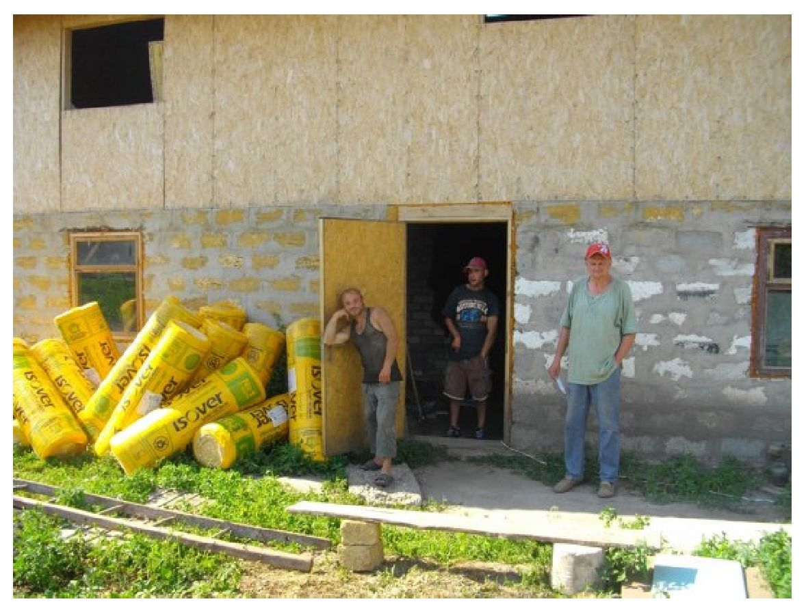

A house in Shcherbynivka village. Photo from open sources

Over 20 years of the boys’ stay in a residential institution and a psycho-neurological institution did not contribute to the formation of vital skills. In residential facilities, the care recipients are deprived of the need

44 <https://helpus.org.ua/a.php?n=33333>

to make any efforts to organize their own lives. In real life, residents are faced with the need to take care of themselves with limited resources.

*“If a PNI resident is transferred to a center, such as Shcherbynivka, he receives only a pension of UAH 950 per month (about $43), that is, more than UAH 3,000 per month less... the state saved UAH 12,000 per month on just four of our boys, or UAH 288,000 in two years! At the same time, the house in Shcherbynivka did not receive a penny from the state ” (from the website:* [*https://helpus.org.ua/a.php?n=530053*](https://helpus.org.ua/a.php?n=530053)*).*

At the beginning of the project, the houses are primarily aimed at able-bodied residents with mental or physical disabilities who have self-service skills, without manifestations of aggression or antisocial behaviour.

Supported living apartments of the NGO “Emmaus”

In 2022, the NGO “Emmaus” opened 9 supported living apartments for 35 people in Kharkiv. After February 24, 2022, the care recipients were evacuated to Italy, and they are currently temporarily staying in Milan.

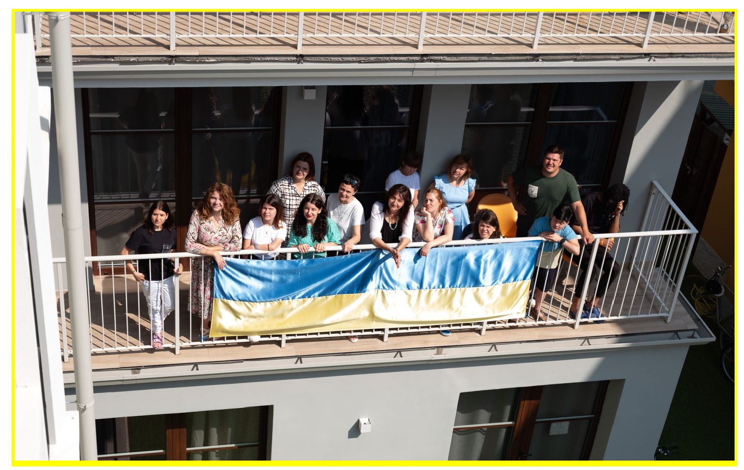

. NGO “Emmaus”. Photo from open sources

*“We have been working in Kharkiv since 2011. Our main activity was to open supported living apartments for vulnerable youth and help them prepare for independent living. The first project was “Flying House” – an apartment for two girls (and later more) with physical disabilities who graduated from a specialized residential institution” (from the website:*

The “Emmaus” NGO opened its first supported living apartment “Flying House” in 2013 for two girls withlocomotor disorders. According to the existing system, both girls should be transferred to a psycho-neurological or geriatric residential institution after the children’s residential institution. However, they met people who radically changed their fate.

*“We spent two years to create the “Flying House”. The most difficult thing was finding funds. Our friends from abroad helped a lot. Once they told their friends about our girls and together raised money for the first year of renting an apartment. That’s how it all started,” recalls Olha Filonenko, program director of the Emmaus NGO (from the website:* [*https://helpus*](https://helpus)*. org. ua/eng/a.php?n= 751918).*

In supported living houses/apartments, residential institution graduates or people with disabilities who need support live free of charge. At the beginning of the project they are daily accompanied by tutors, psychologists and other specialists. Residents are taught to take care of themselves, cook food, use transport, buy food and everyday goods in the store.

*“It is difficult for residential institution graduates to adapt. For them, this is a story of a forced, very rapid leap into adulthood. When the world after living inside four walls becomes open, with a lot of people. And they have to enter it right away,” says Olha. “Boys and girls lack basic knowledge about everyday life. They are used to food appearing on the table, plates disappearing, and they do not understand that time must be allocated for all this.”*

A successful case is the graduation of one of the residents from the master’s degree program at Kharkiv University and work as a tutor in one of the supported living apartments.

In the publication “They just need a home. What is supported living for residential institution graduates?” NGO “Ukrainian Child Rights Network” gives an example of joining the efforts of the public to create conditions for supported living for people with disabilities45.

Home for Orphans with Disabilities “The House of Faith, Hope and Love”

One of the first houses for supported living in Ukraine and the first one to receive funding under the social order model is the Home for Orphans with Disabilities “The House of Faith, Hope and Love”, which was opened in the village of Obertyn, Ivano-Frankivsk region in 2019 by the charitable organization

45

[https://childrights.org.ua/news/yim-prosto-potriben-dim-shho-take-pidtrymane-prozhyvannya-dlya-vypusknykiv-int](https://childrights.org.ua/news/yim-prosto-potriben-dim-shho-take-pidtrymane-prozhyvannya-dlya-vypusknykiv-internativ/) [ernativ/](https://childrights.org.ua/news/yim-prosto-potriben-dim-shho-take-pidtrymane-prozhyvannya-dlya-vypusknykiv-internativ/)

“Ukrainian Charitable Network”. In the “House”, the care recipients are assisted by an employee who helps care recipients with various issues of organizing their daily lives46.

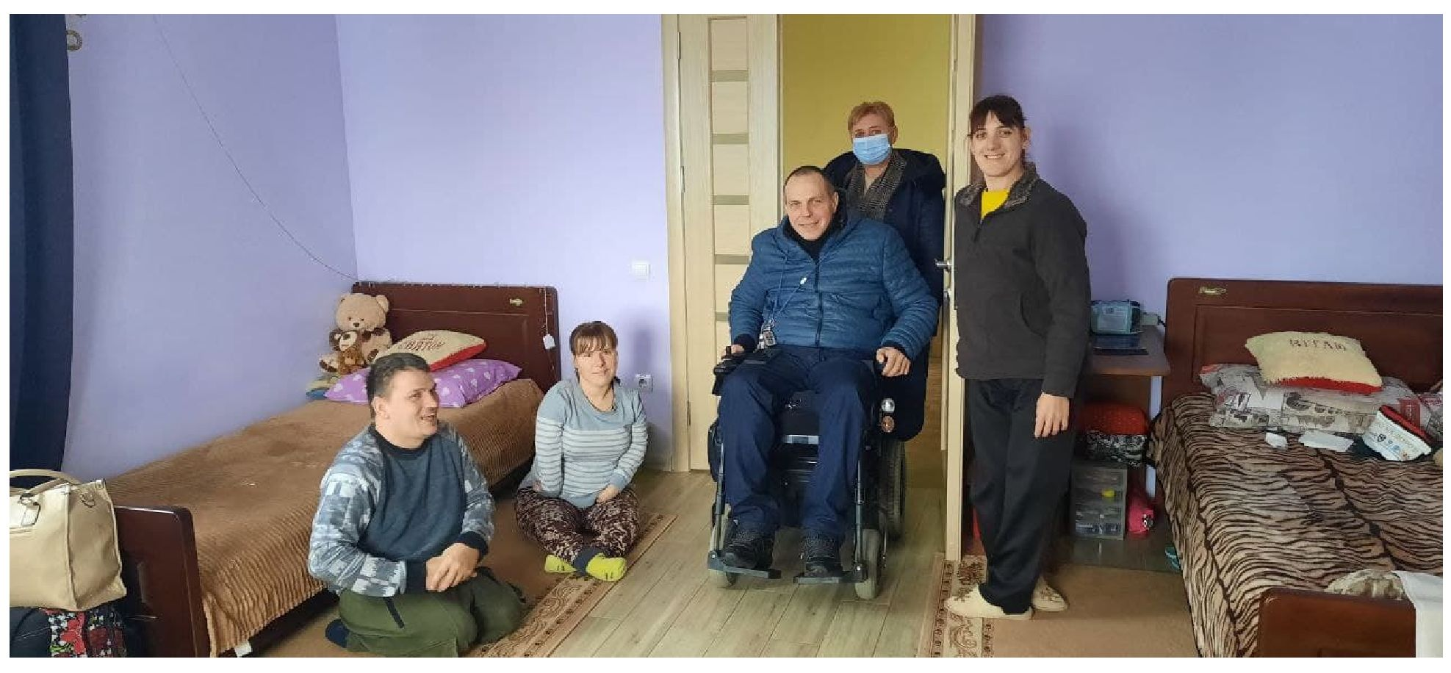

Photo from open sources.

The complex of activities in “The House of Faith, Hope and Love” is aimed at developing and supporting independent living skills, training, assistance in organizing the daily routine, organizing medical patronage, assistance in housekeeping (cooking food, cleaning rooms, etc.). Residents are also assisted in organizing interaction with other specialists and services, information on social protection of the population, protection of rights and interests and their involvement in the life of the territorial community. The house has not received budget funds since April 2022.

1. <https://www.if.gov.ua/news/socialna-posluga-pidtrimanogo-prozhivannya-dlya-lyudej-z-invalidnistyu>

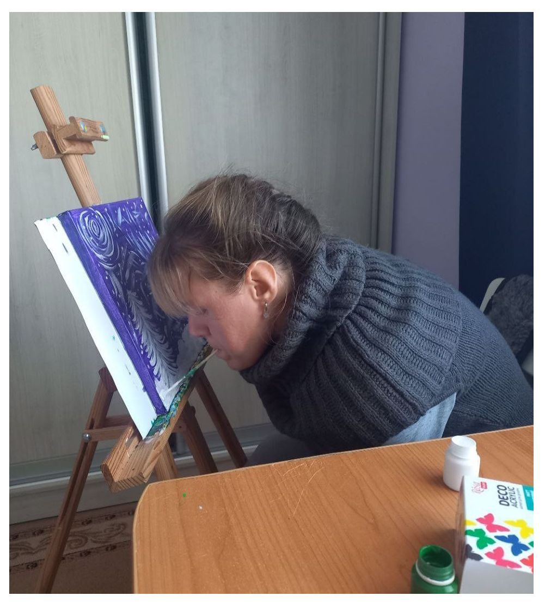

Photo from the official website of the house47:

According to the Ministry of Social Policy of Ukraine, in Lviv, Kyiv regions and in city of Kyiv, a pilot project of a social service of supported living is implemented. In Lviv region, such a service is provided by 3 supported living houses, where live 22 persons with mental disabilities (11 of them are people who lived in psycho-neurological institutions); 1 supported living apartment, where live 4 people.

Supported living houses “Dream Workshop”

In Lviv “Dream Workshop”, the dream of the care recipients about life outside the residential institutions and psychiatric hospitals, where the care recipients had lived for decades, was fulfilled48 49 50.

*“Residents of the Lviv supported living house “Dream Workshop” tried a tram ride for the first time in their lives, for the first time they were able to peel potatoes and prepare a salad on their own, learned that there is another language (and not just one) and that you don’t need to ask the staff for permission to make yourself tea,” Lyudmila Annych (house’s mentor) shares her impressions.*

1. <https://www.facebook.com/photo/?fbid=685875643723589&set=pcb.685877350390085>
2. <https://www.youtube.com/watch?v=ZaOb0Icn6AQ>
3. <https://www.youtube.com/watch?v=65QRF8AF3tI>
4. <https://www.youtube.com/playlist?list=PL1QSX68ubHH8DR5mX0N_JO3ZqiotcQcqm>

The organization was registered in 2015 and began its activities by introducing a day care service for young people with disabilities due to psychic disorders. The first center was opened in January 2017. In January 2023, the second center with supported living was opened. The total capacity of the supported living project is 15 people (one house for 7, another for 8 mixed-sex residents). Residents receive 24/7 support services.

The project involves only care recipients of residential social care facilities, which is almost not practiced in Ukraine.

*“...people from facilities have a lot of behavioural challenges, a lot of blank spots in their biography. That is, sometimes you face the fact that you simply do not know who you will actually work with. And this is one of our main conclusions, that you will explore everything along the way. So, we are, it seems to me, the only organization that works with people who were not only in psycho-neurological institutions, but in psychiatric hospitals. Because, I assume that until recently this was a really stigmatized topic. Getting out a person from a psychiatric hospital if they lived there for 8 years, like, for example, some of our guys. And before that, 25 years in a residential institution. And now he is living in the community for the first year... ” (from an interview with the head of the organization)*

The organization has 25 employees and attracts part-time employees on a freelance basis. In 2024, residents aged 18-35 received the service. Assistants work with the center’s residents, who daily develop their skills to live an independent life, the main method is case management. People are helped to master basic skills that at first glance seem insignificant. Sometimes it takes six months for individual residents to study the route from the Dream Workshop to another place.

The team draws up an individual plan for each resident, which is adjusted if necessary, and systematically conducts case analysis. The staff providing services in supported living houses and day care centers have undergone special training in working with people with psychic disorders, and each team member is provided with supervision.

*“...for example, at the beginning we had a guy with a very severe seborrhea. And we’ve seen all the doctors until we understood the simple fact that he couldn’t wash his hair and he didn’t wash off the shampoo. And that was the reason why his scalp was peeling badly. Sometimes you have to work with a person, starting with very basic things that are obvious to you that you don’t even think of them” (from an interview).*

There are different areas of work, for example, a program to support families with adult members with psychic disorders.

An important part of the activity is working with society – from raising awareness through various information campaigns to developing an educational video course. The organization cooperates with authorities at different levels.

*“...we don't have a complete understanding of how to do everything correctly. Because we simply don't have legislation. This is one issue. For example, we are currently looking for a lawyer who would help us write some policies and procedures for protecting employees. So that we don't violate some conditional norms. Different, for example, crisis situations can occur when we have to go to the hospital and hospitalize a person. And this is what we are working on together with hospitals: how we contact them, for how long they accept persons, how the return to the community is carried out... ” (from an interview with the head of the organization)*

The houses are located in residential areas to socialize residents and involve them in community life.

*“…we had a case when the house actually worked for six months, we launched it somewhere in August, and in February or January there was very heavy snowfall. And the neighbours simply got their car stuck in the snow. And our guys went and started pushing this car out. And, you know, it was really cool, because this is a neighbourhood where there are no poor houses. And those neighbours, perhaps, they never even thought about the existence of any residential institutions, etc. They kind of lived their lives. And could they even imagine that people who lived in psycho-neurological institutions and hospitals would help them push their car out of the snow? And it was some sort of an improvised team building. And this provides this bridge of communication with the community. Therefore, it is important to place the service in the community. Because then, even at the level of communicating with the seller in the store, this saleswoman will go and tell others. And that is how the attitude changes, the stigma towards people decreases” (from an interview with the head of the organization)*

**Difficulties in providing the service:**

Residents need medical support during their stay in the homes, including dental services, for which there is no funding. After a long time in residential social care facilities, people remain toothless. Therefore, it is important to solve this issue at the level of ministries and advocacy capabilities.

*“... this should not be a part of the supported living service. It is very important, when we talk at the level of the ministry, at the level of some advocacy capabilities, not to pile everything into supported living. Because otherwise there will be no actor, nothere will be no organization able to carry on. It is important to say that this service is about living... ”(from an interview).*

The organization has to renew documents for internally displaced persons (IDPs), pay for the treatment of somatic diseases.

*“... it is not a public organization that should treat somatic diseases. These somatic diseases should be covered, I don’t know, by some kind of insurance medicine, or some expanded state package for this category of people. In fact, there is nothing. Therefore, our partnership manager goes, calls, writes to all possible clinics, makes appointments for CT scans, MRIs, otolaryngologists, endocrinologists, etc. We do it. But we shouldn’t. Because supported living is not a medical service. (from the interview).*

There is a lack of coordination in the system between the links. According to the social service of supported living providers, a person should be referred with a full package of documents, with a medical history. Everyone should have their own area of ​​responsibility.

*I hospitalized (a person) with the first seizures of epilepsy because there was no understanding. I also came for the first attacks of aggression and stood in front of the police saying: “Good afternoon. My name is Halia. Nice to meet you. We have a service here.” So that the police doesn’t think that this is something, you know, dangerous and requires application of force. Because they also come and they don’t understand. They came to call for aggression. They may be ready to react aggressively. And therefore it is necessary to explain here that: “We are experts, this is a professional service. We can handle everything. We just need securing from you.”*

There is no funding from the state. We have to find money for expensive rent, for medical and social services, maintenance of buildings, and wages for employees. The entire service is financed from donor projects.

*“...we really hope for cooperation with the Ministry of Social Policy, that they will implement their pilot program, which has been talked about so well and beautifully for quite a long time. I would also like to see the financial result of this. But. Well, we hope that everything will happen gradual. In Lviv, there is some kind of a regional program, but it does not affect the financing of the service in any way” (from an interview).*

**Charity Fund “Caritas Stryi Eparchy UGCC”**

The supported living houses of the Charity Fund project “Caritas” have been operating since 2023. The project is being implemented with the support of the MH4U project and the Embassy of Switzerland in Ukraine and is financed by donor funds. In accordance with the Law of Ukraine “On Social Services”, Caritas is included in the Register of Social Services Providers and Recipients of the Ministry of Social Policy of Ukraine.

At Caritas, the supported living service is provided in two houses and a supported living apartment. They are designed to accommodate 20 people: 8 people in each house and 4 people in an apartment. Currently, 15 beneficiaries receive the service, their average age is 18 – 45 years. Among the beneficiaries of Caritas are orphans, children deprived of parental care, people in difficult life circumstances, and those who have experience living with people with psychic disorders. Caritas also takes care of IDPs.

The supported living house “DiM” was the first in the Stryi community and in the Caritas Ukraine network, designed for youth with mental and complex disorders. Thanks to the support of a team of specialists, residents have the opportunity to socialize and acquire self-service skills.

*We see those changes very much.. It’s like, every day we do, do and give up. And then – wow! There is a result! For example, we had a case with a guy. We said to each other: “Mowgli”. Because the way he was described, it gave the impression that he doesn’t know how to do anything at all, can’t do anything, and no one knows where he’s from. And at first it was very scary. Now he does a lot of things. Once he was in the hospital for the first time. So he was accompanied 24/7. Now he can stay there himself, take IVs. It proves that a person changes in an environment, in a favorable environment. And when he felt that he is accepted, he started smiling a lot. Because before that, we had a feeling he never smiles” (from an interview)*

The Caritas supported living houses are two large two-story buildings. One of them is located within the city limits, the other is in a suburban area. The houses have a gazebo and a large courtyard where beneficiaries spend their free time. Residents live in rooms designed for 1-2 people (there is also one room for three people). The houses have comfortable conditions close to home: a large living room, recreation rooms, a kitchen, sanitary and hygienic rooms and places for washing and drying clothes.

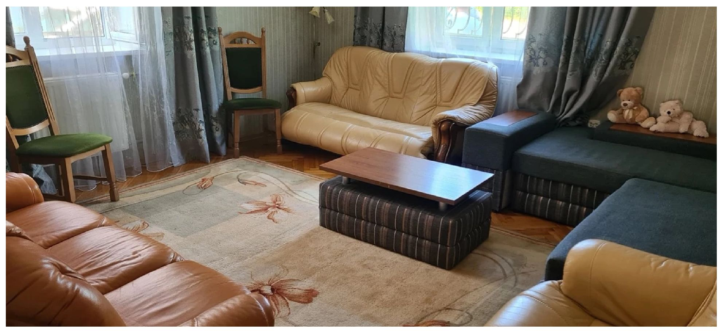

Photo from open sources

An individual program is developed for each resident, aimed at successfully mastering independent living skills, in particular, acquiring social and household skills, self-service and personal hygiene. Beneficiaries receive rehabilitation and psychological services, including individual and group counselling, psychological support, and physical rehabilitation. The day care center organizes occupational therapy, sports, and creative activities.

At the moment, Caritas does not have any employed beneficiaries due to a number of reasons: a small number of vacant jobs in the community, employers’ unwillingness to employ people with psychic disorders, and parents’ or guardians’ and beneficiaries’ unwillingness to employ them.

*“We actually already have a few who are looking for work, who have tried. But it didn’t last very long. And, unfortunately, they, let’s say, didn’t get used to it, if I may say so. One girl tried at a garment factory. She tried working at Ukrtelecom, working at the post office. But it didn’t work out. In a practical way. Boys too, we see, they really want to be involved in some sort of men’s work. But, unfortunately, employers are not quite ready to take them” (from an interview).*

The Caritas team, which provides supported living services, consists of 18 people – social workers and assistants. All of them have undergone preliminary external and internal training and have a supervisor who helps in solving various issues and provides appropriate recommendations.

**Issues that arise**

Despite the existing positive individual cases, there are also some problematic issues regarding the provision of supported living services. This is the stability of the provision of the service, which requires systemic funding, including state funding. Ensuring communications in communities and taking destigmatizing measures. Cooperation with relatives and guardians, in particular in providing medical care and maintaining social payments, since not all guardians are conscious and responsible.

*“...some families even live off those pensions (of persons with disabilities). In our practice, unfortunately, there is abuse when the beneficiary wanted to be in supported living, but the family did not let him go only because they were afraid of losing (the pension).*

Improvement of the conditions for providing supported housing services requires systematic funding and support from the state and communities, which will ensure the stability of services and reduce the stigma associated with psychic disorders of residents.

*“... things will change in supported living when, like in medicine, money will follow the person. This will be a perfect option. The one that, as I understand it, corresponds to European practices” (from an interview).*

**“Kolping Family in Vinnytsia”**

Since 2020, in cooperation with the Department of Social and Youth Policy of the Vinnytsia Regional State Administration, they have begun work on creating supported housing for children with complex developmental disorders, and have become social services providers.

*“... I am a mother. My son is already 19 years old. His name is Ihor. He has a rather complex form of autism – he does not speak, he has many concomitant developmental disorders. And once we were very closely involved in such an issue as the development of inclusive education in Ukraine. But we constantly thought most of all about the question of what will happen when he grows up” (from an interview with Lesia Samoilenko).*

To provide services, a house was rented for 6 boys. Later, a new service was introduced for 30 teenagers with autism and intellectual disabilities aged 12 to 18. A transit supported living program has been developed, where teenagers learn independent living skills on the basis of the same supported living house. Residents from the supported living house act as assistants and even teachers. The organization is also a provider of support services during inclusive education, which is provided by 41 child assistants in educational institutions.

*Our boys ... have an average level of developmental disabilities. That is, my son cannot receive this service according to these scales. Therefore, we understand that it definitely needs to be changed and the question is again that, we were also told: “Do not confuse supported living with palliative care”. As long as a person can walk, as long as a person can be included, as long as we understand how to create an environment and structure, a person has the right to receive supported living services. And there is no need to say that this is only palliative care. Yes, there should be, perhaps, for certain people the issue of a personal assistant at some points” (from an interview with Lesia Samoilenko)..*

The SL team includes a behavioural therapist, psychologist, social educator, a specialist in the basics of social and emotional development, volunteers. We cooperate well with the free legal aid bureau, which tells residents simple things in an accessible language, how to behave in different life situations.

*“But in fact, this is really our routine, and this is the basis of the basics – to teach routines – to teach people to live independently. I mean hygiene, what we start our morning with – washing, brushing our teeth, cooking, checking if everything is clean, looking after ourselves. It’s also about financial literacy. The guys have their own joint budget. And they put some money in trust there. And, for example, they calculate how much money is taken for some purchase, for example, a set for cooking borshch. They counted, wrote it down, went to buy it, and put the change in. And everyone knows how it all happens, everything is recorded, everything is accounted for. That is, things that seem very simple to us are actually not so simple” (from an interview with Lesia Samoilenko).*

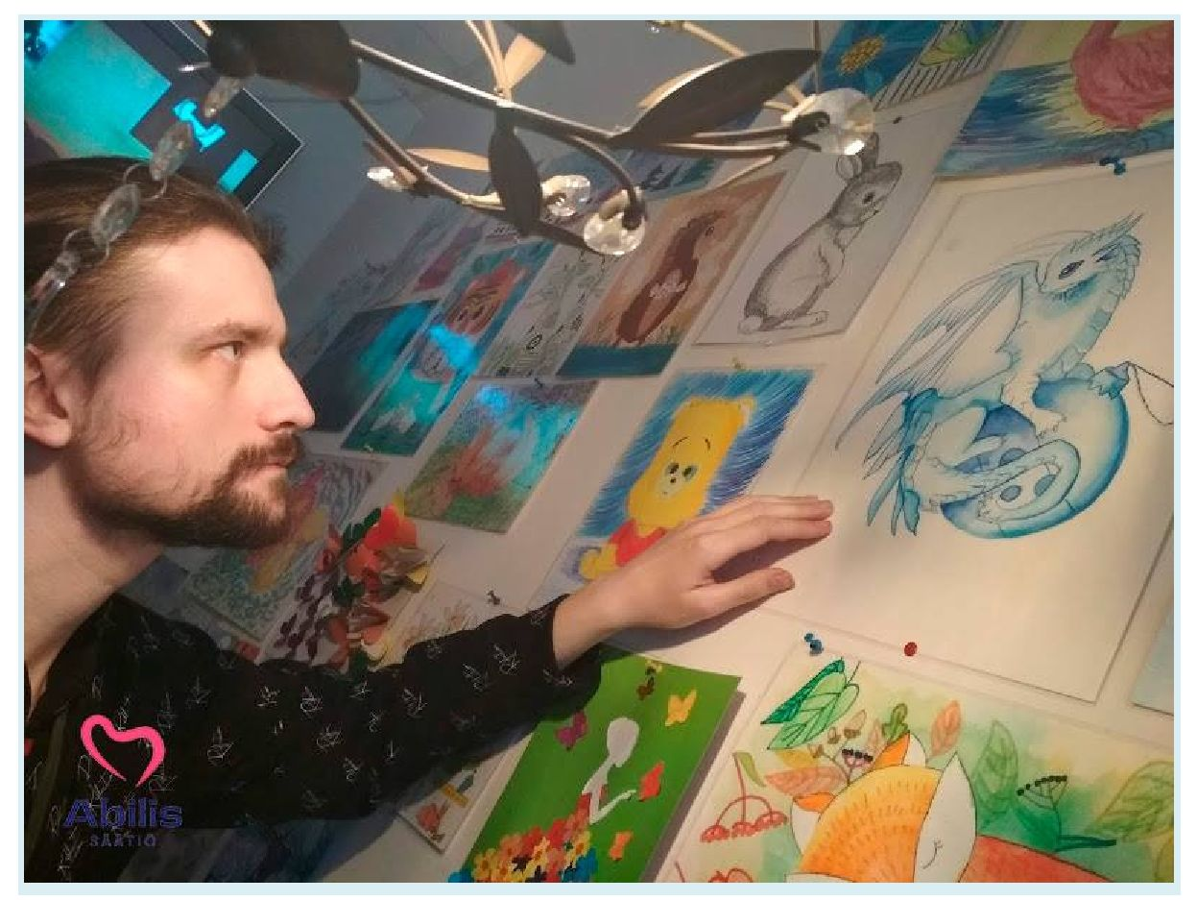

“Kolping Family in Vinnytsia. Photo from the website51:

The cessation of state funding became a challenge, which was later restored. Support is provided by charitable foundations such as “Abi^”.

A social enterprise “Smachnenko” was launched to produce dried fruits, involving 10 people with disabilities.

*“...for the first time, we started cooperation with the city of Vinnytsia to purchase the service of supported living of the Vinnytsia city territorial community. Now we are closely cooperating with the department of social policy. And now we are looking at how to take into account all the requirements, and so that for the first time we can make such a purchase from the city budget” (from an interview with Lesia Samoilenko).*

The issue of compliance with State Construction Standard is debatable for parents. Since the rent is paid mainly by parents, meeting the requirements of the State Construction Standard in full may become financially unaffordable and put an end to parents initiatives. Therefore, according to parents, it is important to find a reasonable balance between the capabilities of the parent community and the safety of services.

Training center on the basis of the [Lviv Regional Clinical Psychiatric](https://kulparkiv.org.ua/) [Hospital](https://kulparkiv.org.ua/)

The [Lviv Regional Clinical Psychiatric Hospital](https://kulparkiv.org.ua/) runs a Center for Supported Living, which includes a training center.

*“The idea of creating supported living appeared due to the fact that we have been observing this category of social patients for a long time, who are our patients, but in general they do not need any medical supervision or support. These are mostly social patients who simply have nowhere to go, let’s say – they are not accepted by the communities, their relatives do not want to look after them, take care of them. And due to the fact that they have been in hospitals or other facilities for a long time, they have lost their life skills, their livelihoods, starting with basic skills, like how to cook or plan their budget, or go shopping” (From an interview with Natalia Oryshchyn).*

The training center for supported living was opened within the framework of the Comprehensive Program for Mental Health Care and Psychosocial Support of the Civilian Population in the Lviv Region52.

*We have 3 residents. The training center is designed for 3 people.*

*We have 6 assistants. We have 3 nurses and 3*

1. <https://www.facebook.com/photo/?fbid=986833380113082&set=pcb.986842096778877&locale=ru_RU>
2. <https://www.facebook.com/watch/?v=1465000420724208>

*doctors-interns, psychiatrists. And they are already working according to the schedules, changing shifts. That is, the service is provided 24/7. Patients are with assistants day and night” (From an interview with Natalia Oryshchyn).*

The hospital is a social services provider and has entered information into the Register of Social Services Providers and Recipients of the Ministry of Social Policy of Ukraine. The Center for Supported Living is an initiative aimed at developing mental health services within the framework of the Comprehensive Program for Mental Health and Psychosocial Support of the Civilian Population in Lviv Region (<https://loda.gov.ua/documents/78112>), which was created by the joint efforts of the Ukrainian-Swiss project “Mental Health for Ukraine” in partnership with the Ministry of Health of Ukraine and with the support of Switzerland. This initiative is aimed at improving the quality of life of people facing mental health issues, promoting their independence and integration into society.

*“We also started while not knowing what to do. And a stable mental state is the selection criteria. Because, first of all, we have people with mental disorders. Then – age. I will explain why. Because if a person is older, there are concomitant diseases, and then it is more difficult to provide them with a service. Therefore, we take into account age. And in general, we take a patient, they are our residents, and we draw up an individual plan. We have a developed plan, we note current skills, the skills that need to be improved, and the skills that need to be restored in general. That is, we have an individual approach to each resident. And according to the plan, we move during the period that they are with us. And in the end, at the exit, we look at the results, what we succeeded in, what we failed in, accordingly, we analyse and draw some conclusions for the future. Because this is the first time we have such an experience, and we are also learning, and we still need to gain experience too” (From an interview with Natalia Oryshchyn).*

Supported living was introduced as rehabilitation measures within the framework of the package of medical guarantees from the National Health Service of Ukraine, however, it is not financed by the medical guarantees program.

The supported living center was opened in 2022. During this time, there were three “graduations” of residents. At the time of the visit, there were two residents in the center. They have the opportunity to live in separate rooms designed for one person. Shared meals are organized, all residents are involved in cooking. living in the training center is provided with the support of specialists, including 24/7. Residents have the opportunity to be employed and freely manage their own funds.

*“We set items up, sell them little by little, and raise funds for rehabilitation. We have a carpenter’s shop here. Right now, there are classes. What are we doing here?... A flower box ... We make all kinds of benches, tables. The guys tried to make candlesticks. And some other items. Which could then be set up in this shop, for example. Or, for example, we equip the courtyards of the departments. Because each department has its own courtyard where patients walk. For example, we put benches and tables there. So that it is also comfortable there. The guys are satisfied, they like it” (from an interview with the medical director Marian Tsudnyi).*

Thanks to the implementation of the Comprehensive Program for Mental Health Care and Psychosocial Support of the Civilian Population in the Lviv region, cooperation has been organized with social workers from 10 communities. However, before the implementation of the specified program, the hospital specialists introduced the “Green Bus” initiative, when hospital patients who did not require further inpatient treatment were delivered to their place of residence in the communities. However, this practice turned out to be provocative and not constructive and required a systematic solution of the issue of the further stay of former hospital patients in the communities. But there were certain positive results of such initiative, in particular, the mayor of the city of Stryi opened a “Mental Health Center” in the community as a result of the “Green Bus”.

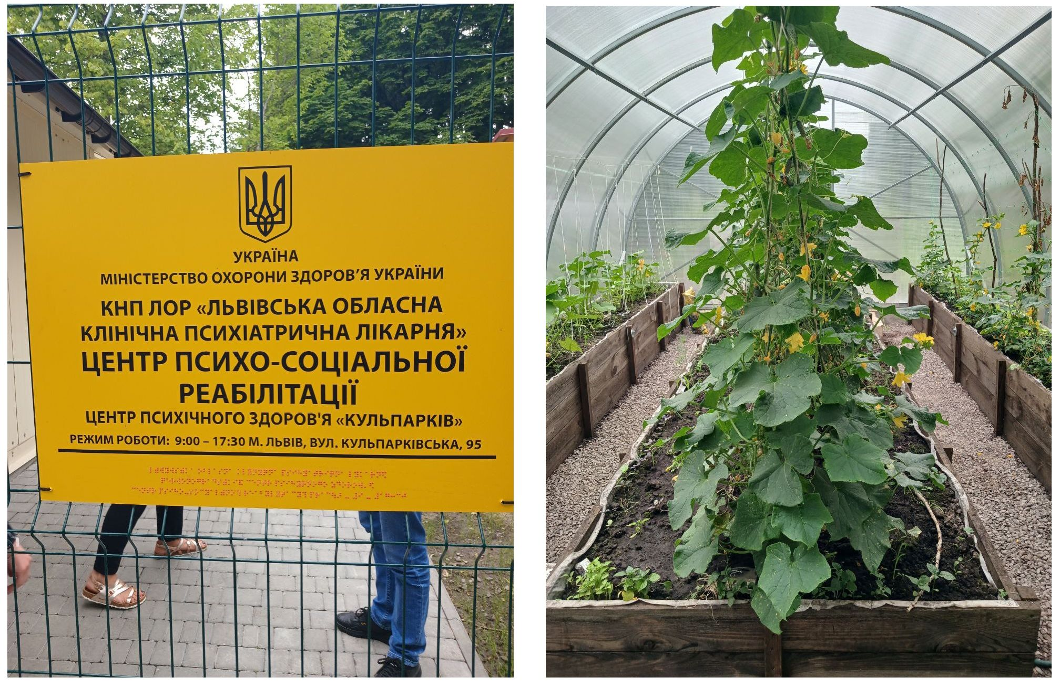

*“Patients who live in supported living. They train to live independently. They necessarily choose specialisation. Some sort of profession they would haveat home, what they would like to do. A person cannot survive alone, they need to do something.*

*Some want to garden. Some want to take care of animals. Some want to be a carpenter. We also want a pottery workshop. A more advanced one, we also want culinary training. We want some kind of bakery, but we lack financial resources” (from an interview with Marian Tsudnyi).*

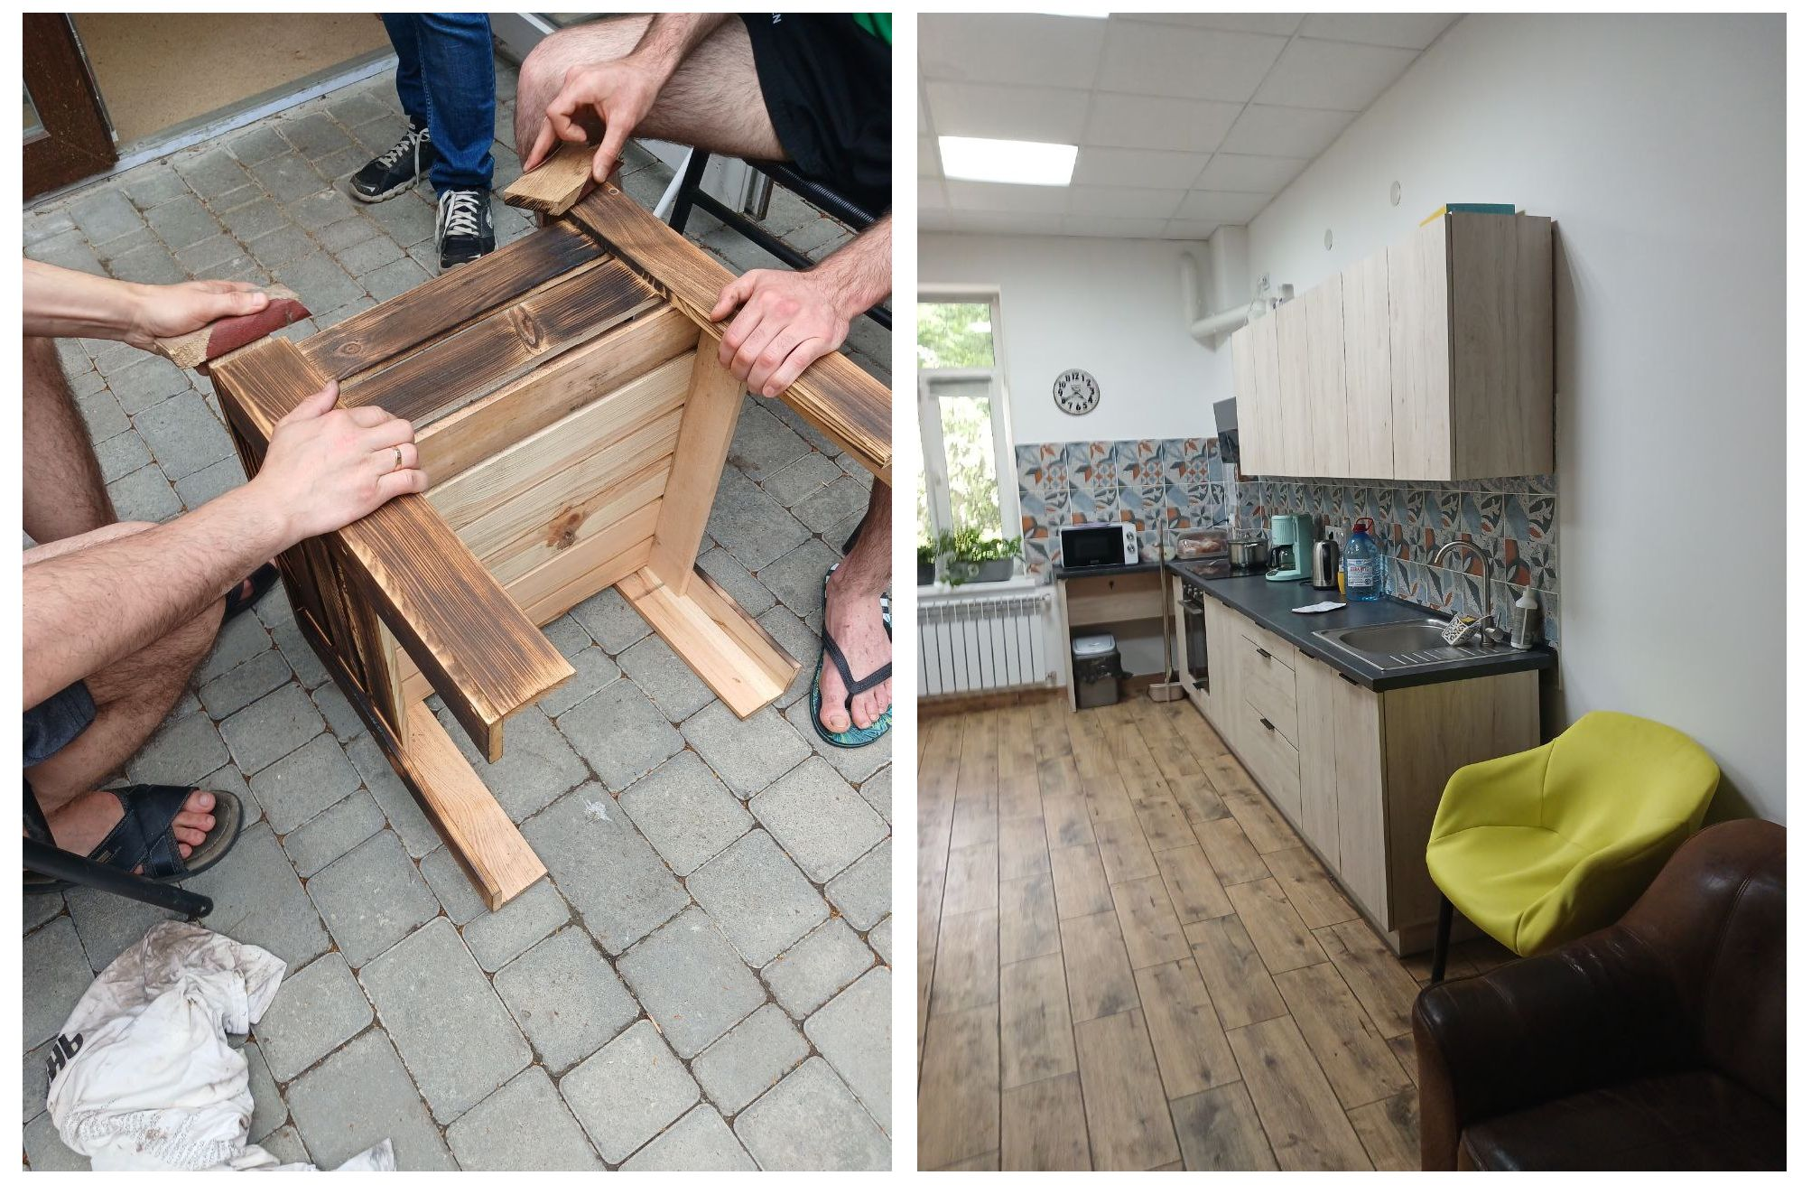

Kyiv and Kyiv region

Currently, in the regions and the city of Kyiv, which participate in the implementation of the pilot project, the approval of the draft Model Regulation on a house (apartment) of supported living developed by the Ministry of Social Policy is being carried out.

In the Kyiv region, there is 1 supported living house, where live 8 people, in the city of Kyiv – 2 transit/training apartments, where 6 people live and undergo training (the training course lasts from 1.5 months to 6 months).

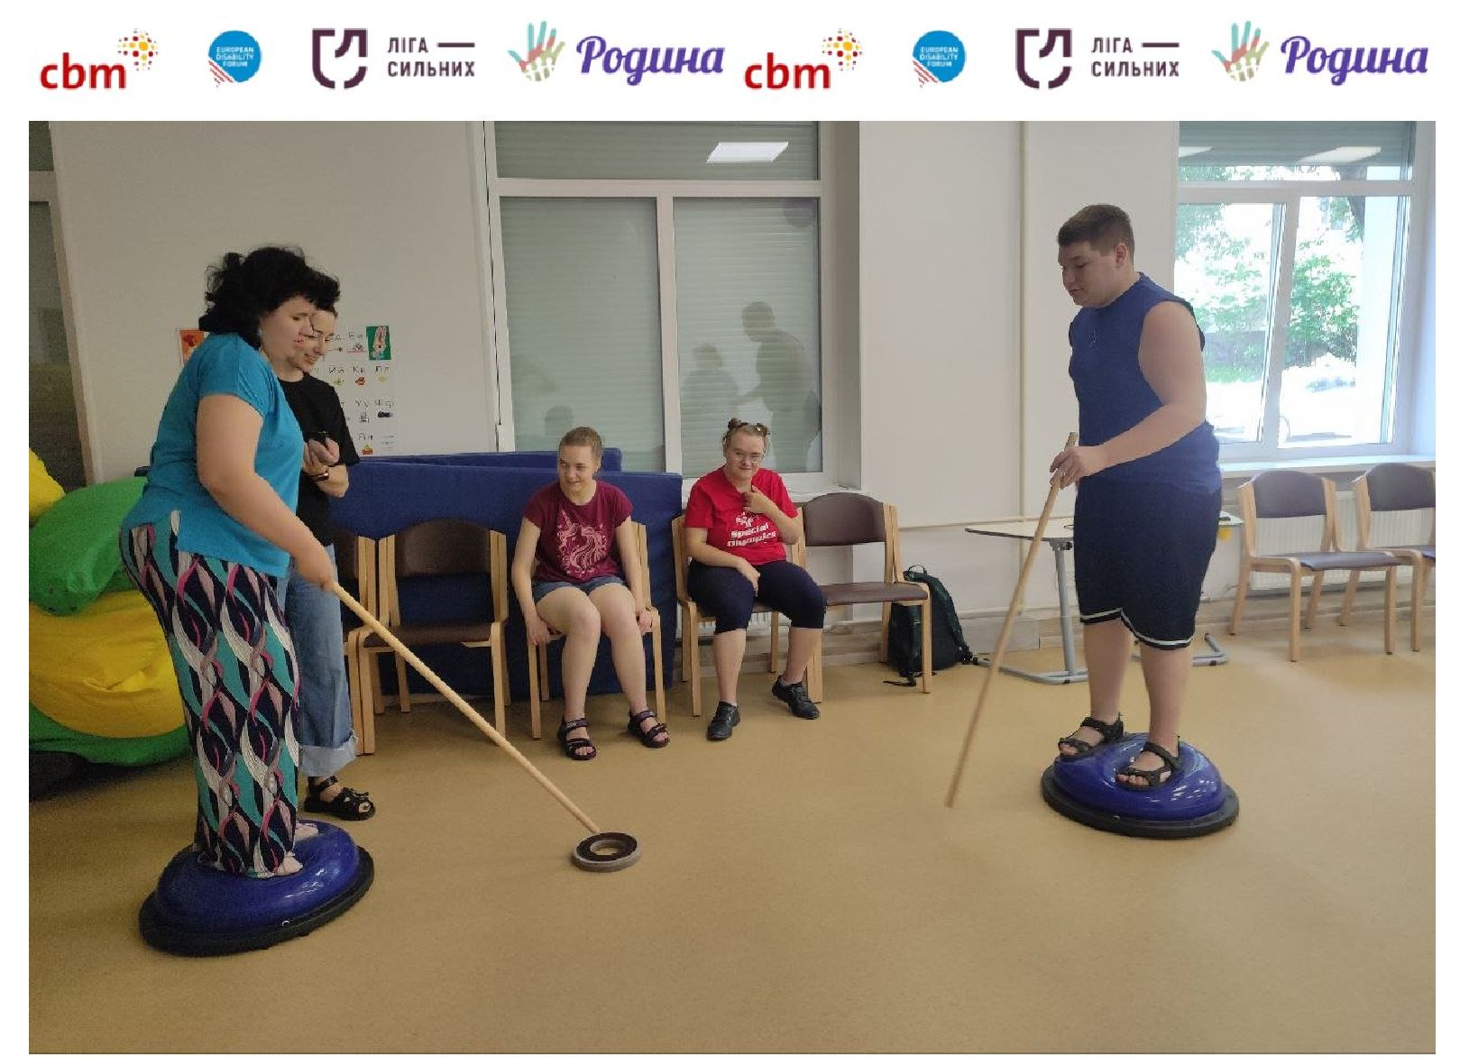

NGO “See with Your Heart”

The NGO [“See with Your Heart”](https://www.facebook.com/bachytysercem) has been operating since 2014. The idea of helping own children has turned into a large-scale project helping children with disabilities in Ukraine and abroad receive support and the right to a happy childhood.

The goal is to provide comprehensive support to families raising children with severe developmental disabilities, to assist in providing them with comprehensive physical, socio-pedagogical, psychological, legal, and household assistance, to identify, support, and promote talents, to promote the employment of young people with disabilities, to create and equip workplaces for them, to provide social patronage directly at the workplace, to organize meaningful leisure activities, to integrate them into society, and to create an atmosphere of respect and tolerance in society for children with developmental disabilities and their families53.

The team’s work is aimed at socializing adolescents and young people with complex developmental disabilities (School of Socialization for adolescents 12-16 years old (online and offline), the “START” project for adolescents 16-18 years old, the “TAK” Creative Workshop for young people over 18 years old, an inclusive summer camp for 100 children with disabilities “Kosmotabir: A Space for Everyone” the “Art Hub” project: a space for young people with disabilities from 18 years where they spend time together with young people without disabilities: watch movies together,

53

<https://media.zagoriy.foundation/speczproyekty/dity-cze-prosto-dity-yak-organizacziya-bachyty-serczem-r> [ujnuye-stereotypy-pro-invalidnist/](https://media.zagoriy.foundation/speczproyekty/dity-cze-prosto-dity-yak-organizacziya-bachyty-serczem-rujnuye-stereotypy-pro-invalidnist/)

visit exhibitions and performances, participate in master classes together, organize parties, talk about important and secret things.

In 2023, the “Training Apartment” project was launched for people with disabilities who have reached adulthood and have complex developmental disorders, most often cannot live independently, requiring the same constant care of their parents and guardians.

The “Training Apartment” project is a training platform for independent living with the support of specially trained assistants. This project is the first step towards building a system of supported living.

In addition to acquiring skills for independent living, project participants undergo training in the online project “School for Everyone” according to a levelled educational program three times a week. Students of the educational project “Training Apartment” join volunteer activities with children and adolescents in “Kosmotabir: A Space for Everyone”.

The program is implemented with the support of the project “[Mental Health](https://www.facebook.com/MH4Ukraine?__cft__%5b0%5d=AZW-5q8IHAsEVah6mycbwvvcHzm_QnDsSOr5pOkMAeAyxZOn2Gfg2deA8XPTi6-0eug8QazhHVjknMuYG6Ec3BIDHrQHeNlxcShmaoAPHOBh1IR-KqyEUK-u-SAL7_PwRiBOD8GapQQGDHwXcKAyFXxTCkjBEnCqVOQS7_iWDmRiq4WTOoXSlYfy65lEoTP5SNg&__tn__=-%5dK-R) for [Ukraine](https://www.facebook.com/MH4Ukraine?__cft__%5b0%5d=AZW-5q8IHAsEVah6mycbwvvcHzm_QnDsSOr5pOkMAeAyxZOn2Gfg2deA8XPTi6-0eug8QazhHVjknMuYG6Ec3BIDHrQHeNlxcShmaoAPHOBh1IR-KqyEUK-u-SAL7_PwRiBOD8GapQQGDHwXcKAyFXxTCkjBEnCqVOQS7_iWDmRiq4WTOoXSlYfy65lEoTP5SNg&__tn__=-%5dK-R)”.

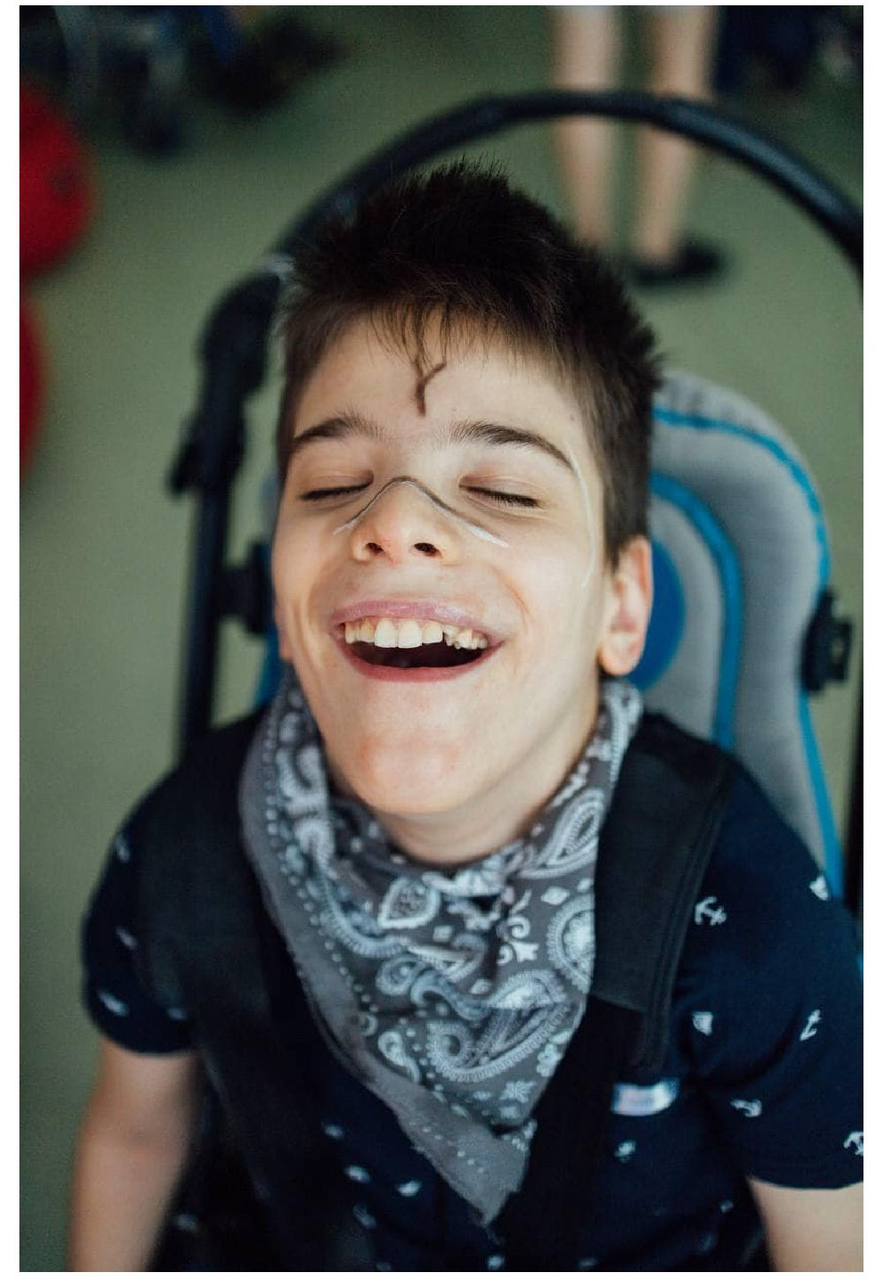

Photo from open sources 54:

54<https://www.facebook.com/photo/?fbid=887074876779527&set=ecnf.100064310696233&locale=uk_UA>

NGO “Family for Persons with Disability”: a transit apartment for children with intellectual disabilities

NGO “Family for Persons with Disability” was created in 2000 by parents raising children with developmental disabilities. The goal of the activity is to develop a support system for persons with disabilities and their families from birth to the end of life.

To implement this goal, the NGO has created a Center for Social Services, where children with complex developmental disabilities, youth with intellectual disabilities, as well as their family members can receive social services that will protect persons with disabilities from residential social care facilities, guarantee them socialization and inclusion in the community, and also help develop the skills and knowledge necessary for adult, independent life.

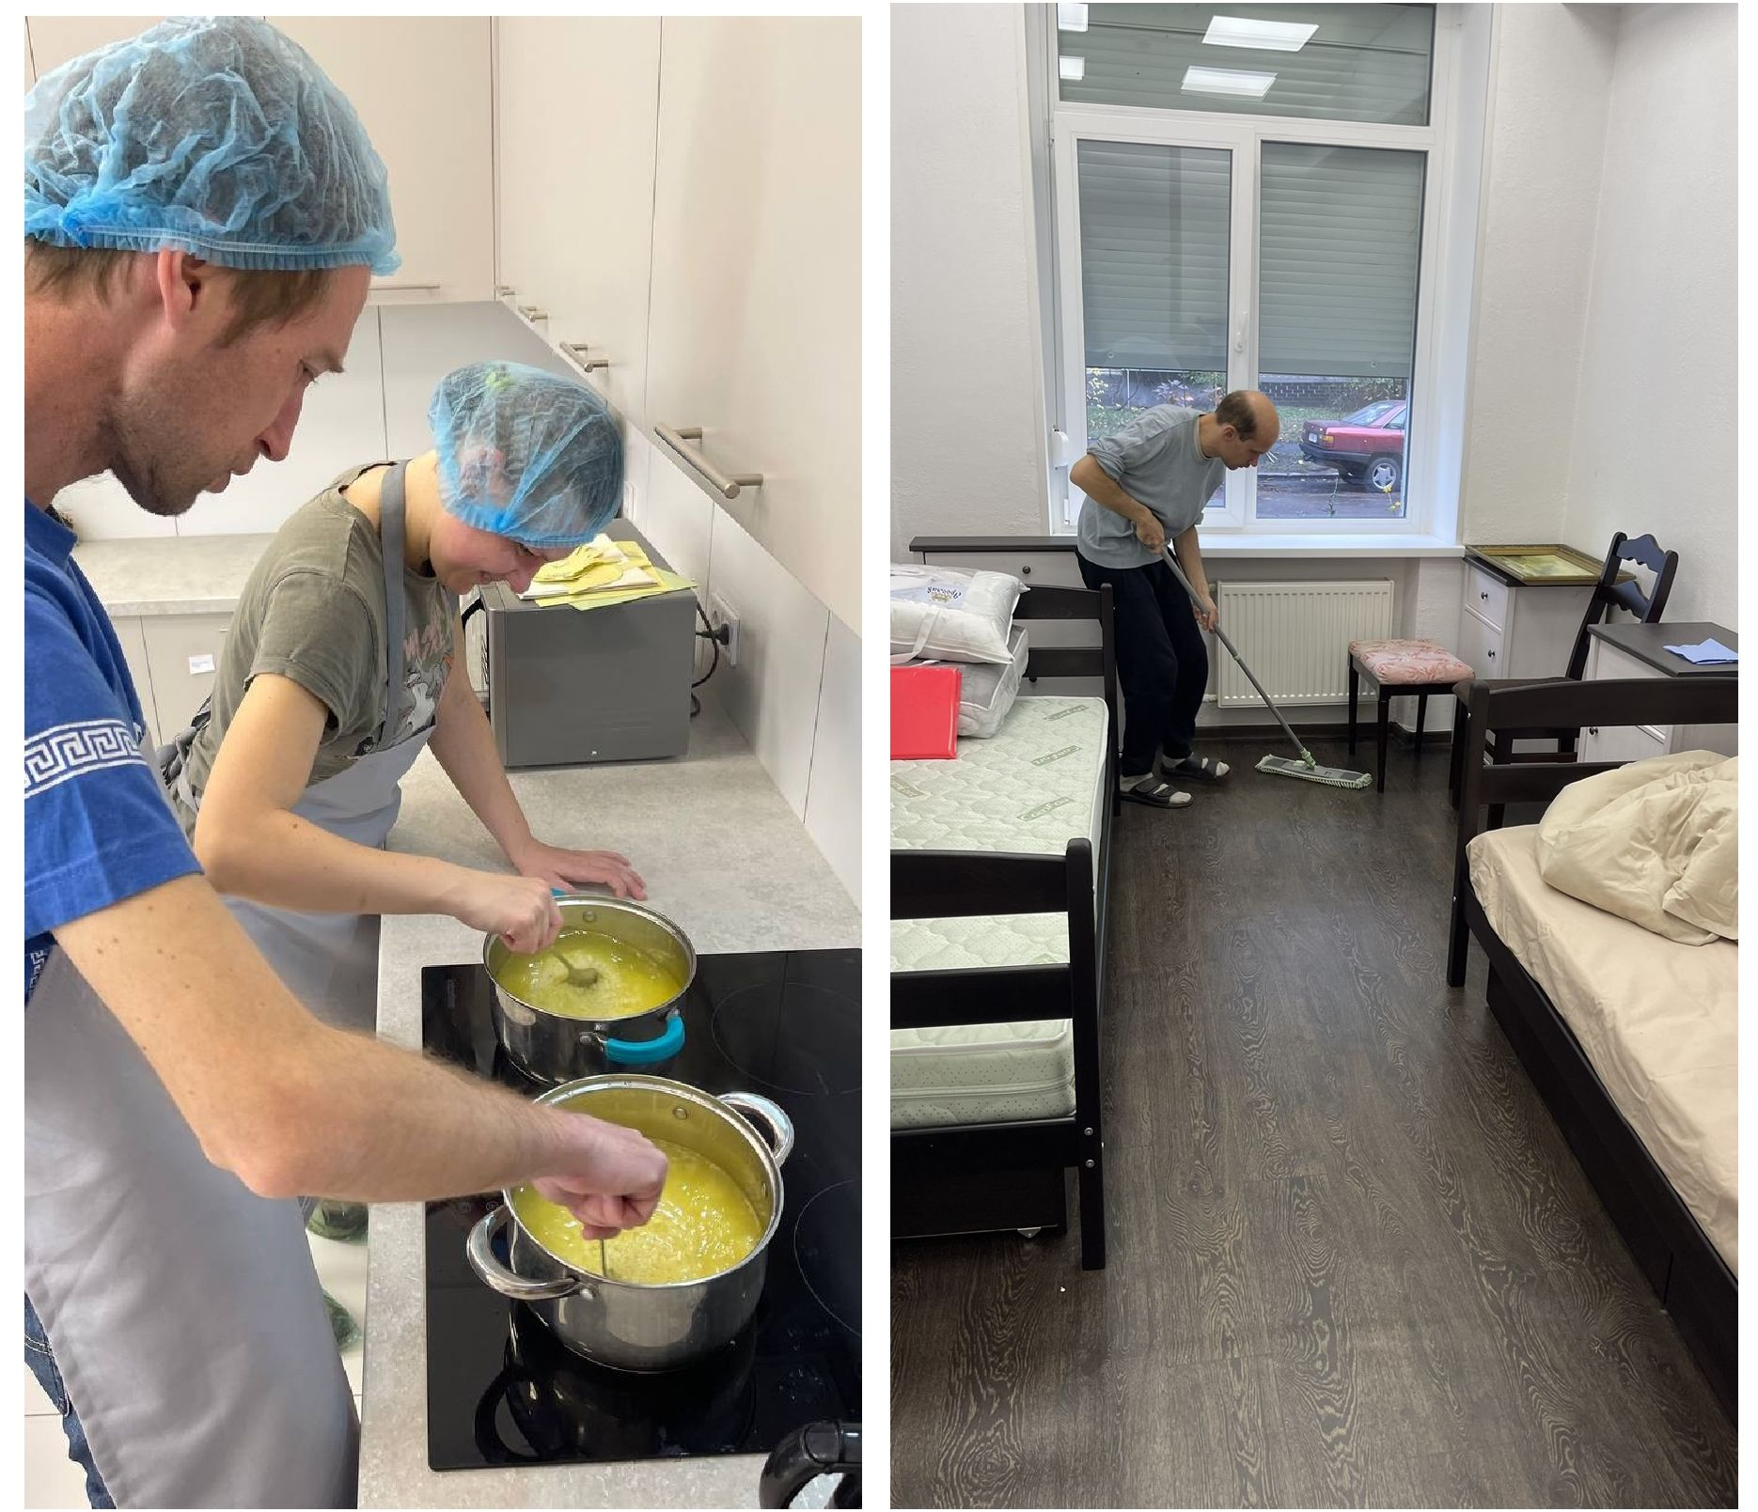

*Cooking in a transit apartment of the NGO “Family for Persons with Disability”*

Since 2023, a transit apartment has been operating in the Inclusive Center “Horniatko Dobroty”, where children with intellectual disabilities master social skills living in families, with the support of the “Mental Health in Ukraine” project.

One of the tasks is to show parents of children who have never left their families, that children can live separately from them and build relationships, be independent.

Social workers, psychologists, and a rehabilitation specialist work with residents according to individual rehabilitation plans during a month. After completing the training course, parents and residents are given recommendations on maintaining independent living skills.

The organization of activities is carried out in accordance with the requirements of the state standard for social services for supported living of the elderly and people with disabilities. A service provision agreement is concluded with residents or legal representatives.

Two residents can undergo rehabilitation at the same time, and apartment is adapted for their comfortable residence: living rooms, kitchen, sanitary rooms are equipped in accordance with the requirements of the State Construction Standard. Until now, about 16 people have been trained.

*“We have certain results. Previously the child was constantly using gadgets, now he takes his father for walks. At the center, he was recommended to take daily walks to lose excess weight. Now he takes his father out and tries to stick to the regimen” (from an interview with Nadia Maiorova).*

In In Fastiv, Kyiv region, the renovation of a supported living house for 8 people (in 4 living rooms) continues. A cooperation has been established with representatives of the city authorities.

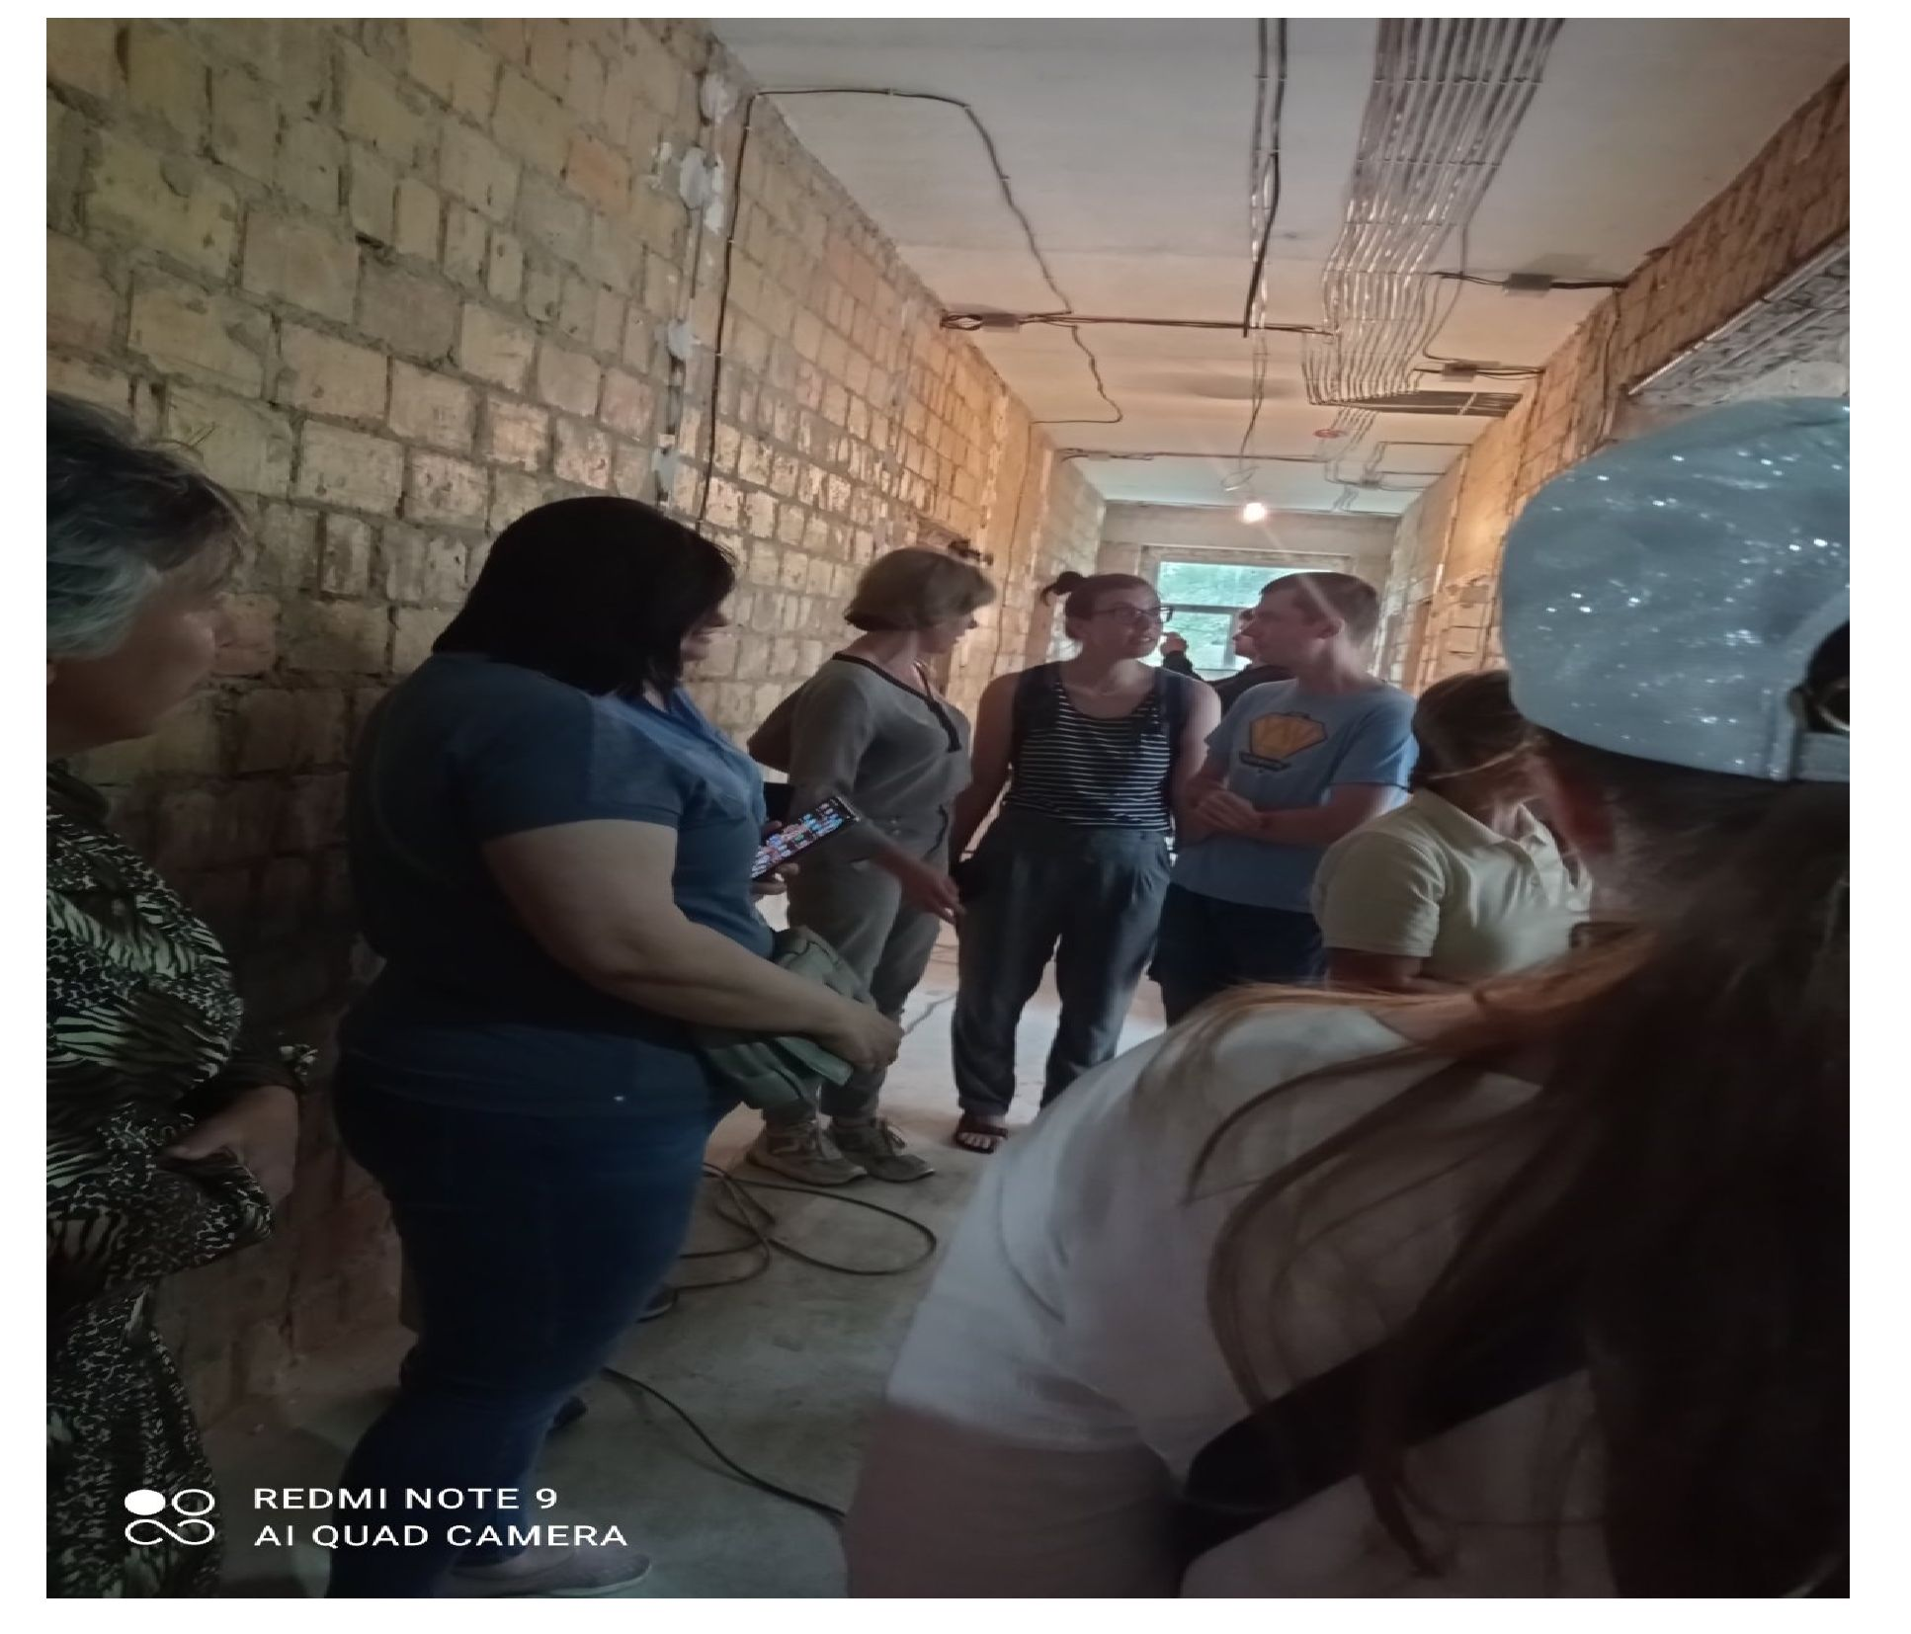

*Future supported living house in the city of Fastiv*

Other providers of social services of supported living

According to information of regional military administrations, the following charitable organizations provide social services of supported living for 196 people: Charitable Organization Foundation “Hospital Ivanopil” in Zhytomyr region;

Charitable Foundation “House of Mercy of Blessed Mykola Charnetskyi” in Ivano-Frankivsk region;

Charitable organization “Mykolaiv Center for Social Rehabilitation “Vidnovlennia”.

According to the Ministry of Social Policy of Ukraine, in 2024, in addition to Lviv and Kyiv regions, Chernivtsi and Chernihiv regions will be involved in the supported living pilot project. In Chernivtsi region, with the support of the United Nations Development Program, it is planned to create a supported living house for 10 people and 1 transit / educational apartment of supported living for 3 people.

Implementation of the idea of supported living in residential institutions

The idea of supported living found a response from several heads of residential institutions, who tried to adapt the service to the conditions of their facilities.

Thus, for 5 care recipients of the Veselivskyi Psycho-Neurological Institution, a “Funny Apartment” for[social adaptation](https://helpus.org.ua/a.php?n=521012) was arranged in a building for employees next to the boarding house. The main issue was finding funds to pay the staff who would provide support to the women.

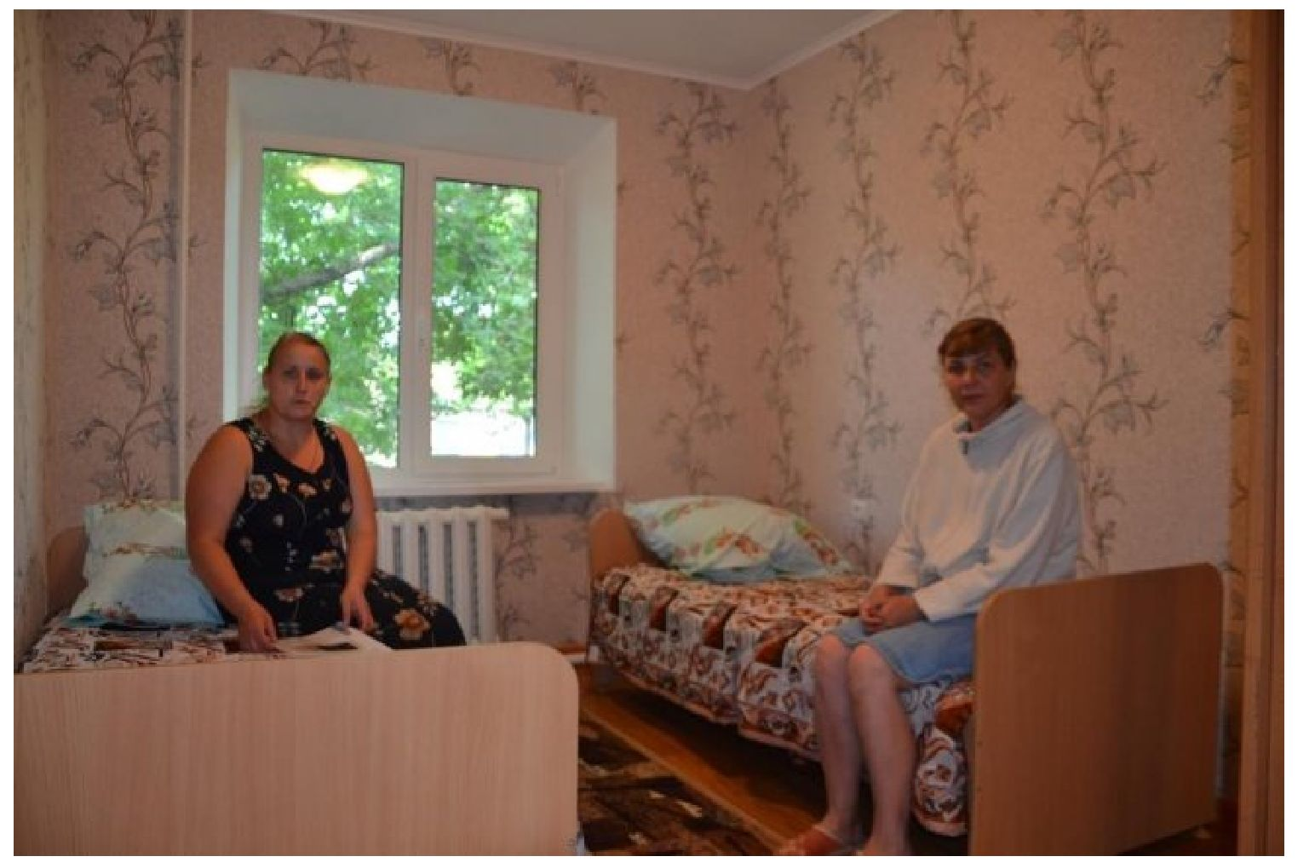

*“Funny Apartment”. Photo from open sources*

In 2017, the deinstitutionalization reform was launched in Ukraine, which provided for the gradual closure of residential institutions and the creation of alternative forms of care, such as supported living. The goal of the reform is to provide people with disabilities with the opportunity to live in the community, receiving the necessary support.

The organization of supported living on the territory of residential social care facilities, despite the opportunity to implement it, is causing a discussion in civil society about its effectiveness. The issues that cause concern when organizing the provision of SL on the territory of facilities:

1. Difficulties in the free exit of care recipients outside the facility;
2. The remote location of facilities from populated areas, which prevents the establishment of social ties between care recipients and other residents of the communities;
3. Lack of opportunities for care recipients to be employed in remote communities and stigmatization when hiring;

*“...there is one woman who … came (to the NGO “Destigma”) and wanted to get a job. She submitted a resume. And then they submitted this resume to the employer. To the store, if I recall. He looked at her whole story and said: “No, no, we don’t need such people.” But when she at the same time. But when (the organization employee) and this woman directly came to the owner, he says: “No, no. You’ve sent the documents. I don’t need her, you see. Anything can happen.” And this assistant says: “Well, look. Here, she is standing, playing with your grandson on the street.” The grandson was small, and she was talking to him, playing. And he had a completely different idea of a person when he read the description, the documents. And when he saw her, what she can do, he hired her. Do you understand?...The stigma decreases with a personal contact” (from an interview with Orest Suvalo).*

1. Possible transfer of the institutional model to the practice of the SL department/apartment/room;
2. Lack of specific knowledge of providing services by staff;
3. Lack of funding and separate premises;
4. Lack of a regulatory framework which takes into account all aspects of providing SL services;
5. Lack of qualified personnel who can provide services.

*“We have developed a range of measures, taking into account the ICF, Paradise and other scales for assessing (needs) of persons with mental and intellectual disorders.*

*1/4 of (care recipients) had professional experience, had experience living in the community, with a workforce. So, they have these skills. But, nevertheless, experience shows and the results of the survey showed that the longer people are in residential institutions, the fewer skills they have regarding independent life” (from an interview with Iryna Serhienko).*

One significant obstacle is the extremely difficult process of returning civil capacity to a person in facilities.

*“...the institution of incapacity. should be abolished in Ukraine in general, but it exists – and this is the biggest risk, I believe. And one more thing: the absolute lack of readiness of communities to provide services. 10 communities don’t have any social service for people with disabilities” (from an interview with Olena Temchenko, NGO “Ukrainian Human Rights Initiatives”).*

Despite numerous issues, there are also positive practices of implementing services in residential facilities:

1. During the period from 2018 to 2024, 7 people living in the community under social support were integrated into society (MI “Gorohiv PNI of Volyn Regional Council”);
2. Employment and independent living in a social dormitory of 6 care recipients with the support of mentors-employees of the institution (MI “Odesa Children’s Residential Institution”);
3. A department of supported living on the basis of a children’s institution was equipped in accordance with the requirements of barrier-free living (Municipal Institution “Сenter for social services” of the Hlodosy Village Council);
4. Ten residents of the supported living department were transferred from the PNI to a geriatric home in the period from 2018 to 2023 (MI “Sniatynskyi PNI of Ivano-Frankivsk Regional Council”);
5. Increasing the level of life competence, mastering professional skills (loader, janitor, gardener, orderly, cook, seamstress,working with a computer) (MI “Nizhyn Children’s Residential Institution of Chernihiv Regional Council”);
6. Two individuals created a family and live in the community (MI “Zamhlai Psycho-Neurological Institution”);
7. Employment of care recipients (MI “Bila Tserkva Children’s Residential Institution of Kyiv Regional Council”);
8. After completing vocational training, 6 care recipients were employed in the institution for positions that do not require special education (MI “Odesa Children’s Residential Institution”).

At the same time, the practice of implementing SL in facilities faces numerous issues that are often almost impossible. The issues are primarily related to the enormous difficulties in employing a person with a disability, which is the basis for his independent existence in the community.

There is no state system of support for persons who have left residential social care facilities. In the absence of interaction between all stakeholders interested in implementing reforms, such reforms may remain unrealized.

“...in order for people not to end up in a residential institution, in our opinion, in the opinion of the expert community, the public, this is, first of all, the procedure for placement in a residential institution must end; basic social services in the community must be developed. *Including, with support for such categories of persons. ” (from an interview with Olena Temchenko).*

With the participation of the international organization SOFT Tulip, specialists of specialized departments of the Transcarpathian RMA, heads of charitable organizations and residential facilities discussed plans for the development of supported living for persons with disabilities in Transcarpathia and the implementation of a pilot project of supported living on the basis of the Vilshanskyi Children’s Residential Institution55.

Experience in organizing supported living in the MI “Gorohiv Psycho-Neurological Institution of Volyn Regional Council”

The department of supported living was created in 2018 in accordance with the Model Regulation on the Supported Living Department for the Elderly and Persons with Disabilities, approved in 2017.

55

[https:/ //www.0312.ua/news/3652673/pidtrimane-prozivanna-dla-osib-invalidnistu-ak-jogo-rozvivatimut-v-zakarpatti](https://www.0312.ua/news/3652673/pidtrimane-prozivanna-dla-osib-invalidnistu-ak-jogo-rozvivatimut-v-zakarpatti)

“...on January 30, 2018, we created a department. *At that time, we had 5 clients who wanted to, had a desire to be in this group” (from an interview with Yuliia Kovalchuk).*

The department does not have a separate building, it is located in a separate wing of the PNI building, having 6 living rooms, designed for living of 1 to 5 people. Residents of the department have a separate bathroom, a living room with 2 washing machines, a kitchen with all the necessary appliances (kitchen set, electrical appliances, refrigerator, built-in dishwasher, electric oven, electric stove) and a hall for general meetings and watching TV.

*“We have a contact with social specialists (in the communities). We have been maintaining contact with them for quite a long time because in the communities, unfortunately, they do not know what to do with such people. And at the beginning, when we socialized one person, their eyes were round. And, it was, you know, such uncertainty: “What are we going to do with them? We are not ready! We do not know! We are not a residential institution!” (from an interview with Yuliia Kovalchuk).*

A multidisciplinary team of 8 specialists has been created to work with clients. The team includes a director, a psychiatrist, 2 psychologists, a senior nurse, an occupational therapy instructor, a cultural organizer and a nurse, a legal advisor. The needs of the care recipients are studied through questionnaires. The care recipients are taught to cook, use payment cards, a terminal, and pay their bills on time.

*“...at first it was quite difficult. It took us a whole year to be able to guide people in the right direction. This was training. It was pure training. We talked to them. We observed their ... “issues” every day. And the issues were that they were mainly... they came from orphanages. And they didn’t know how to peel potatoes or boil them, to cook something for themselves. And even more, use a washing machine (from an interview with Yuliia Kovalchuk).*

As of 2024, the department is visited by 18 people, in five years 7 people have been socialized and returned to the community. The Rokada Foundation conducted trainings for residents of supported living facilities on mastering social skills.

*“The main issue today is the premises. The premises must be separated from the inpatient building. People must live separately. They must have their own exit and entrance so that no one can control them when they come. We ask the Germans for a tiny house, at least for 8-10 people. This is first. Secondly, workshops. Workshops areextremely necessary because people in supported living have to study somewhere”.*

**Supported living and social adaptation in the geriatric hospital of the Zaporizhzhia city territorial center of social services**

Supported living services for elderly and the organization of social adaptation activities have been introduced in the geriatric hospital of the Zaporizhzhia City Territorial Center for Social Services56.

The geriatric hospital is the only institution in Zaporizhzhia that provides the social service of supported living. Elderly and people with disabilities who are partially unable to self-care temporarily live here. The period of stay starts from one month. The facility has single and double rooms for clients.

People are sent to the institution by decision of the Department of Social Protection of the Population based on the results of determining needs. The recipients of the service are elderly or persons with disabilities. The stay can be free of charge or differentiated, depending on the client’s income.

Upon the doctor’s prescription, clients can undergo procedures in a physiotherapy room. Exercise machines are installed on the territory of the geriatric hospital. In the geriatric hospital, they say that many of the care recipients use them, despite their age.

Supported living in the Pereiaslav city territorial community

The second department of supported living for people with psychic disorders has been opened in the Pereiaslav city territorial community of the Kyiv region. Pereiaslav was one of the first in the Kyiv region to open a department of supported living for 7 people in 2019.

The first department of supported living in Pereiaslav was opened as a structural unit of the Center for the Provision of Social Services and Social Integration (hereinafter referred to as the “Center”) in 2019. It is financed from the regional budget. Coordination of the work of the department, organizational and methodological support and control over its activities are carried out by the Center.

*“The Ministry of Social Affairs today redirected the powers of the activities of the social sphere institutions of the region to the consideration of the management, the Kyiv Regional Council is our founder, basically, it delegated the rights of the founder to approve all our activities to us, and we*

1. <https://forpost.media/novosti/u-zaporizhzhi-diie-posluha-pidtrymanoho-prozhyvannia-dlia-litnikh-liudey.html>

*did it, we put it down as we see it, but without violating the requirements of the Ministry of Social Affairs and we work under the state standards of the Ministry of Social Affairs and provide services according to state standards. And the classifier of social services, which is for each standard, we have developed our own standards for each department, social services, we now have up to 70 different social services” (from an interview with Raisa Holovanova).*

The department is located in a separate building that belongs to the Center. The department consists of four separate living rooms, a kitchen, a corridor, utility and sanitary rooms. 7 people live in the department (3 men and 4 women). During the period of operation of the department, three civil couples have been formed among the clients, who, accompanied by assistants, lead their own lives, furnish rooms, buy things and prepare food according to personal preferences.

*“. three men, young guys, agreed to move to our department for permanent residence (and another PNI), at first we took them as if on vacation, registered them for 2 months and when I saw that civil couples had formed, we transferred them to our permanent place of residence in the supported living department, and thank God, they are living successfully. They have already been able to earn money at this time, since 2019, I allowed them to work part-time, they furnished their rooms the way they wanted, I allowed them to do it, everything, including curtains, sheets, bed linen, which they ordered online, lamps, refrigerators, everything they wanted, they are now firmly on their feet and arranged their housing the way they want” (from an interview with Holovanova Raisa).*

One of the care recipients of the supported living department (hereinafter referred to as the “SL”) is employed at the Center, other care recipients also have the opportunity to work and receive a salary for their work on an equal basis with others. The care recipients of the SL department are involved in community life, are active participants in cultural and mass events57.

The second department (building) of the SL Center was opened in December 2023 with the support of the Ukrainian-Swiss project MH4YOU. With the help of grant assistance, a major renovation of abandoned building was carried out, rooms were equipped for living, staff training was conducted, and assistants were involved to provide support for care recipients. Clients were provided with conditions for social integration and personal development.

1. <https://phm.gov.ua/?p=199414>

The department is financed mainly by the funds of a donor project, which is planned until the end of 2024, only individual items of expenditure are covered from the regional budget. The department is located in a rented building in the center of Pereiaslav, which was crucial for the formation of social interaction skills of care recipients and their involvement in the life of the territorial community. The department is equipped with a large dining room and kitchen, furnished and equipped with the necessary appliances: refrigerators, microwave ovens, multicookers, kettles and dishes.

*“...they (clients) prepare a menu, cook for the week, prepare what they want, the first few days they ate fried potatoes, they ate the entire norm, we even brought them our potatoes from home. In the end I still had 5-6 bunches in the cellar that my husband and I hadn’t eaten, so I gave them those potatoes and said, people, please enjoy fried potatoes until you’re full. When I arrived, a month and a half later I asked, what are you eating now? Do you still eat fried potatoes? “No, we don’t eat fried potatoes anymore, we bake pizzas, pies, etc.” And then there was the second stage – varenyky, varenyky with all sorts the fillings, they had already eaten them” (From an interview with Raisa Holovanova).*

The department has a large hall with a plasma TV and wireless Internet (Wi-Fi). Residents of the SL live two people in a room, choosing their neighbours. They are given the right to choose and the opportunity to change neighbours. As of June 2024, 8 clients live in the SL (6 women and 2 men), two of whom are employed at the Center.

Assistants of the SL departments who provide support have undergone special training. The main social services provided to clients of the SL department are the development and support of self-care skills and other skills necessary for independent living; assistance in organizing the daily routine and household management (purchasing and delivering food, medicines and other goods, cooking, cosmetic cleaning); assistance in solving social issues, etc. The staff teaches SL clients to use ATMs and bank cards, which they are currently successfully doing on their own and encourages them to earn money on their own, helps restore and maintain clients’ ties with relatives, friends and members of the local community, organizes various cultural and entertainment events, including excursions, visits to museums, entertainment evenings, participation in local holidays and festivals.

Each client of the SL department has an individual rehabilitation plan, which assistants help to implement through the participation of clients in relevant rehabilitation processes and classes. Clients of SL departments have the opportunity to receive rehabilitation in the Center’s comprehensive rehabilitation department, withlarge training halls, a swimming pool, a computer class, a phytobar, and emotional discharge rooms.

*Now I’m directing them to that guys. Let’s learn to make money if you want ... new computers., make money. They learned to dress, I’ll tell you honestly, their first purchases were in second-hand stores,... a social worker... took them to a second-hand store, and you know, they chose such products that when they came to my office, I looked at these sneakers for a long time and asked: “Liosha, how much did you pay for these sneakers, because I saw that they were expensive,” – and he told me that he bought them for 70 hryvnias in a second-hand store, so I was very surprised, because ... they learned to dress, and they do it well. Now they can afford to go to the market to buy. This is the first supported living department, which I have been operating for almost 5 years” (from an interview with Raisa Holovanova).*

Rehabilitation classes include physical exercises, classes with a psychologist, computer courses and other activities under the guidance of qualified specialists. In addition, clients undergo rehabilitation in labour workshops, are involved in cultural and educational events, with the aim of their socialization and adaptation in society, establishing communicative ties, in particular, this is cooperation with students of the local pedagogical university, who are often the same age as clients of the SL departments.

*“Look, my advice, if someone wants to open such a supported living department outside the residential institution, the first task is to accustom the residents of the city or community or village to the fact that these people are just like them. They went to these classes in groups, at first with caution, but now they walk calmly, they are well dressed, they are photogenic, they are accompanied, for example, 10 people are accompanied by one person, they know where the crossings are. Then we gave them tickets for public transport, for example, they went weaving nets for the military, they went there with a labourer and they also walk to this department on foot, it's about a kilometer and a half, but it’s in the city, you know, the city center, and they come there, and there are four hours of classes scheduled, some with a rehabilitation specialist, some in a physical education room, some in a computer class and that’s how they undergo educational rehabilitation” (from an interview with Raisa Holovanova).*

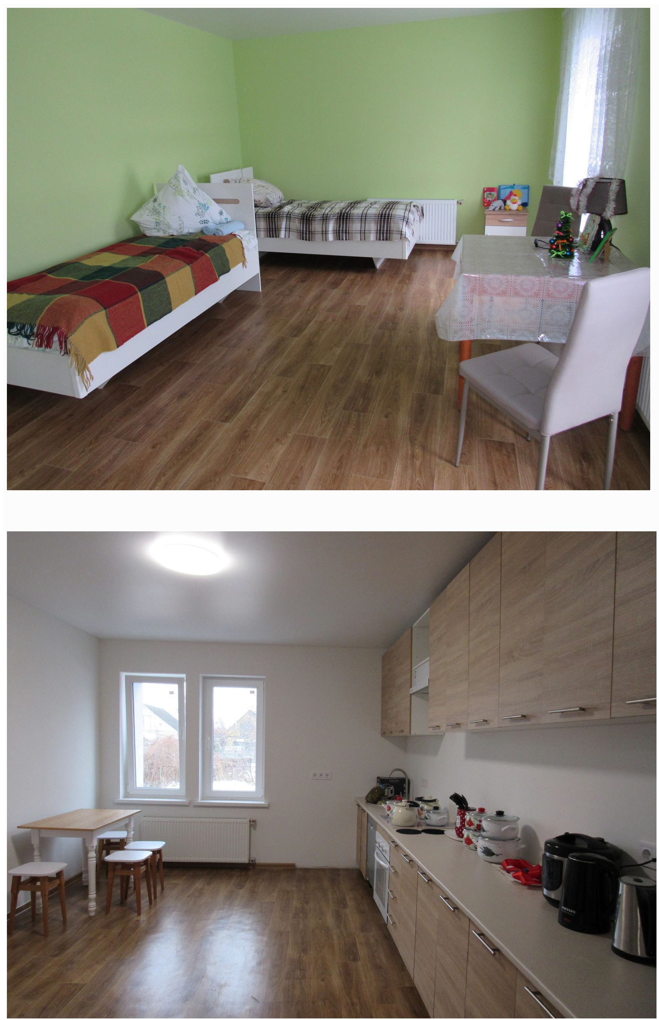

Department of supported living in Pereiaslav, Kyiv region. *Photo from open sources.*

Borodiansk Psycho-Neurological Institution with a Geriatric Department

Since 2017, the SL unit has been home to 16 people, 7 people of them are employed. With the support of the World Health Organization and Humanitarian Aid Office in Ukraine, Project HOPE Ukraine, another supported living department has been opened for 8 people with physical impairments.

**Attitudes of communities to the introduction of supported living. Barriers to the development of SL**

In order to study public opinion, 55 residents of territorial communities of Sumy, Odesa, Vinnytsia, and Lviv regions were involved in the work of focus groups, 13 interviews were conducted, including with social services providers and recipients. The focus group participants made important conclusions about the situation of people with disabilities in Ukraine and the progress of supported living development.

1. One of the issues is the lack of adequate aggregated statistics on the number of people with disabilities in Ukraine and the failure to assess the quality of care.

*“...As of today, the most recent figure that I have been able to obtain from government agencies is 3.1 million people with a registered disability.* But of these people, a very small number actually have a visible disability” (from an interview with Iryna Fedorovych, an expert).

1. Despite positive changes, the system of supported living in Ukraine still faces many challenges. These include insufficient funding, a lack of qualified personnel, and the need to develop appropriate infrastructure.

According to experts, communities are mostly not ready to equip supported living centers due to a lack of finances, ignorance of how to do it, widespread stigmatization of people with psychic disorders, and are not ready to see people with disabilities, especially mental, as their neighbours.

*“...communities do not have an understanding and vision of how to create certain services for such citizens. For now, it is beneficial for them, because it does not require them to use extra resources, which are already limited. And, accordingly, it does not require them to create any new initiatives or think about what to do with those people. Right? People with disabilities are sent to a residential institution, everyone is calm and satisfied” (from an interview with Orest Suvalo).*

1. Existing barriers that prevent the active development of SL can be combined into three groups:
2. Construction of infrastructure, which involves the construction or rental of the necessary number of dwellings to transfer a large group of people who currently live in institutions to the system of supported living. (houses, apartments, social hostels) and requires significant resources.
3. Training and payment of qualified specialists to support people in supported living conditions.

*“... social services assess needs based on existing services. That is, they assess the needs of the population in services that communities can provide. They do not assess what the population really needs. People who need something more do not fall into their field of vision at all” (from an interview with Iryna Fedorovych, an expert).*

1. Difficulties in integration processes in people with acquired helplessness. Restoring social communication skills will cause difficulties, especially for elderly.

*“The idea of reforming institutions will also worry communities. People worked and paid taxes to the budget. Perhaps community leaders will think that they will lose everything, in particular, the buildings will stand empty, and they will have to think about what to do with them. We need to approach this not as an issue, but as open opportunities. Perhaps they should think about what services the communities lack, and what exactly these buildings could be used for, or to remodel the building itself, use it for other community needs. Perhaps it could have been social housing for displaced persons after reconstruction” (from an interview with Tetiana Lomakina).*

1. Residents of communities mostly identify a person with a disability as a person in a wheelchair, deaf or blind, or with other visible physical impairments.

*“...we still have a medical-charitable model of understanding disability in Ukraine, which, accordingly, affects the perception of people with disabilities and the attitude towards them: from sympathy and pity to the unfounded idea that these people are incapable of something. The second thing that is worth emphasizing is that we still do not really understand what disability is and the diversity of people with disabilities. We perceive them as a large group. Forgetting that we have visible and invisible disabilities, there are very different disabilities and different experiences – which also affects perception.”*

1. People with psychic disorders are not perceived as a person with a disability, but are perceived as carrying a hidden or open threat to others.

*“.there is such a “capricious pity”. That is, on the one hand we seem to pity, but on the other hand we distance ourselves from all this, we have fears, clear stereotypes that this is a danger, for example,intellectual disabilities are a danger to others. There is ignorance, that is, total ignorance regarding the fact that in general, children and adolescents with intellectual disabilities often become victims”.*

*“Of course, there are fears, you pass, you don’t know what’s going on in his head”.*

1. The communities have not created conditions for the autonomous existence of persons with disabilities on an equal basis with others. Despite the rapid changes in ensuring a barrier-free environment, there is no systematic solution to the issue of transport and accessibility to public places.

*“In T... community, we have Centers for Administrative Services Provision, for example, and a shop, which are adapted for people with disabilities. But, unfortunately, transport, minibuses are not designed for people with wheelchairs, it is very difficult for them. I think it’s the same situation in all communities.”*

*“For example, we have a court on the second floor, and we also have a bell there. But, as far as I know, only women work in our court, I can’t even imagine how they will go out and lift someone in a wheelchair there. So, it’s there just as formality.”*

1. No assistance is provided with employment, accompaniment or employment with support, provision of a permanent assistant at work and supported living.

*“Employers don’t really want to hire people with disabilities, it is believed that they are not so capable, they are difficult to fire later, there are some restrictions and barriers.”*

1. There is a problem with medical care for children and adolescents, related to the absence or insufficient number of pediatric psychiatrists in the communities. There is also a need to increase attention to early intervention, which can help prevent a child from becoming disabled.
2. Inclusive education has been introduced in general secondary education institutions (GSE), but at the same time, the barrier-free environment needs further improvement.

The availability of the “Child’s Assistant” service does not meet the urgent need. Providing children with disabilities with the opportunity to receive education in GSE will reduce the risk of them ending up in residential institutions.

*“The Child’s Assistant service has only been operating since last year and its availability is extremely low, plus the accessibility, physical accessibility of schools is at a very low level. At best, it is a ramp at the entrance, but what about the restroom, and between floors? Children withmusculoskeletal disorders currently have significantly less access to inclusive education than other children.*

1. . After completing their studies in secondary education institutions, children with disabilities do not have equal opportunities with other children to choose a profession, vocational training, and employment.

*“...the development of social services is hampered by the lack of understanding of communities, unwillingness. Despite the fact that the actual authority of each community is to provide social services, not every community understands these authorities. There is not always a structural unit that should be engaged in the administration and development of the system of social services provision. There is no planning regarding development of social services. Because information, counselling and home care are the main social services that have been provided and are provided today. There is no desire to develop and expand the list of social services. Needs are not identified in many territorial communities. Therefore, they do not know what social services are needed and by which categories. Therefore, of course, working with communities. advocacy for the development of social services is very necessary”*

Social services financing

Financing of social services of supported living and assisted living is a weak link in the implementation of the deinstitutionalization reform.

Houses/apartments/rooms of supported living are financed by donor organizations. The vast majority of such initiatives are funded by charitable foundations and organizations.

State funding for such services is sporadic and not sustainable. Despite the forced break of state funding in 2022, Vinnytsia RMA resumed the procurement of supported living and social support services during inclusive education in 2023.

*“Now we have to take care of transit supported living: when a person with a disability is taught to calmly continue his life in a familiar environment and independently serve himself under the supervision of a social worker, even if his parents are gone. On the other hand, we work with mothersof individuals who are relieved that their child will not go to a residential institution,” – Nataliia Zabolotna, Deputy Head of Vinnytsia MRA 559.*

According to the Ministry of Social Policy of Ukraine, in order to ensure the availability of social services for people in difficult life circumstances due to hostilities, temporary occupation, de-occupation, etc., and to ensure the provision of certain social services aimed at preserving life and health, the Ministry of Social Policy has developed a new mechanism for the transition from using budget funds for maintaining budget institutions to using them as payment for social services.

*“I support the idea of benefits monetization. Because when the state decides for you what means of rehabilitation you receive and when, regardless if it suits you or not, money is better” (focus group materials).*

In particular, a draft resolution of the Cabinet of Ministers of Ukraine “Some issues of implementing a pilot project on organizing the provision of social services of inpatient care and supported living to internally displaced persons on the principle of “Money follows the person” (hereinafter referred to as the “pilot project”)”60 has been developed. The resolution No. 888 was adopted on August 6, 2024. Within the framework of the pilot project, internally displaced persons in need of inpatient care or supported living services will receive funds to their own special account to pay for such services.

Conducting training on organizing the provision of social services of supported living

Training specialists is a priority task of the state for further development of supported living in Ukraine. In accordance with the Procedure for Using Funds Provided in the State Budget Funds for Advanced Training of Social Work Specialists and Other Social Protection System Employees, approved by Resolution of the Cabinet of Ministers of Ukraine No. 598 dated June 9, 2021, the Ministry of Social Policy transfers budget funds to regional social protection bodies for the purchase of services for conducting short-term seminars (trainings) for social work specialists and other social protection system employees, which ensure the identification of individuals/families with children belonging to vulnerable groups of the population and/or in difficult life circumstances, the organization of providing them with social services in order to improve their qualifications (deepening knowledge, forming and developing relevant professional skills).

1. [https://www.msp.gov.ua/news/23616.htmPPrintVersion](https://www.msp.gov.ua/news/23616.html?PrintVersion)
2. [**http://surl.li/xgkixt**](http://surl.li/xgkixt)

[https://www.vin.gov.ua/dep-smp/sotsialni-posluhy/690-sotsialne-zamovlennia/28519-oholoshennya-5-sotsialna-posl](https://www.vin.gov.ua/dep-smp/sotsialni-posluhy/690-sotsialne-zamovlennia/28519-oholoshennya-5-sotsialna-posluha-pidtrymane-prozhyvannia-osib-z-invalidnistiu) [uha-pidtrymane-prozhyvannia-osib-z-invalidnisti](https://www.vin.gov.ua/dep-smp/sotsialni-posluhy/690-sotsialne-zamovlennia/28519-oholoshennya-5-sotsialna-posluha-pidtrymane-prozhyvannia-osib-z-invalidnistiu)

60

In 2024, the Ministry of Social Policy has determined one of the priority areas of such training, in particular, ensuring decent care for persons in need (reforming the institutional care system, providing full or partial opportunities for persons with disabilities to live independently with the necessary services at their place of residence through the development of a social service of supported living).

In order to implement joint projects and programs aimed at the development of a social service of supported living, the Ministry of Social Policy cooperates with international and public organizations.

In particular, within the framework of piloting a social service of supported living together with partners from the Swiss project “Mental health for Ukraine – MH4U”, the Lviv City Center for Social Services and Rehabilitation “Dzherelo” launched a training program for specialists in providing a supported living service in 2023.

In accordance with the Law, in order to provide quality social services, educational institutions (including institutions of postgraduate education) that have an appropriate license issued in accordance with the established procedure shall carry out training, retraining and advanced training of specialists and professionals of social service providers.

Public associations, international organizations, charitable, religious and non-governmental organizations, institutions and organizations that have experience in working with relevant vulnerable groups of the population may be involved in the advanced training of the above specialists and professionals.

Training, retraining and advanced training of social workers are carried out through formal or informal professional training in accordance with the legislation.

Seminars and trainings on the provision of social services for employees of institutions, institutions that provide social services in the relevant administrative units, social work specialists, officials of district, district in Kyiv and Sevastopol state administrations, local self-government bodies are held by regional, Kyiv city centers of social services.

At the same time, the proposed training is not enough, and such training is carried out by public organizations involved in the implementation of SL services. Thus, with the support of the Ukrainian-Swiss Project [Mental Health for Ukraine](https://www.facebook.com/MH4Ukraine?__cft__%5b0%5d=AZVHi-KOd4xiGc8y16ypkesJXTLh7HxPixF_WppYaeFuAisNJ39l5D9iMyT4PAAse7c7J-ljQN5YSv1hscm1sd-E7pXPBLLqJvRLUo73NO1bEjyCWwGQR0cyjIokHamylXhJDCozv6jh4EEGryKTwke16nwchOK8QG65XGKdrCv5iu6nXvYhjNQZVAm6CYJdocYyvA-FaaTvGEvASNhDINQGG552grvGWfhulOSBpANRgAlta7AHqG0EzTXjFg9Eq49P9G0CPlNBSS83IWb7raVQ&__tn__=-%5dK-y-R), teams of specialists of the NGO “Family for Persons with Disability”, NGO “See with Your Heart”, and Municipal Institution “Сenter for social services” from Kyiv, Fastiv and Pereiaslav made a study visit to Lviv. In Lviv, they adopted the experience of creating supported living houses and services for people with disabilities from the NGO [“Dream Workshop”](https://www.facebook.com/maysternia.mriyi?__cft__%5b0%5d=AZVHi-KOd4xiGc8y16ypkesJXTLh7HxPixF_WppYaeFuAisNJ39l5D9iMyT4PAAse7c7J-ljQN5YSv1hscm1sd-E7pXPBLLqJvRLUo73NO1bEjyCWwGQR0cyjIokHamylXhJDCozv6jh4EEGryKTwke16nwchOK8QG65XGKdrCv5iu6nXvYhjNQZVAm6CYJdocYyvA-FaaTvGEvASNhDINQGG552grvGWfhulOSBpANRgAlta7AHqG0EzTXjFg9Eq49P9G0CPlNBSS83IWb7raVQ&__tn__=-%5dK-y-R), and [Emmaus](https://www.facebook.com/emaus.ucu?__cft__%5b0%5d=AZVHi-KOd4xiGc8y16ypkesJXTLh7HxPixF_WppYaeFuAisNJ39l5D9iMyT4PAAse7c7J-ljQN5YSv1hscm1sd-E7pXPBLLqJvRLUo73NO1bEjyCWwGQR0cyjIokHamylXhJDCozv6jh4EEGryKTwke16nwchOK8QG65XGKdrCv5iu6nXvYhjNQZVAm6CYJdocYyvA-FaaTvGEvASNhDINQGG552grvGWfhulOSBpANRgAlta7AHqG0EzTXjFg9Eq49P9G0CPlNBSS83IWb7raVQ&__tn__=-%5dK-y-R).[The Center for Support for People with Special Needs](https://www.facebook.com/emaus.ucu?__cft__%5b0%5d=AZVHi-KOd4xiGc8y16ypkesJXTLh7HxPixF_WppYaeFuAisNJ39l5D9iMyT4PAAse7c7J-ljQN5YSv1hscm1sd-E7pXPBLLqJvRLUo73NO1bEjyCWwGQR0cyjIokHamylXhJDCozv6jh4EEGryKTwke16nwchOK8QG65XGKdrCv5iu6nXvYhjNQZVAm6CYJdocYyvA-FaaTvGEvASNhDINQGG552grvGWfhulOSBpANRgAlta7AHqG0EzTXjFg9Eq49P9G0CPlNBSS83IWb7raVQ&__tn__=-%5dK-y-R), [L'Arche-Kovcheh](https://www.facebook.com/LArche.Ukraine.Lviv?__cft__%5b0%5d=AZVHi-KOd4xiGc8y16ypkesJXTLh7HxPixF_WppYaeFuAisNJ39l5D9iMyT4PAAse7c7J-ljQN5YSv1hscm1sd-E7pXPBLLqJvRLUo73NO1bEjyCWwGQR0cyjIokHamylXhJDCozv6jh4EEGryKTwke16nwchOK8QG65XGKdrCv5iu6nXvYhjNQZVAm6CYJdocYyvA-FaaTvGEvASNhDINQGG552grvGWfhulOSBpANRgAlta7AHqG0EzTXjFg9Eq49P9G0CPlNBSS83IWb7raVQ&__tn__=-%5dK-y-R), and MI “Dzherelo”.

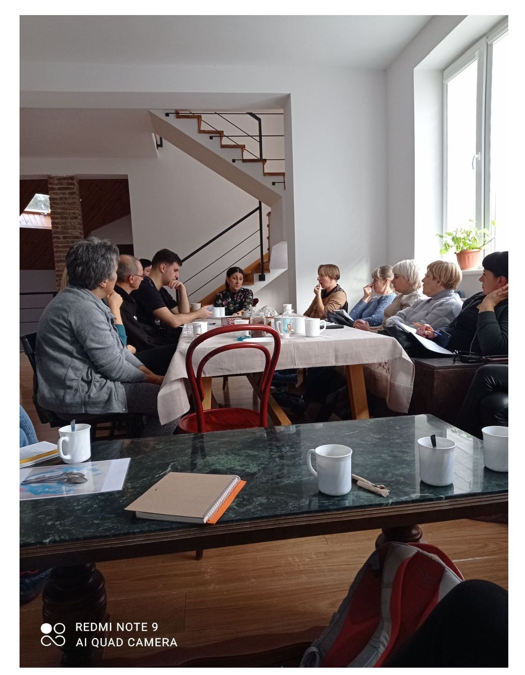

CONCLUSIONS AND RECOMMENDATIONS

1. The development of social services of supported living and assisted living has been identified as a priority area of activity by the Ministry of Social Policy of Ukraine.
2. There are numerous barriers to the development of supported living in Ukraine, such as the lack of infrastructure, which requires significant resources; lack of qualified specialists; acquired helplessness of social services recipients.
3. The primary tasks are to prevent the placement of children with intellectual disabilities to institutions by introducing inclusive education and changing the state policy on the employment of people with mental disorders.
4. The regulatory and legal framework for the provision of social services of supported living requires improvement. Supported living services are actually provided to different categories of the population: children and adults with disabilities, internally displaced persons, and elderly. There is a need to improve the State Standard for the Provision of Social Services of SL for all categories of the population that need services.
5. The Model Regulation on a House (Apartment) of Supported Living has not been developed.
6. The main sources of funding for supported living in Ukraine are charitable foundations and organizations, the system of state orders is hard to access for social service providers.
7. To ensure supported living for children with intellectual and complex disabilities, parents unite in public organizations and try to independently provide training in social skills for children to live independently.
8. To ensure the proper level of provision of supported living services, conditions are needed for training and advanced training of personnel, especially in regions with an insufficient number of employees.
9. According to the Ministry of Social Policy of Ukraine, as of 01.01.2014, 40.8 thousand people lived in 259 residential social care facilities.
10. About 9.4 thousand people live in the inpatient departments of territorial social service centers (provision of social services), centers for the provision of social services.
11. Residential social care facilities (excluding non-state providers) have 29 supported living units (620 care recipients) and 7 rooms (148 care recipients). Another 386 people receive the service of supported living under another form of organization of social service provision.
12. 1,154 people received supported living services, while, according to the institution staff, 1,490 people can receive such services outside the institution. This means that in presence of appropriate conditions, 1,490 people can leave institutions and return to their communities, provided with support.
13. According to information from residential facilities (374 responses), 76 residents of residential social care facilities have been employed. At the same time, under condition of necessary conditions, according to the managers, another 272 people could work.
14. According to the information provided (366 responses), 19 people in 6 residential facilities are receiving education.
15. According to the heads of residential social care facilities, conditions for providing the SL service are available in 53 (15.6%); conditions are absent in 286 (84.4%).
16. The main obstacle to the introduction of SL in residential social care facilities is the lack of separate equipped premises outside residential institutions, the lack of separate funding, and the lack of personnel to implement the service.
17. There are some positive results of work in residential social care facilities, where, in the absence of conditions, people are socialized and returned to the community.
18. Communities lack a vision of ways to implement SL and reduce the level of stigmatization of people with psychic disorders.
19. As of 06.06.2024, the Register of Social Services Providers and Recipients of the Ministry of Social Policy of Ukraine included information about 255 social services providers providing social services of supported living, of which 103 institutions are municipally owned, 152 are non-state social services providers.
20. In 61 residential social care facilities, assistance to SL clients is provided by social workers, in 11 by psychologists.
21. The lack of a comprehensive system of social service of supported living in communities is the reason for the long-term stay of patients in healthcare institutions providing psychiatric care. As of 01.06.2024, 17,142 patients were in healthcare institutions providing psychiatric care. Of them:

IDPs – 1004;

have lost social ties and require transfer to residential social care facilities of the Ministry of Social Policy of Ukraine (lack of housing, relatives, documents, etc.) – 865;

have lost social ties, but due to their mental and physical health are capable of autonomous life in conditions of supported living in communities – 250.

1. .supported living (assisted living – SL), home care (HC), day care (DC) services are provided in territorial communities at the place of residence of citizens and by stationary residential social care facilities.
2. .According to information of regional military administrations, as of 24.06.2024, 300,870 residents of territorial communities of 24 regions received the above services.
3. .The social service “Supported living ” (SL) is provided for 556 people in communities, which is 0.2% of the total number of social services of supported living, home care, day care recipients. The social service is provided by 63 social workers/employees; 11 psychologists; 27.5 full-time junior healthcare workers.
4. . The social “home care” service (HC) is the most popular social service in communities. Received by 268,124 persons. In communities 17,521.75 social workers, 273.5 psychologists and 73.5 junior healthcare workers are involved.
5. . The “Day Care” social service (DC) is provided to 32,190 persons. The Day Care service is provided by 190 social workers/employees, 54 psychologists, and 391 junior healthcare workers.
6. .Today, supported living has become a more widespread and recognized type of social service in Ukraine. New institutions and programs providing supported living are emerging. New standards and approaches contributing to the integration of service recipients into society, providing them with opportunities for self-realization and improving the quality of life are being introduced.
7. .Continuation of reforms and adaptation of best international practices remain priorities for the further development of this important social service.
8. .It is worth noting the international practice of financing care and support separately from the cost of housing, the consistency of payment conditions in different institutions. The current need is the organization of supported employment of persons with disabilities, the adoption of supported employment programs. There is a request for the introduction of the “Personal Assistant” service.
9. .Providers of SL services need systematic state assistance.
10. .The social service of supported living should be based on the principles of an individual approach, decentralization, partnership with NGOs and an orientation towards integration into the community. Such comprehensive approach allows for a high level of support and contributes to the creation of an inclusive society, where every person has the opportunity to live with dignity and actively participate in public life.

***Recommendations for increasing the implementation of supported living:***

Recommendations for the supported living system in Ukraine

1. Integration of existing services:

Integrate existing social and medical services into supported living programs.

1. Creating a multi-level support system:

Provide different levels of care, from basic (home care) to specialized (medical and legal assistance).

1. Financing:

Provide for various sources of funding, such as government programs, grants from international organizations, and private donors.

Develop financial mechanisms for sustainable financing of programs. Implement the “Money Follows the Person” initiative for supported living.

1. Training:

Provide a system of training and certification of specialists providing supported living services.

1. Legal support:

Develop a regulatory framework for supported living programs.

1. Cooperation with non-profit organizations:

Involve NGOs in the implementation of programs, as they have experience working with vulnerable groups of the population.

Involve business representatives to ensure employment of persons with disabilities and strengthen the state policy aimed at the development of supported living.

1. Information support and accessibility:

Increasing awareness of citizens about available services through various communication channels.

Develop systems for easy access to services, including online platforms and hotlines.

1. Pilot projects and scaling up:

Launch pilot projects in several regions to assess program effectiveness.

After success of pilot projects, scale up programs nationwide.

ANNEXES

*Annex 1*

**QUESTIONNAIRES FOR INTERVIEWS**

Questions to the Government Representative

1. Please tell about the Government’s strategy aimed at developing supported living and assisted living in Ukraine. Does it have such a strategy? If so, when was it adopted and what was its rationale?
2. What specific actions have been taken by the Government to ensure the development of social services for supported living and assisted living in communities?
3. Is the regulatory framework sufficient to ensure such activities?
4. What issues and challenges do you think the state needs to overcome for anyone to receive social services for supported living in communities?
5. How does the Government plan to ensure financing for supported living programs? Are additional sources of funding envisaged, in particular from international funds or organizations?
6. What criteria determine the need for supported living? What methods are used to assess the effectiveness of the services provided?
7. Are there any regional differences in access to supported living services in Ukraine? If so, how does the Government plan to address this issue?
8. How does the Government plan to involve local communities and civil society organizations in the development and provision of supported living services?
9. What education and training programs are available for staff providing supported living? How does the Government ensure their professional development?
10. Does the Government plan to develop special programs for specific groups of people, such as people with disabilities, the elderly, the homeless, etc.?
11. What measures are taken to raise public awareness of the possibilities of supported living?
12. How does the Government plan to monitor and evaluate the implementation of supported living programs? Are independent experts or organizations involved in this process?

Questions to the social service of supported living recipient

1. How shall I address to you?
2. Do you know the name of the institution you are currently in? Why are you here?
3. Where did you live before and why?
4. Describe your day, what you do.
5. What do you study, who teaches you?
6. What do you eat? What food do you like?
7. Can relatives or friends come to visit you?
8. Do you like everything in the institution now? Is there anything you would like to change?
9. What things can you use yourself, and what does the staff help you with?
10. Do you have free access outside the institution, if so, where do you go and for what purpose?
11. Do you have the opportunity to earn money, if so, tell about it.
12. What would you like to change in the institution you are in?
13. Are you satisfied with the help of the staff?
14. Do you have plans for the future, if so, how you imagine it.

Questions to representative of state authorities

1. Please introduce yourself, where you work, what is your position.
2. What can you say about statistics, in particular about the number of people with disabilities in Ukraine, about the network of social services for inpatient care and supported living/assisted living.
3. Is there a mass demand for this type of service in communities?
4. What regulatory and legal acts aimed at the development of assisted living/supported living have been developed in Ukraine.
5. What regulatory and legal acts for the provision of the above-mentioned social services are lacking?
6. Please tell about the strategy of the Ministry of Social Policy aimed at the development of supported living in Ukraine. Does it have such a strategy? If so, when was it adopted and what was its rationale.
7. What has been implemented to date? What is planned to be done in the near future.
8. In your opinion, what issues do not allow the full implementation of supported living in communities.
9. Is the regulatory and legal framework sufficiently developed? How should the supported living service be financed? Who is the provider?
10. Do you know any positive practices of implementing supported living projects in Ukraine? If so, can you tell more about it?
11. What can you say about the role of the state in the development of supported living?

Questions to representatives of a public organization

1. Please introduce yourself, what PO you represent, what is your position.
2. Why are you interested in the topic of assisted living (supported living), when and why did you start it?
3. What are the prospects for the development of supported living in Ukraine?
4. Tell about your role (the role of the organization) in the development of supported living in Ukraine. What is your project about?
5. Has the community contributed to the implementation of the project aimed at supported living, or is it ready to cooperate? Tell more about this experience.
6. What difficulties do you encounter during the implementation of the project?
7. In your opinion, what issues do not allow the full implementation of supported living in communities.
8. Do you know any positive practices of implementing supported living projects in Ukraine? If so, can you tell more about it?
9. What can you say about the role of the state in the development of supported living?
10. What can you advise organizations that plan to introduce supported living, how should they start and what should they pay attention to?
11. Who is funding your project and paying for supported living?

Questions to the head of the institution providing the service of supported living

1. Please introduce yourself, your full name, position, and what institution you represent.
2. Tell about your supported living unit, when and for what purpose it was established.
3. The number and profile of the unit’s clients. Who are your clients?
4. List social services provided to the unit’s clients in detail.
5. What living conditions are created in the unit?
6. What rehabilitation methods are used, what other social services are provided? What “quality of client’s life” means for you?
7. Employees providing support. Their number, professional education, professional training, how many of them work on a permanent basis. How their skills are improved? What are measures for their burnout prevention?
8. What are their main work responsibilities?
9. How is the unit funded (by state, by donor projects, combined funding). Sources? Scope? Are paid services provided? What is the demand for services in the market?
10. Are there any volunteer organizations that provide help, what are their names, and what assistance do they provide?
11. How do you cooperate with state authorities and local governments?
12. What are the main issues of the supported living unit?
13. What are your plans for the future, what assistance do you need?
14. What positive experience can you share? What results can you share?
15. What mistakes can other organizations make during organizing the activities of a similar supported living facility? Have you made any mistakes during organizing supported living?
16. What could you have done better under more favourable conditions? What “favourable conditions” are?

*Annex 2*

**GUIDELINES FOR CONDUCTING FOCUS GROUPS**

**Guide for Focus Groups with Supported Living Service Recipients General Questions**

In your opinion, how many children and adults with disabilities are in your community? Where do they mostly live?

What challenges do people with disabilities typically face? What do they need most? What kind of support do they need?

How would you describe society’s attitude toward people with disabilities? What fears or prejudices do you think people might have about neighbouring with people with disabilities?

**Opportunities for people with disabilities**

How well, in your opinion, is the support for children and adults with disabilities organized in Ukraine? Which categories of people with disabilities are most in need of external support?

Is your community accessible, well equipped for people with various forms of disabilities? Why?

Are there institutions or services providing such support? Please, specify. Any public organizations that deal with issues of people with disabilities?

**Attitudes and awareness towards residential facilities**

Have you ever lived in a residential institution or a boarding house? Describe your experience. What did you like about the residential institution? What did you dislike? Were there any restrictions (in walks, in dates, in going outside the institution, in food, in the daily routine, etc.)?

What did you miss in the residential institution which is available now?

Why do people with disabilities get to residential institutions? Does everyone who lives there require it? Which of the residents of residential institutions, in your opinion, can live in the community? Why?

Who do you think needs residential institutions? And who can live in the community? Why?

In general, in your opinion, where should people with various forms of disabilities live?

**Supported living**

What do you know about supported living? How did you find out about this service? Describe your experience. What do you like? What do you dislike?

What kind of help do you get? What can you do on your own?

What do you do during the day? How often do you take a walk? Do you socialize in the community? Do you buy things? How do you relax?

What changes have you noticed in your well-being, mood after moving to supported living?

What do you miss in supported living? What should be changed/added/removed?

How many people do you think require supported living services? Who are these people, first of all?

How do you think is society ready for the active involvement of people with disabilities in the everyday life of the community?

**Taking action**

What do you think needs to be done to make the community/population ready to accept people with different disabilities?

How much should children be told in schools about people with disabilities and their needs? How important is it to cover this in the media? How do you feel about involving people with disabilities in employment, in social projects in communities? What else can be done to ensure that every person can live in their own family or live with support in their community?

How do you feel about the idea that part of the community budget would be spent on developing services for people with psychic/mental disorders? What percentage of the budget could be allocated for this each month?

**Guide for Focus Groups with heads of institutions regarding Supported Living Service**

**General questions**

Tell about people with disabilities in your institution or in institutions similar to yours in general. What are their main needs regarding living conditions? And regarding social support and assistance? Medical, rehabilitation needs? What other needs can you mention?

What difficulties may residents of residential institutions with disabilities face when living in the community?

What stereotypes about people with disabilities do you think exist in society? Why?

**Attitudes towards people with psychic/mental disorders**

Let’s separate people with psychic/mental disorders. What do you think are the main issues faced by people with psychic/mental disorders in our society?

How would you describe society’s attitude toward people with mental disabilities? Is it different from the attitude towards people with physical disabilities? How?

What fears or prejudices do you think people might have about neighbouring with people with mental disabilities?

**Opportunities for people with disabilities**

In your opinion, how well are Ukrainians aware of the rights and needs of people with disabilities? How often are events related to people with disabilities covered in the media?

How well is support for people with disabilities organized in Ukraine? Which categories of people with disabilities are most in need of external support? in our country?

Is your community accessible, well equipped for people with various forms of disabilities?

How well is physical accessibility ensured for people with disabilities? for visiting various institutions and organizations?

What social support is provided to people with physical disabilities? With psychic/mental disorders?

Are there institutions or services providing such support? Please, specify. Any public organizations that deal with issues of people with disabilities?

To what extent are educational opportunities provided for children with disabilities? Children with psychic/mental disorders? What is missing?

**Attitudes towards residential facilities**

In your opinion, do residential facilities cover all the needs of people with disabilities? If not, why? Which ones don’t they cover?

Do you think that residents of residential institutions had an alternative to life in residential facilities?

Where, in your opinion, should people with various forms of disabilities live?

In your opinion, is it possible to return care recipients of residential facilities to their families/own homes and what is required for this?

In your opinion, what are the caveats regarding the return of people with disabilities and psychic/mental disorders to the community? Is it possible to overcome them? How?

**Supported living**

What do you know about supported living? What is it and is it implemented in your institution/community?

*If people don’t know, briefly explain to them that supported living is a model of care allowing people with disabilities to live as independently as possible in their communities, while receiving the necessary support for a full life. Such as medical, rehabilitation services, assistance in everyday life, in professional life, etc. This model will reduce the number of people with disabilities entering and staying in residential institutions.*

What advantages and disadvantages do you see in living of people with disabilities in the community compared to their living in residential facilities – residential institutions, boarding houses, etc.? What do you consider better for such people? And for other residents of the community?

What services should be included in the supported living program? Do you agree that these services can be paid for?

What risks or challenges do you foresee in implementing supported living programs in your community?

How many people do you think require supported living services? What are these categories?

How do you think is society ready for the active involvement of people with disabilities in the everyday life of the community?

**Taking action**

What measures could increase the level of understanding of the needs of people with disabilities in your community?

What do you think needs to be done to make the community ready to accept people with mental disabilities?

How effective can educational programs for children be? Information campaigns for the population? Involvement of people with disabilities in social projects, their employment? What else?

What do you think can be done in your communities to ensure that everyone can live in their own families or live with support in their community? How can you engage in this process?

How do you feel about the idea that part of the community budget would be spent on developing services for people with psychic/mental disorders? What percentage of the budget could be allocated for this each month?

Do you think people are willing to fully or partially pay for social services for people with disabilities?

**Guide for Focus Groups with community residents regarding Supported Living Service**

**General questions**

In your opinion, how many people with disabilities are in your community? How do you feel about people with disabilities? In your opinion, how many people with disabilities are in Ukraine? And in your community?

Are there people with disabilities among your acquaintances or relatives? Where do they live?

What challenges do people with disabilities typically face? What are their main needs regarding living conditions? And regarding social support and assistance? What other needs can you mention?

What is the first thing that comes to mind when you hear about people with disabilities? Who do you imagine?

What stereotypes about people with disabilities do you think exist in society? Why?

**Attitudes towards people with psychic/mental disorders**

Let’s separate people with psychic/mental disorders? Do you have such acquaintances or relatives? Where do they live?

What do you think are the main issues faced by people with psychic/mental disorders in our society?

How would you describe society’s attitude toward people with mental disabilities? Is it different from the attitude towards people with physical disabilities? How?

What fears or prejudices do you think people might have about neighbouring with people with mental disabilities?

**Opportunities for people with disabilities**

In your opinion, how well are Ukrainians aware of the rights and needs of people with disabilities? How often are events related to people with disabilities covered in the media?

How well is support for people with disabilities organized in Ukraine? Which categories of people with disabilities are most in need of external support? in our country?

Is your community accessible, well equipped for people with various forms of disabilities?

How well is physical accessibility ensured for people with disabilities? for visiting various institutions and organizations?

What social support is provided to people with physical disabilities? With psychic/mental disorders? Are you willing to pay for social services for yourself and your family?

Are there institutions or services providing such support? Please, specify. Any public organizations that deal with issues of people with disabilities?

To what extent are educational opportunities provided for children with disabilities? Children with psychic/mental disorders? What is missing?

**Attitudes and awareness towards residential facilities**

In your opinion, where do people with disabilities live, especially those with psychic/mental disorders?

Are you aware of any residential facilities in your community that accommodate people with disabilities? What do you know about the services and living conditions in these facilities? Are they open?

What do you think are the reasons why people end up in residential social care facilities?

Do you think these people had any alternative to living in residential facilities?

Where should people with various forms of disability mostly live?

In your opinion, is it possible to return care recipients of residential facilities to their families/own homes and what is required for this?

In your opinion, what are the caveats regarding the return of people with disabilities and psychic/mental disorders to the community? Is it possible to overcome them? How?

**Supported living**

What do you know about supported living? What is it and is it implemented in your community?

*If people don’t know, briefly explain to them that supported living is a model of care allowing people with disabilities to live as independently as possible in their communities, while receiving the necessary support for a full life. Such as medical, rehabilitation services, assistance in everyday life, in professional life, etc. This model will reduce the number of people with disabilities entering and staying in residential institutions.*

What advantages and disadvantages do you see in living of people with disabilities in the community compared to their living in residential facilities – residential institutions, boarding houses, etc.? What do you consider better for such people? And for other residents of the community?

What services should be included in the supported living program? Do you agree that these services can be paid for?

What risks or challenges do you foresee in implementing supported living programs in your community?

Do you know anyone in your community who would need supported living services? How many? Are you willing to pay supported living services for yourself and your family?

How do you think is society ready for the active involvement of people with disabilities in the everyday life of the community?

**Taking action**

What measures could increase the level of understanding of the needs of people with disabilities in your community?

What do you think needs to be done to make the community ready to accept people with mental disabilities?

How effective can educational programs for children be? Information campaigns for the population? Involvement of people with disabilities in social projects, their employment? What else?

What do you think can be done in your communities to ensure that everyone can live in their own families or live with support in their community? How can you engage in this process? Volunteer? Take in a person with a disability? Support public organizations that deal with this topic?

How do you feel about the idea that part of the community budget would be spent on developing services for people with psychic/mental disorders? What percentage of the budget could be allocated for this each month?

**Guide to a focus group with experts on supported living**

**General questions**

In your opinion, how, how many people with disabilities are in Ukraine? How many of them are outside the statistics? Why?

What challenges do people with disabilities typically face? What are their main needs regarding living conditions? And regarding social support and assistance? What other needs can you mention?

What do you think is the first thing people think of when they hear about people with disabilities? Is it a physical disability? Mental disorder?

What stereotypes about people with disabilities do you think exist in society? Why?

**Attitudes towards people with psychic/mental disorders**

Let’s separate people with psychic/mental disorders. What do you think are the main issues faced by people with psychic/mental disorders in our society?

How would you describe society’s attitude toward people with mental disabilities? Is it different from the attitude towards people with physical disabilities? How?

What fears or prejudices do you think people might have about neighbouring with people with mental disabilities?

**Opportunities for people with disabilities**

In your opinion, how well are Ukrainians aware of the rights and needs of people with disabilities? How often are events related to people with disabilities covered in the media?

How well is support for people with disabilities organized in Ukraine? Which categories of people with disabilities are most in need of external support? in our country?

Are communities accessible, well equipped for people with various forms of disabilities? Is there any territorial difference? By the size of the settlement? By the distance from regional centers? What else?

How well is physical accessibility ensured for people with disabilities? for visiting various institutions and organizations?

What social support is provided to people with physical disabilities? With psychic/mental disorders in communities? Are you willing to payfor social services for yourself and your family? Are people willing to pay for social services for yourself and your family?

Do you know any examples of communities/settlements of well-implemented social support for people with disabilities? Please, specify.

How many institutions or services provide such support? Please, specify. Any public organizations that deal with issues of people with disabilities?

To what extent are educational opportunities provided for children with disabilities? Children with psychic/mental disorders? What is missing?

**Attitudes towards residential facilities**

In your opinion, do residential facilities cover all the needs of people with disabilities? If not, why? Which ones don’t they cover?

Do you think that residents of residential institutions had an alternative to life in residential facilities? Why? What?

Where, in your opinion, should people with various forms of disabilities live?

In your opinion, is it possible to return care recipients of residential facilities to their families/own homes and what is required for this?

In your opinion, what are the caveats regarding the return of people with disabilities and psychic/mental disorders to the community? Is it possible to overcome them? How?

**Supported living**

What do you know about supported living? What is it and is it implemented in Ukraine?

*If people don’t know, briefly explain to them that supported living is a model of care allowing people with disabilities to live as independently as possible in their communities, while receiving the necessary support for a full life. Such as medical, rehabilitation services, assistance in everyday life, in professional life, etc. This model will reduce the number of people with disabilities entering and staying in residential institutions.*

What advantages and disadvantages do you see in living of people with disabilities in the community compared to their living in residential facilities – residential institutions, boarding houses, etc.? What do you consider better for such people? And for other residents of the community?

What services should be included in the supported living? Personal assistant? Involvement of other professionals? How individualized should supported living be? Do you agree that these services can be paid for?

What do you think about the duration of supported living service? Can it be permanent? Why?

What risks or challenges do you foresee in implementing supported living programs in communities?

How many people do you think require supported living services? What are these categories? Are you willing to pay supported living services for yourself and your family?

How do you think is society ready for the active involvement of people with disabilities in the everyday life of the community?

**Taking action**

What measures could increase the level of understanding of the needs of people with disabilities in Ukraine?

What do you think needs to be done to make the community ready to accept people with mental disabilities?

How effective can educational programs for children be? Information campaigns for the population? Involvement of people with disabilities in social projects, their employment? What else?

What do you think can be done in communities to ensure that everyone can live in their own families or live with support in their community?

In your opinion, how does population feel about the idea to spend part of the community budget on developing services for people with psychic/mental disorders?

**Guide for Focus Groups with parents of Supported Living Service Recipients**

**General questions**

In your opinion, how many children and adults with disabilities are in your community? Where do they mostly live?

What challenges do people with disabilities typically face? What are their main needs regarding living conditions? And regarding social support and assistance? What other needs can you mention?

What do you think is the first thing people think of when they hear about people with disabilities? Is it a physical disability? Mental disorder?

What stereotypes about people with disabilities do you think exist in society? Why?

**Attitudes towards people with psychic/mental disorders**

Let’s separate people with psychic/mental disorders. What do you think are the main issues faced by people with psychic/mental disorders in our society?

How would you describe society’s attitude toward people with mental disabilities? Is it different from the attitude towards people with physical disabilities? How?

What fears or prejudices do you think people might have about neighbouring with people with mental disabilities?

**Opportunities for people with disabilities**

In your opinion, how well are Ukrainians aware of the rights and needs of people with disabilities? How often are events related to people with disabilities covered in the media?

How well is the support for children and adults with disabilities organized in Ukraine? Which categories of people with disabilities are most in need of external support? in our country?

Is your community accessible, well equipped for people with various forms of disabilities?

How well is physical accessibility ensured for people with disabilities? for visiting various institutions and organizations?

What social support is provided to people with physical disabilities? With psychic/mental disorders?

Are there institutions or services providing such support? Please, specify. Any public organizations that deal with issues of people with disabilities?

To what extent are educational opportunities provided for children with disabilities? Children with psychic/mental disorders? What is missing?

**Attitudes and awareness towards residential facilities**

Are you aware of any residential facilities in your community that accommodate people with disabilities? What do you know about the services and living conditions in these facilities? Are they open?

In your opinion, do residential facilities cover all the needs of people with disabilities? If not, why? Which ones don’t they cover?

What do you think are the reasons why people end up in residential social care facilities?

Do you think that residents of residential institutions had an alternative to life in residential facilities? Why? What?

Where, in your opinion, should people with various forms of disabilities live?

In your opinion, is it possible to return care recipients of residential facilities to their families/own homes and what is required for this?

In your opinion, what are the caveats regarding the return of people with disabilities and psychic/mental disorders to the community? Is it possible to overcome them? How?

**Supported living**

What do you know about supported living? How did you find out about this service? Describe your experience. What do you like? What do you dislike?

What advantages and disadvantages do you see in living of people with disabilities in the community compared to their living in residential facilities – residential institutions, boarding houses, etc.? What do you consider better for such people? And for other residents of the community?

What services should be included in the supported living program? Do you agree that these services can be paid for?

What risks or challenges do you foresee in implementing supported living programs in your community?

How many people do you think require supported living services? What are these categories?

How do you think is society ready for the active involvement of people with disabilities in the everyday life of the community?

**Taking action**

What measures could increase the level of understanding of the needs of people with disabilities in your community?

What do you think needs to be done to make the community ready to accept people with mental disabilities?

How effective can educational programs for children be? Information campaigns for the population? Involvement of people with disabilities in social projects, their employment? What else?

What do you think can be done in your communities to ensure that everyone can live in their own families or live with support in their community?

How do you feel about the idea that part of the community budget would be spent on developing services for people with psychic/mental disorders? What percentage of the budget could be allocated for this each month?

*Annex 3*

**Number of residential social care facilities and number of people as of 01.01.2024 by regions**

|  |  |  |  |
| --- | --- | --- | --- |
| **No.** | **Residential social care facilities**  **protection** | **Number of institutions** | **Number of care recipients** |
| 1 | Residential institutions (PNI, geriatric homes) | 259 | 34.8 thousand people |
| 2 | Children’s residential institutions | 36 | 4.1 thousand people |
| 3 | Residential institutions for the elderly and persons with disabilities | 78 | 10.7 thousand people |
| 4 | Psycho-neurological institutions | 145 | 26.0 thousand people |
| 5 | Residential departments  of territorial social service centers (provision of social services), centers for the provision of social services | 305 | 9.4 thousand people |
| Total care recipients/residents | | 564 | 44.2 thousand people |

*Annex 4*

**Number of clients receiving supported living services in residential social care facilities by region**

|  |  |  |  |  |  |  |  |  |
| --- | --- | --- | --- | --- | --- | --- | --- | --- |
| No. | 1 | 2 | 3 | 4 | 5 | 6 | 7 | 8 |
| 1 | Vinnytsia | 4882 | 38 | 36 | 0 | 2 | 0 | 0 |
| 2 | Volyn | 1167 | 31 | 57 | 0 | 12 | 0 | 2 |
| 3 | Dnipropetrovsk | 2498 | 23 | 1 | 11 | 3 | 0 | 0 |
| 4 | Luhansk | 87 | 10 | 4 | 0 | 10 | 2 | 5 |
| 5 | Zhytomyr | 2846 | 490 | 367 | 4 | 28 | 0 | 5 |
| 6 | Donetsk | 6 | 6 | 0 | 0 | 0 | 0 | 0 |
| 7 | Zakarpattia | 1226 | 15 | 60 | 6 | 53 | 0 | 35 |
| 8 | Ivano-Frankivsk | 1928 | 47 | 166 | 0 | 20 | 0 | 0 |
| 9 | Kyiv | 1445 | 101 | 56 | 12 | 31 | 0 | 28 |
| 10 | Kirovohrad | 4869 | 61 | 205 | 1 | 50 | 0 | 0 |
| 11 | Lviv | 17 | 17 | 15 | 2 | 5 | 1 | 6 |
| 12 | Mykolaiv | 439 | 82 | 84 | 2 | 7 | 0 | 5 |
| 13 | Odesa | 3987 | 146 | 131 | 11 | 74 | 1 | 17 |
| 14 | Poltava | 1956 | 45 | 0 | 0 | 0 | 0 | 0 |
| 15 | Rivne | 492 | 348 | 1 | 0 | 0 | 0 | 0 |
| 16 | Sumy | 115 | 28 | 19 | 9 | 3 | 6 | 0 |
| 17 | Ternopil | 1231 | 20 | 16 | 0 | 2 | 0 | 2 |

|  |  |  |  |  |  |  |  |  |
| --- | --- | --- | --- | --- | --- | --- | --- | --- |
| 18 | Kharkiv | 145 | 12 | 6 | 0 | 0 | 0 | 0 |
| 19 | Khmelnytskyi | 6678 | 502 | 708 | 15 | 58 | 0 | 14 |
| 21 | Cherkasy | 1600 | 0 | 22 | 0 | 16 | 0 | 6 |
| 21 | Chernihiv | 1699 | 31 | 16 | 0 | 14 | 0 | 10 |
| Total: | | 39,313 | 2053 | 1970 | 73 | 388 | 10 | 135 |

Note:

1. Region
2. Total number of clients in residential facilities
3. Number of persons receiving supported living services in the institution (specify the number)
4. Due to their health condition, they can receive supported living services outside the institution
5. Number of employed receiving social service of supported living
6. Number of persons whose health allows for work, if the necessary conditions were created
7. Number of persons receiving education while receiving social service of supported living
8. Number of persons whose health allows them to receive education if the necessary conditions were created (specify the number).

*Annex 5*

**Information on the number of healthcare institutions providing psychiatric care and the number of their patients as of 01.06.2024**

|  |  |  |  |  |  |  |  |
| --- | --- | --- | --- | --- | --- | --- | --- |
| **1** | **2** | **3** | **4** | **5** | **6** | **7** | **8** |
| 1 | CNE “Vinnytsia Regional Clinical Psychoneurological Hospital named after Academician O. І. Yushchenko of Vinnytsia Regional Council” | Vinnytsia | 852 | 889 | 18 | 84 | 35 |
| 2 | CE “Volyn Regional Psychiatric Hospital of Lutsk” | Volyn | 620 | 787 | 8 | 3 | 5 |
| 3 | CE “Dnipropetrovsk Multidisciplinary Clinical Hospital for Psychiatric Care” of the Dnipropetrovsk Regional Council | Dnipropetrovsk | 1,695 | 1,795 | 24 | 41 | 0 |
| 4 | CNE “Regional Clinical Psychiatric Hospital of Sloviansk” | Donetsk | 30 | 29 | 0 | 0 | 0 |
| 5 | CNE “Psychiatric Hospital of Kramatorsk” | Donetsk | 30 | 23 | 3 | 0 | 0 |
| 6 | CNE “Psychiatric Hospital of Mariupol” | Donetsk | 30 | 30 | 24 | 0 | 0 |

|  |  |  |  |  |  |  |  |
| --- | --- | --- | --- | --- | --- | --- | --- |
| 7 | CNE “Regional Medical Specialized Center” of the Zhytomyr Regional Council | Zhytomyr | 500 | 586 | 0 | 15 | 2 |
| 8 | CNE “Regional psychiatric care facility” of Berehove” | Zakarpattia | 240 | 228 | 0 | 20 | 5 |
| 9 | CNE “Transcarpatian Regional Medical Center of Mental Health and Medicine of Addictions of the Transcarpatian Regional Council” | Zakarpattia | 110 | 104 | 12 | 2 | 7 |
| 10 | CNE “Regional Clinical Institution Psychoneurological and socially significant diseases” of Zaporizhzhia Regional Council | Zaporizhzhia | 813 | 373 | 8 | 25 | 0 |
| 11 | CNE “Prykarpattia Regional Clinical Center of Mental Health” of the Ivano-Frankivsk Regional Council | Ivano-Frankivsk | 641 | 464 | 45 | 93 | 0 |
| 12 | CNE of the Kyiv Regional Council “Regional Psychiatric and Narcological Medical Association” | Kyiv | 505 | 470 | 112 | 14 | 0 |
| 13 | CNE “Regional Center for Mental Health” | Kyiv | 335 | 335 | 73 | 9 | 0 |
| 14 | CNE “Regional Clinical Psychiatric Hospital” of Kirovohrad Regional Council | Kirovohrad | 560 | 760 | 22 | 31 | 0 |
| 15 | CNE “Oleksandriia Psychiatric Hospital” of Kirovohrad Regional Council | Kirovohrad | 40 | 31 | 0 | 7 | 1 |
| 16 | CNE of Lviv Regional Council “Lviv Regional Psychiatric Hospital” | Lviv | 773 | 807 | 80 | 19 | 6 |
| 17 | CNE “Clinical Hospital “Psychiatry” of the Executive Body of the Kyiv City Council” | Kyiv | 1390 | 1,093 | 57 | 9 | 23 |
| 18 | “City Institution for the Provision of Psychiatric Care” of the Executive Body of the Kyiv City Council | Kyiv | 145 | 159 | 0 | 18 | 51 |
| 19 | CNE “Mykolaiv Regional Center for Mental Health’” | Mykolaiv | 590 | 627 | 20 | 1 | 0 |
| 20 | CNE “Odesa Regional Medical Center of Mental Health of the Odesa Regional Council | Odesa | 1,405 | 1,784 | 137 | 10 | 2 |
| 21 | CNE “Regional Psychiatric Hospital No. 4” of Odesa Regional Council | Odesa | 300 | 257 | 39 | 19 | 6 |
| 22 | CNE “Regional psychiatric care facility” of Poltava Regional Council | Poltava | 753 | 724 | 136 | 128 | 18 |
| 23 | CNE “Rivne Regional Center for Mental Health” of Rivne Regional Council | Rivne | 145 | 137 | 4 | 2 | 0 |

|  |  |  |  |  |  |  |  |
| --- | --- | --- | --- | --- | --- | --- | --- |
| 24 | CE “Ostroh Regional Psychiatric Hospital” of Rivne Regional Council | Rivne | 250 | 321 | 28 | 32 | 4 |
| 25 | CE “Regional Psychiatric Hospital of Orlivka” of the Rivne Regional Council | Rivne | 225 | 225 | 20 | 0 | 0 |
| 26 | CNE of Sumy Regional Council “Regional Clinical Specialized Hospital” | Sumy | 560 | 578 | 14 | 36 | 10 |
| 27 | CNE of Sumy Regional Council “Regional Specialized Hospital of Hlukhiv” | Sumy | 160 | 160 | 0 | 5 | 0 |
| 28 | CNE “Ternopil Regional Clinical Psychiatric Hospital” of Ternopil Regional Council | Ternopil | 825 | 397 | 19 | 21 | 0 |
| 29 | CNE of the Kharkiv Regional Council “Regional Psychoneurological Clinical Psychiatric Hospital” | Kharkiv | 1,325 | 874 | 27 | 115 | 43 |
| 30 | CNE “ Kherson Regional psychiatric care facility” | Kherson | 570 | 134 | 3 | 39 | 12 |
| 31 | CNE “Khmelnytskyi Regional psychiatric care facility” of Khmelnytskyi Regional Council | Khmelnytskyi | 750 | 582 | 25 | 17 | 5 |
| 32 | CNE “Cherkasy Regional Psychiatric Hospital of Cherkasy Regional Council“ | Cherkasy | 405 | 408 | 38 | 22 | 0 |
| 33 | CNE “Uman Psychiatric Hospital” of Uman City Council | Cherkasy | 25 | 32 | 2 | 0 | 0 |
| 34 | RCNE “Chernivtsi Regional Psychiatric Hospital” | Chernivtsi | 420 | 471 | 3 | 6 | 3 |
| 35 | CNE “Chernihiv Regional Psychoneurological Hospital” of Chernihiv Regional Council | Chernihiv | 420 | 468 | 3 | 22 | 12 |
| TOTAL: | | | 18,437 | 17,142 | 1004 | 685 | 250 |

Note:

Legend

1. Serial number;
2. Name of the healthcare institution providing psychiatric care on an inpatient basis;
3. Region;
4. Estimated number of patients in the institution;
5. Total number of patients as of 01.06.2024;
6. Of them, IDPs;
7. Of them, have lost social ties and require transfer to residential social care facilities of the Ministry of Social Policy of Ukraine (lack of housing, relatives, documents, etc.);
8. have lost social ties, but due to their mental and physical health are capable of autonomous life in conditions of supported living in communities.

*Annex 6*

**Information on the number of recipients and employees providing social service of supported living, by region**

|  |  |  |  |  |
| --- | --- | --- | --- | --- |
| Region | **Supported living** | | | |
| number of social services recipients | number of social services employees | | |
| social worker | psychologist | junior healthcare workers |
| Vinnytsia | 10 | 0 | 0 | 0 |
| Volyn | 0 | 0 | 0 | 0 |
| Dnipropetrovsk | 54 | 4 | 2 | 0 |
| Donetsk | 0 | 0 | 0 | 0 |
| Zhytomyr | 54 | 1 | 0 | 8 |
| Zakarpattia | 0 | 0 | 0 | 0 |
| Zaporizhzhia | 0 | 0 | 0 | 0 |
| Ivano-Frankivsk | 3 | 3 | 0 | 0 |
| Kyiv | 88 | 10 | 3 | 0 |
| Kirovohrad | 12 | 1 | 0 | 0 |
| Luhansk | 4 | 1 | 1 | 3 |
| Lviv | 0 | 0 | 0 | 0 |
| Mykolaiv | 38 | 1 | 0 | 0 |
| Odesa | 63 | 4 | 1 | 9 |
| Poltava | 0 | 0 | 0 | 0 |
| Rivne | 34 | 1 | 1 | 0 |
| Sumy | 0 | 0 | 0 | 0 |
| Ternopil | 0 | 0 | 0 | 0 |
| Kharkiv | 71 | 28 | 0 | 0 |
| Kherson | 0 | 0 | 0 | 0 |
| Khmelnytskyi | 125 | 9 | 3 | 7.5 |
| Cherkasy | 0 | 0 | 0 | 0 |
| Chernivtsi | 0 | 0 | 0 | 0 |
| Chernihiv | 0 | 0 | 0 | 0 |
| **Total** | **556** | **63** | **11** | **27.5** |

*Annex 7*

**Information on the social home care service provision by region**

|  |  |  |
| --- | --- | --- |
| **Region** | **Home care** | |
| number of social services recipients | number of social services employees |

|  |  |  |  |  |
| --- | --- | --- | --- | --- |
|  |  | social worker | psychologist | junior healthcare workers |
| Vinnytsia | 15,329 | 7 | 12.5 | 0 |
| Volyn | 8555 | 664 | 3 | 0 |
| Dnipropetrovsk | 32,803 | 2140 | 15 | 8 |
| Donetsk | 4857 | 366 | 4 | 0 |
| Zhytomyr | 16,372 | 1132 | 9 | 7 |
| Zakarpattia | 3132 | 178 | 4 | 5 |
| Zaporizhzhia | 1414 | 124 | 0 | 0 |
| Ivano-Frankivsk | 4822 | 477 | 4 | 2 |
| Kyiv | 12,038 | 994.5 | 9 | 19 |
| Kirovohrad | 11,025 | 820 | 5 | 6 |
| Luhansk | 0 | 0 | 0 | 0 |
| Lviv | 10,939 | 1092.75 | 5 | 6 |
| Mykolaiv | 5495 | 645 | 111 | 0 |
| Odesa | 13,444 | 878 | 10 | 5 |
| Poltava | 19,481 | 1861.5 | 1 | 0 |
| Rivne | 7248 | 709 | 0 | 0 |
| Sumy | 13,301 | 48 | 16 | 1 |
| Ternopil | 8899 | 959.5 | 8 | 0 |
| Kharkiv | 22,515 | 1664 | 15 | 0 |
| Kherson | 1483 | 294 | 1 | 0 |
| Khmelnytskyi | 15,393 | 525 | 10 | 9.5 |
| Cherkasy | 18,251 | 40 | 25 | 0 |
| Chernivtsi | 3585 | 281.5 | 2 | 4 |
| Chernihiv | 17,743 | 1621 | 4 | 1 |
| **Total** | **268,124** | **17,521.75** | **273.5** | **73.5** |

*Annex 8*

**Information on the number of recipients and employees providing social day care service, by regions**

|  |  |  |  |  |
| --- | --- | --- | --- | --- |
| **Region** | **Day care** | | | |
| **number of social services recipients** | **number of social services employees** | | |
| **social worker** | **psychologist** | **junior healthcare workers** |
| Vinnytsia | 83 | 2 | 1 | 4 |
| Volyn | 0 | 0 | 0 | 0 |
| Dnipropetrovsk | 4450 | 43 | 8 | 11 |
| Donetsk | 0 | 0 | 0 | 0 |
| Zhytomyr | 713 | 0 | 2 | 1 |

|  |  |  |  |  |
| --- | --- | --- | --- | --- |
| Zakarpattia | 294 | 6 | 1 | 1 |
| Zaporizhzhia | 132 | 0 | 0 | 2 |
| Ivano-Frankivsk | 269 | 19 | 4 | 4 |
| Kyiv | 1070 | 17 | 7.5 | 9 |
| Kirovohrad | 397 | 1 | 0 | 1 |
| Luhansk | 0 | 0 | 0 | 0 |
| Lviv | 288 | 29 | 0 | 0 |
| Mykolaiv | 1034 | 5 | 3.5 | 9 |
| Odesa | 37 | 1 | 1 | 5 |
| Poltava | 15,351 | 32 | 8 | 24.5 |
| Rivne | 0 | 0 | 0 | 0 |
| Sumy | 754 | 4 | 2 | 3 |
| Ternopil | 1298 | 3 | 2 | 1 |
| Kharkiv | 34 | 2 | 1 | 0 |
| Kherson | 0 | 0 | 0 | 0 |
| Khmelnytskyi | 3351 | 10 | 9 | 303.5 |
| Cherkasy | 350 | 4 | 0 | 0 |
| Chernivtsi | 103 | 4 | 1 | 6 |
| Chernihiv | 2182 | 8 | 3 | 6 |
| **Total** | **32,190** | **190** | **54** | **391** |